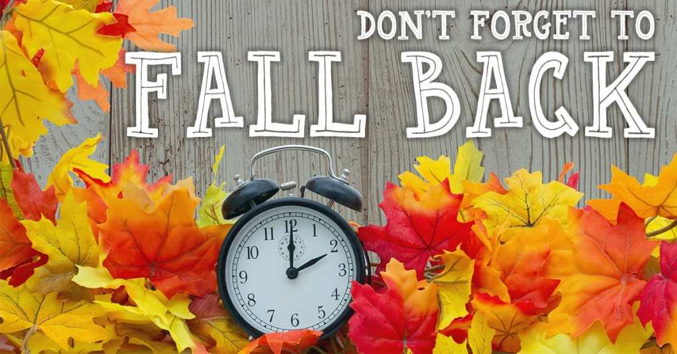

Class News
Mrs. Williams’ Second Grade
November 3, 2025

Math: wrap up subtraction with regrouping

Science/Social Studies: continue unit on Native Americans

Upcoming Events:
November 11 - Veteran’s Day Parade – 2pm
November 24 - 28 - Thanksgiving Break

