

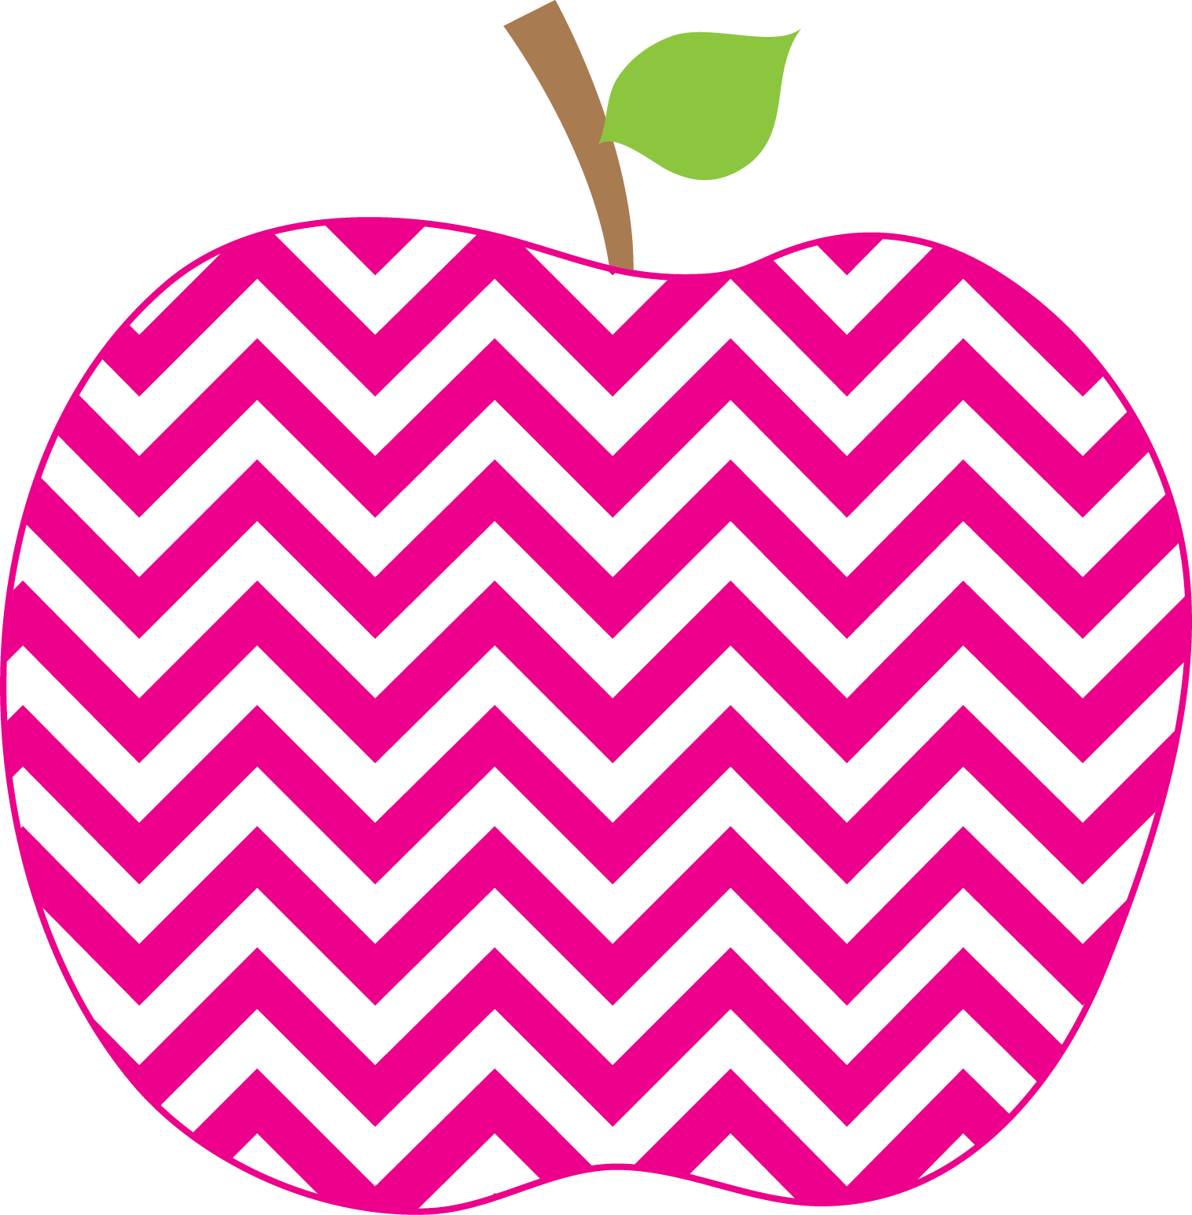



E. Robinson Weekly
Ms. E

September 2, 2025

Reading:
Phonics Skills:
*Consonant /p/ spelled p
* Consonant /l/ spelled l
* Vowel /o/ spelled o
* Consonant /b/ spelled b
*Making Predictions
*Sequencing
*Compare/Contrast

High-Frequency Words:
has, at
*RED WORDS: has, there

Writing:
*Singular and Plural Nouns
*Spacing between Words

Math:
*Topic 1 Test

Social Studies/Science- Living and Nonliving Things

This Week’s Focus:

Star Apple of the Week:
Jasen Acreman
Colored Cardstock
Colored Paper
Candy for Candy Jar
Prizes for Treasure Box

Friday, September 5th Grandparent’s
Picnic Lunch @ 11:51 AM

Monday, September 8th -Open House
@ 5:00 PM
-Progress Reports

Class Wish List:
Important Dates:

