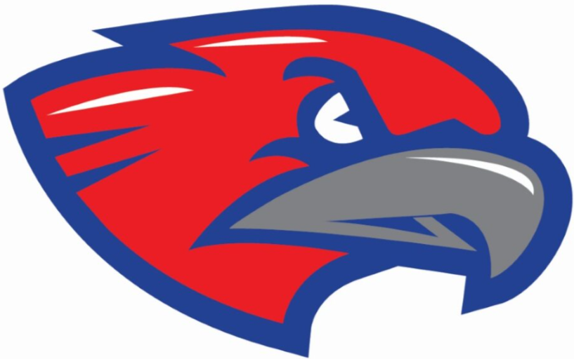
Mr. Matthew Fortson
Email: Matthew.Fortson@hcbe.net
School Number: 478-218-7537
Veterans High School
2026-2027

World History

Course Description
World History is an exciting course that takes students on a journey through time to explore how people, cultures, and civilizations have shaped our world. Students will learn about the earliest civilizations and trace important events, ideas, and developments across different regions of the world. Throughout the course, they will examine how societies changed over time, how people and cultures connected through trade and exploration, and how these interactions led to the increasingly global world we live in today. The course concludes with a look at major changes and global connections in the early 21st century.
Individual standards for the course are available upon request.

Text
As a student of this course, you will be required to complete assigned reading and tasks from the online virtual text World History Interactive. Access will be provided through Canvas. Additionally, outside texts, documents, and articles will be assigned as needed. There will be a class set available for in class work.

School Supplies for Social Studies
Note: All of these are for personal use. Some things are only required on a student to student basis.

Students will need the following supplies for class:

-A binder for your handouts/notes/etc.
-Pencils/Black and Red Pens
-Colored Pencils
-Erasers
-Highlighters
-Reinforcements for papers (Donut Holes)
-Notebook Paper
-Tape
-Personal Pencil Sharpener

Items in italics are required items that each student will need at minimum.

Grades
Grade weights are listed in the chart below. Assignments will vary in point value depending on the length, breadth, and depth of the topic at hand. Periodic progress reports will be issued, but students are responsible for keeping up with their grades and can track them via Infinite Campus. Assignments will be returned to students after grading is completed.

-Major Assignments (Tests, Projects, Essays) 45%
-Minor Assignments (Quizzes, DBQs,Notebook Checks) 20%
-Daily Assignments (Classwork, Warmups, Homework) 15%
-Final Exam 20%

Note: This course includes a cumulative exam at the end of the semester.

Communication

This year, we will use Apptegy Rooms to share class announcements, important updates, and reminders, as well as communicate with families. Please log in using the information provided by the school and enable notifications so you do not miss important information.

If more direct communication is needed, then please contact the counselor's office to set up a conference.

Technology
All students are issued a district-provided chrome book for instructional purposes, student engagement, and student learning. Chromebook use is at the direction and discretion of the classroom teacher. Also, it is expected that students will bring the Chromebook to class everyday. Students will not be allowed to use class chargers. There will be class laptops available, but these are for emergencies.
We will be using Canvas Learning Management System and it will serve as an out of class tool that will allow the students to remain in contact with the class and necessary material.Canvas will also serve as the access point for notes, handouts, study guides, and other materials that are a part of the course. Canvas can be accessed through the student chromebook.
As per the student handbook, devices are strictly forbidden. If you have one out, even to check the time, I will confiscate it. Failure to give up a cell phone when directed will result in an office referral.

Make-Up Work, Remediation, and Extra Help (Tutoring)
Students are responsible for all work, notes, handouts, etc when they are absent from class. Assignments that are turned in by the class when a student is absent are due the day the student returns. If you need an additional copy of something, check the ‘stacks’.
NIs and Instructional absences do NOT negate student responsibility. You must makeup missing assignments/quizzes/tests/etc.
ISS work must be completed and turned in to the ISS teacher correctly and responsibly. If it is an online/Canvas assignment, then it should be submitted electronically.
Tutoring will be available Tuesdays and Thursday from 3:00 to 3:30 PM. I’m available other times, but you have to let me know ahead of time.

Late Work Policy:
Students can submit work late, however work submitted late will automatically receive a 70 regardless of how late it is.
Assignments not made up or submitted within a week of being posted in Infinite Campus will not be able to be made up. A zero will be placed in the gradebook.
Cutoff dates for late/missing work will be at the end of each 9 week grading period. These will be announced in class and dates will be posted on Canvas/Apptegy.
NOTE: If a student has an IEP/504 the late work policies may not apply depending on the student’s plan.

My Expectations
- Have Respect
  - For each other, school property, classroom rules, etc.
- Do Your Job
  - This is your job. You get paid in grades.
- Show Up Prepared
  - Have your notebook, pencils/pens, charged chromebook
- Be Attentive
  - Dial in. Try to keep from being off task and daydreaming.
- Use Tech Appropriately
  - Don’t abuse the tech you have access to. Use it for school related things, not for Youtube!

Expectations and Class Procedures
For a full explanation, see document ‘Expectations and Procedures Overview’ on Canvas.

Parent Syllabus Page – Please fill out and turn in this sheet only ASAP . This is your very first grade!

I have read this syllabus and understand the standards, requirements, and expectations for Mr. Fortson’s class.

Student Name (Printed) _______________________________________________

Student Signature____________________________________________________

Parent/Guardian Signature___________________________________________________________

Parent/Guardian
Email______________________________________________________________

Best Phone number to contact_____________________________________________________________

Additional Notes for Mr. Fortson about your student:

____________________________________________________________________________

____________________________________________________________________________

____________________________________________________________________________

____________________________________________________________________________

____________________________________________________________________________

____________________________________________________________________________

____________________________________________________________________________

____________________________________________________________________________

____________________________________________________________________________

____________________________________________________________________________

