**Ms. Mann’s Class News December 9-13, 2024**

Please check and sign or initial daily folder each day.

**Important:** Eye Screening Tuesday. If you have the form I sent home, please sign and return.

**National Native American Heritage Month – November 20****24**

**What we are studying this week.**

**Science-**Science Spin from Scholastic News

**Social Studies**- Christmas in other countries, students will research, prepare reports and give oral reports Thursday and Friday.

L**anguage Arts**- adjectives/adverbs, reflective pronouns,

**Writing**-writing a fictional narrative diary entry based on a story we are reading

**Math-** measurement

**Reading-***Many Characters, many points of view*,

**Spelling**-Review r-controlled words,

Word list is in the daily folder.

**Tests this week:**

**Monday-**make up work

**Tuesday-**make up work

**Wednesday-** make up work

**Thursday-**County math test-covers all topics from 2nd nine weeks.

**Items needed for Christmas activities**

Sugar cones, (waffle cones will not work since they are not even at the top)

Green icing

Christmas sprinkles

Wide craft sticks, red or green yard

Oatmeal

glitter (white)

small candies for decorations

gallon Ziploc bags

small snack Ziploc bags

red and green

.

**Important Dates**

December 19, class parties

December 20, ½ day

December 23-January 3 Christmas Holidays

Students return on Jan 7

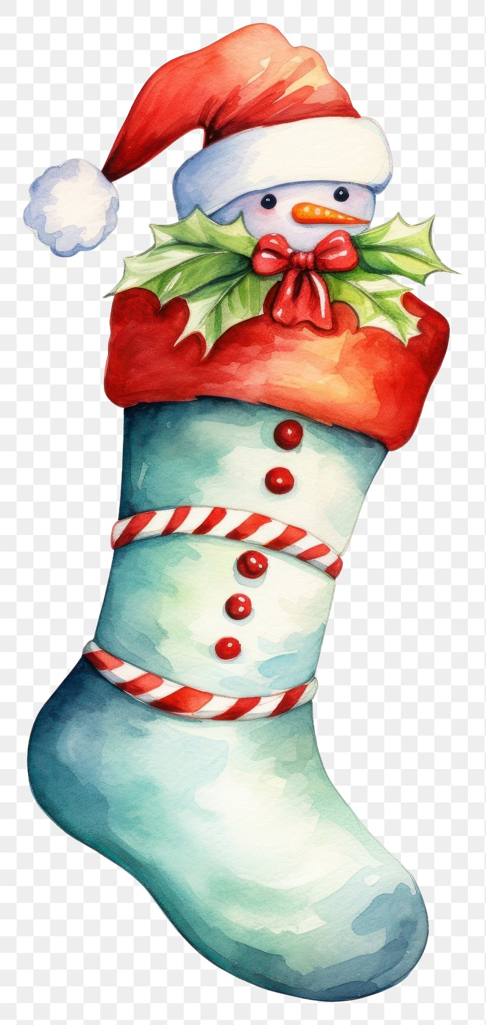

## !

**Classroom Needs**

Baby wipes

Treats for treasure box

**Student needs Dry Erase Markers, and Highlighters**

**Paper Towels** We need each student to bring two rolls a month to keep up with our demand.

**I will be sending a letter out about our Christmas party. Please indicate what you can send and return the letter to me.**

**As always, thank you so much.**

