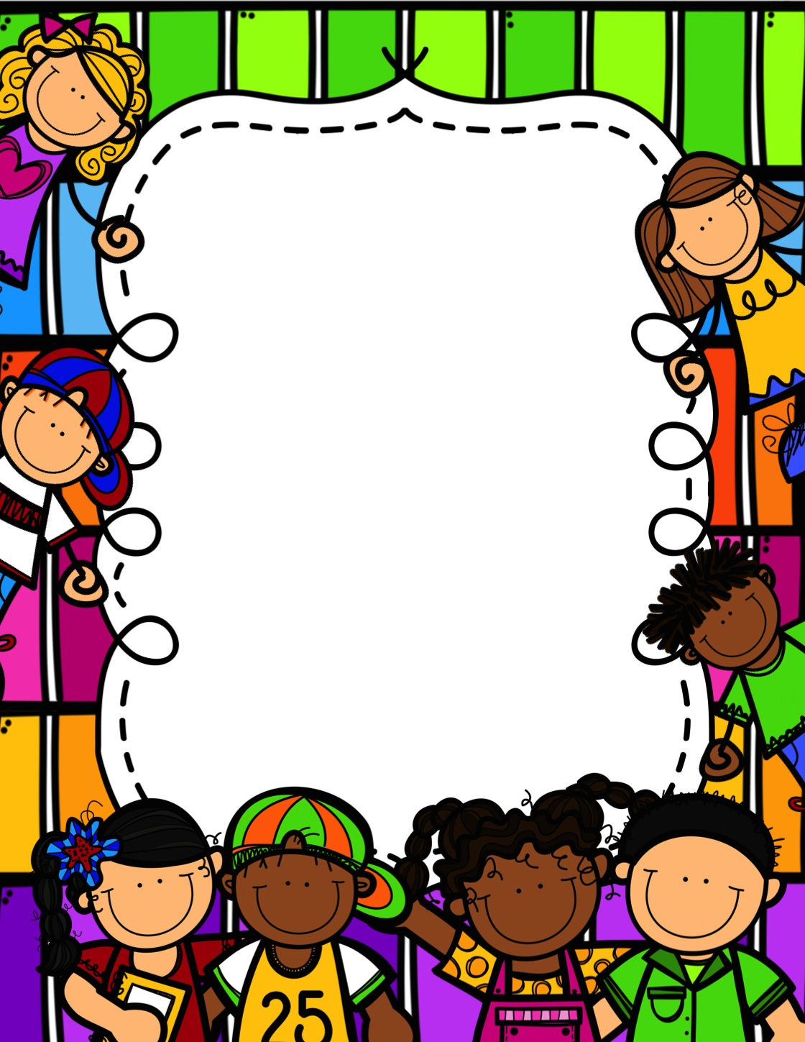
Our Class
Handbook

Mrs. McCool
And
Mrs. Horton-Smith

2023-2024

Welcome to 4th grade Math!
I am so excited about this school year! It is going to be the best one yet! I wanted to introduce myself so that you can know a little bit about me.
My name is Mrs. Abby McCool, and I am your child’s math teacher. This is my 17th year here at HLIS. I taught third grade for 13 years, fifth grade for 1 year, and this makes 3 years in fourth grade. So…I know exactly what your child learned last year while they were third graders, and I know exactly what he/she will need to know for fifth grade. I live in Nesbit, MS with my husband, Jeff and my son, Carter. My son is going into the 10th grade at Lewisburg High School. I am so proud of him! I have a sweet, old dog named Panda and a gray and white cat named Max who things he is the king of the house. I also have a pet rabbit and two aquatic turtles at home.
Some cool things to know about me is that my mom is a teacher too, and she is my partner teacher this year! Her name is Mrs. Horton-Smith. You will find out about her on the next page. She went back to college when I started college, so we graduated from Ole Miss together. That’s her in the picture below. My favorite places to shop are: Five Below, Amazon, Knowledge Tree, and Hobby Lobby. I also love movies, Pioneer Woman ANYTHING from Walmart, Red High Heel or Cucumber Watermelon teas from the Tea Shops, all the colors except yellow and orange, coffee, big funky coffee cups, AND anything teachery. 😉
I hope you enjoyed learning a few things about me. I can’t wait to get to know your child and your family this year.

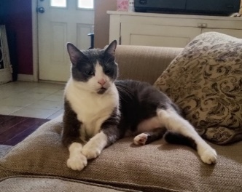
Sincerely, Mrs. McCool
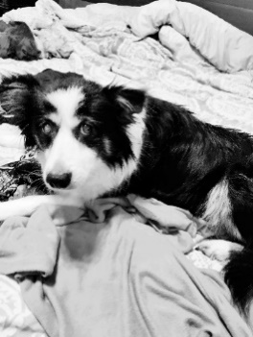

Our goal this year is for our classrooms to be fit, healthy, and ready to succeed. Let us explain what that means:
To be Fit:
Research has shown that daily movement will help students stay on task, have less behavior problems, and has a positive link to academic performance. We will have brain breaks throughout the day in class where we get up and move and exercise.

To be Healthy:
Research has shown that unhealthy eating habits lead to weight gain and high blood pressure. Students who have unhealthy eating habits are at risk of not getting adequate nutrition for proper growth of their bodies and brains, and they are at risk of decreased academic performance.
I STRONGLY encourage your child to have a HEALTHY snack choice when they bring snacks to school.
If you want your child to have a snack Monday-Thursday, please send ANY of the following choices with them to school. (If you think of anything else that is “healthy enough” that is not on this list, that is completely fine.)
Please Note: On Fridays, the school sells snacks for $1.00. (Example of snacks sold: M&Ms, ice cream, beef jerky sticks, Takis, sour punch straws and sour skittles, reg, skittles, and so on.)

Classroom Snacks (Monday -Thursday) that parents provide for their children:
- Granola bars/Nutri-Grain bars
- Fruit/vegetables
- Healthy dips
- Muffins
- Popcorn (must be popped at home)
- Yogurt
- Cheese cubes
- Crackers/pretzels
- Hard boiled eggs
- Trail mix
- Apple sauce
- Meat and cheese roll ups
- Water
- Anything else that you consider to be a healthy snack choice

Friday will be our “cheat day,” and your child can choose any snack they want to eat in class.

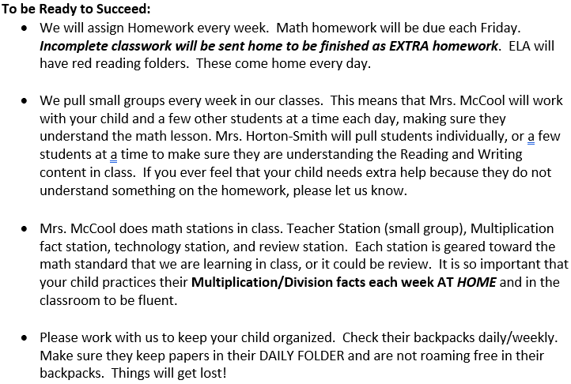

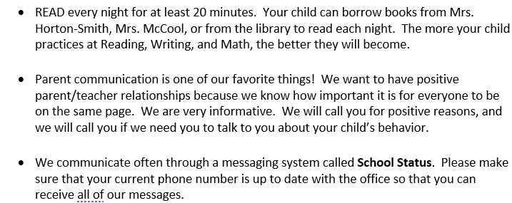

Student Conduct: DeSoto County Code of Discipline
Acts of Misconduct: These acts of misconduct include those student behaviors, which disrupt the orderly educational process in the classroom or on the school grounds including the following:
Level I
1 – 1 Tardiness
1 – 2 Running and/or making excessive noise in the hall or building
1 – 3 Inappropriate personal contact including but not limited to pushing and shoving, inappropriate gestures and public displays of affection, recklessness, or any inappropriate contact which does not result in physical harm, or any additional contact which the principal determines to be in this level.
1 – 4 In unauthorized area without pass (halls, etc.)
1 – 5 Dress code violation
* 1 – 6 Displaying any behavior which is disruptive to the orderly process of education
Disciplinary Action
First Violation
Minimum: Teacher-Student Conference
Maximum: Teacher-Student-Parent Conference Repeated or Flagrant Violation
Minimum: Mandatory Student -Parent-Administrator Conference (Home Suspension)
Maximum: Corporal Punishment, in-school suspension, detention, and/or school suspension *Students, who after having a teacher-student-parent conference, home suspension, Teacher Support Team interventions, continue displaying behavior, which is disruptive to the orderly process of education, can be suspended from school, pending a disciplinary hearing.
Level II
*2-1 Leaving the school grounds without permission
*2-2 Skipping class
*2-3 Insubordination- refusal to follow written or verbal school rules after receiving specific directions from a person in authority including, but not limited to breaking school or classroom rules, failure to respond to staff request, refusal to complete assigned task, or exhibiting disrespect towards adults
*2-4 Students shall not possess, smoke, or use tobacco or any product containing tobacco or nicotine while on campus, while attending school-sponsored activities, 21 or while under the supervision and control of district employees. This includes the possession and/or use of any electronic device that delivers nicotine or other vaporized liquids to the person inhaling from the device, including but not limited to electronic cigarettes, vapes, vaporizers, cigars, pipes, hookahs, or any electronic device that delivers nicotine or other vaporized liquids to the person inhaling from the device.
*2-5 Exhibiting any hostile physical or verbal actions
** 2-6 Unauthorized and/or inappropriate use of electronic devices (as defined in Board Policy IJBA).
2-7 Cheating on tests or exams (The grade “0” will be assigned regardless of other punishment.)
Disciplinary Action
First Violation
Minimum: Administrator-Conference, ALC, mandatory student-parent- administrator conference, corporal punishment Maximum: School suspension (one to three days) Repeated or Flagrant Violation
Minimum: School suspension (three days)
Maximum: School suspension (three days) and/or ALC for up to ten (10) days and/or Teacher Support Team interventions * Students who, after having a student-teacher conference, a teacher-student-parent conference, a mandatory student-parent-administrator conference, and Teacher Support Team interventions, and a Functional Behavior Assessment, continue displaying behavior, which is disruptive to the orderly process of education, can be suspended from school, pending a disciplinary hearing.
* Additional disciplinary action for unauthorized and/or inappropriate use of personal electronic devices (as defined in Board Policy IJBA):
1st Offense: First offense will result in confiscation of the device with parental contact. The electronic device will be returned at the end of the school day to the student or his/her parent/guardian as determined by the building principal.
2nd Offense: Second offense will result in confiscation of the electronic device and a mandatory parent/administrator conference. The electronic device will not be returned directly to the student; parent/guardian must meet with a school-level administrator to collect the electronic device.
3rd Offense: Third offense will be considered repeated and/or flagrant and the penalty for such acts will be determined by the building administrator. The electronic device will be confiscated, and penalties could include, but are not limited to the following: • Check-in/Check-out procedures for the electronic device during the school day (1-10 days) • ALC/In-school suspension (1-3 days) 22
4th Offense: Fourth offense will result in school suspension (1-3 days), and a loss if electronic device privileges pending reinstatement by the building principal.
Level III
3-1 Fighting
3-2 Gambling
*3-3 Theft or possession of stolen property
3-4 Acts which threaten the safety and well-being of students and/or staff: engaging in any behavior (by word or act) that encourages, incites, or instigates threatening or aggressive acts which can create the risk of harm to another person.
3-5 Extortion – use of intimidation, coercion or force
* 3-6 Vandalism of personal and/or school property
**3-7 Using profane, obscene, indecent, immoral, or offensive language and/or gestures, and/or possession of obscene, indecent, immoral or offensive materials
3-8 Inappropriate sexual conduct, including unwelcomed sexual contact, indecent exposure, or transferring sexually suggestive images through personal electronic devices
3-9 Bullying (as defined in Board Policy JDDA)
Disciplinary Action:
First Violation Minimum: School suspension from one to three days, ALC, corporal punishment
Maximum: School suspension (three days) and report to authorities when applicable Repeated or Flagrant Violation Minimum: School suspension (three days), ALC (ten days), and/or Levels 3-4 and 3-8 Teacher Support Team interventions
Maximum: School suspension (three days) and possible assignment to DeSoto County Alternative Center pending the results of a disciplinary hearing.
*For theft or vandalism, restitution shall be made regardless of other punishment.
Level IV
* 4-1 Possession use or under the influence of alcohol, synthetic drugs, counterfeit drugs, illegal drugs, narcotics, controlled substance(s) or paraphernalia.
4-2 Assault on a student. Assault is defined as purposely or recklessly causing or attempting to cause bodily injury (including pain or discomfort) to another.
4-3 Assault on a school employee. Assault is defined as purposely or recklessly causing or attempting to cause bodily injury (including pain or discomfort) to another.
4-4 Directing profanity, vulgar, or threatening language, and/or obscene gestures toward a staff member. 23 Any student in violation of the above shall be suspended by the principal for three days and ordered to appear for a disciplinary hearing before a District Hearing Officer.
Disciplinary Action
*Minimum: Assignment to the DeSoto County Alternative Center and a report will be made to the appropriate law enforcement authorities
Maximum: Expulsion Students below grade 6 may be given other punishment.

Level V
* 5-1 Possession and/or use of a weapon as defined in MS Code 97-37-17 – Weapons possession on educational property. The definition of weapon for the sake of this policy also includes any instrument used as a weapon to be reasonably mistaken as authentic. Examples of weapons include, but are not limited to, guns, rifles, pistols, toy guns, knives, toy knives, craft knives, utility tools, scissors, air or gas operated weapons, Airsoft pistols, BB guns, air rifle, air pistol, daggers, slingshots, razors, dynamite cartridges, bombs, grenades, mines, etc.
Disciplinary Action
Minimum: Possession other than gun will result in assignment to the DeSoto County Alternative Center and a report will be made to the appropriate law enforcement authorities
Maximum: Possession of a fire arm/gun or use of other weapon will result in expulsion from school for a period of not less than one year (under certain circumstances expulsion can be from the student’s assigned school to the DeSoto County Alternative Center)
For students below grade 6, the hearing officer may recommend other punishment if the behavior does not require expulsion and the student is likely to benefit from remediation
5-2 Sale or distribution, or conspiring to sell counterfeit drugs, synthetic drugs, illegal drugs/alcohol, narcotics or controlled substance(s)
Disciplinary Action
Minimum: Assignment to the DeSoto County Alternative Center and a report will be made to the appropriate law enforcement authorities
Maximum: Expulsion 24 For students below grade 6, the hearing officer may recommend other punishment if the behavior does not require expulsion and the student is likely to benefit from remediation
5-3 Students are prohibited from wearing, displaying, or possessing in any manner on school property or at school-sponsored events clothing, apparel, accessories, drawings, or messages associated with any gang or social club that is associated with criminal activity, as defined by law enforcement agencies.
Disciplinary Action
Minimum: Mandatory student/parent/resource officer/administrator meeting to investigate situation and determine proper discipline consequence Repeated: Assignment to the DeSoto County Alternative Center
Maximum: Expulsion for repeated violations and/or gang activity that includes but is not limited to:
• Acts which disrupt the process of orderly education
• Recruitment with use of intimidation
• Tagging or marking
• Assault
• Battery For students below grade 6, the hearing officer may recommend other punishment if the behavior does not require expulsion and the student is likely to benefit from remediation.
5-4 Threats of violence or harm: Any spoken, written, gestured or electronically communicated threat that disrupts the educational environment of the school and/or suggests a student intends to cause bodily harm or carry out an act of violence against district property, students, employees, or others (e.g. bomb threats, school shooting threats, etc.…)
Disciplinary Action
Students found to have made threats of violence or harm against district property, students, employees or others will be subject to expulsion from school for a period of not less than one year (under certain circumstances expulsion can be from the student’s assigned school to the DeSoto County Alternative Center.)
In addition to these penalties, provisions of the Mississippi Criminal Code are applicable to illegal behavior. Principals are required to report illegal activities to the police. Students committing any crime or involved with any criminal behavior are subject to arrest by local law enforcement. 25 The DeSoto County Board of Education permits individual schools to adopt additional regulations governing actions not covered by Conduct Code. However, such additional regulations may neither substitute for nor negate any of the provisions, in spirit or intent of the Conduct Code, and must be approved in writing by the School Superintendent.
Due Process
In cases where the imposition of punishment is for a suspension of three (3) days or less, the student will be orally informed of the charges lodged against him. The student shall have a right to respond and refute these charges. There may be a delay between the time that “notice” is given and the time of the parent/student right to respond. A parent will be notified of the suspension by telephone, if possible, and in writing. The student’s parent/guardian has a right to discuss this matter further and have the charge and punishment explained by the administration along with all other rights provided by board policy.
Disciplinary Hearing
When a student appears before a disciplinary hearing, the student will be subject to additional punishment up to and including suspension of more than three (3) days, assignment to an alternative educational setting for more than ten (10) days, or an expulsion from school. For additional information on due process and disciplinary hearings, please refer to Board Policy JDAAA – Disciplinary Procedures
Alternative Placement Procedures
After a student is referred for consideration of placement at DeSoto County Alternative Center (DCAC), the District Review Board and Transition Team will determine appropriate placement for the student. Once a student is accepted into DCAC, the District Review Board and Transition Team will develop an Individualized Instruction Plan (IIP) for each student. The plan will follow the program and class schedule of the home school. DCAC follows the frameworks that are established by the state of Mississippi for the subject matter to be taught in each course. Certified personnel will send a daily feedback sheet home that requires a parent signature for all students attending DCAC.
An Individualized Education Plan (IEP) committee meets to determine every change of placement for our special education students. Students with special education rulings follow their IEP while at DCAC.
Parents are notified of the recommendation for placement at DCAC during the disciplinary hearing. The home school will contact the parent once acceptance is granted by the District Review Board. All parents and students will meet with a DCAC administrator to discuss the DCAC program and requirements. The student shall 26 complete a minimum of thirty (30) successful days prior to returning to his/her home school.
The District Review Board consists of school-level administrators, district-level administrators, and counselors as determined by the Director of Pupil Services.

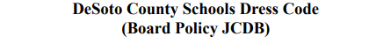
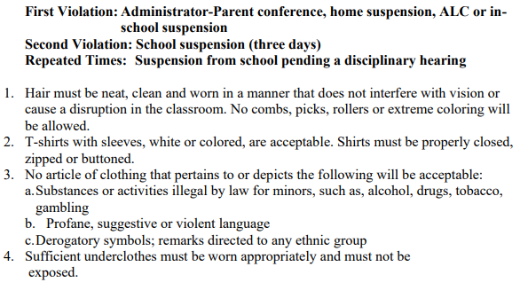
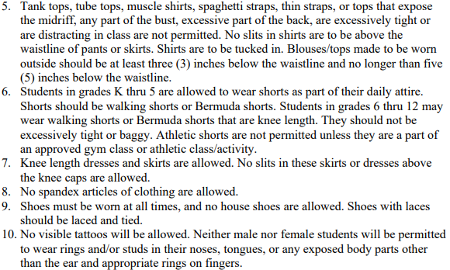

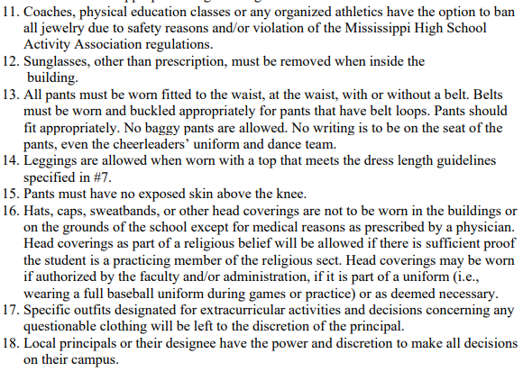

Keep these pages for you to use throughout the year.
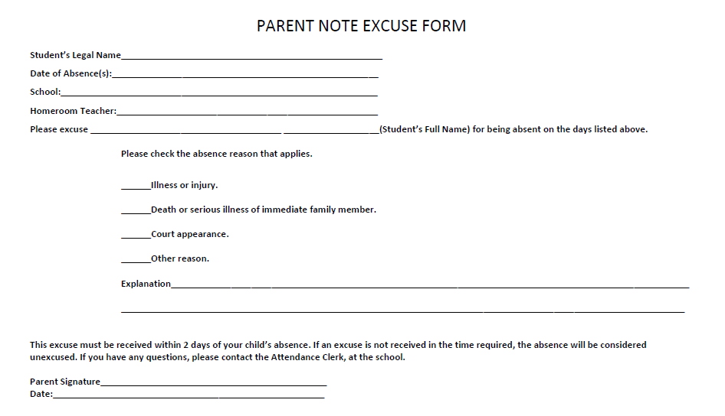

Keep this page too!

4th Grade Quick Sheet

- ELA: Mrs. Horton-Smith’s email: wanda.horton@dcsms.org
MATH: Mrs. McCool’s email: abby.mccool@dcsms.org

- School Status is the messaging system we use to send whole group messages and single messages to individual parents. Keep your phone number updated in the office.

- Send healthy snacks to school Monday-Thursday. ABSOLUTELY NO TAKIS ON THESE DAYS.

- Unhealthy snacks can be sent to school on Fridays or purchased from the Snack Shack for $1.00 each

- Water is the only drink allowed in the classroom (except for parties).

- Breakfast and Lunch menus can be found at www.desotocountyschools.org
Click on Departments, then Child Nutrition

- Check your child’s backpack and Daily Folder every day to help them stay organized.

- You can access the Desoto County quick links page. It can be found at www.dcsdms.org
By using the quick links page, your child’s Power School information (grades), DCS website, Office365 and many more items!

Knowing these things throughout the school year will keep your
child fit, healthy, and ready to succeed. If you have any
questions, please feel free to contact us.

Mrs. McCool and Mrs. Horton-Smith

