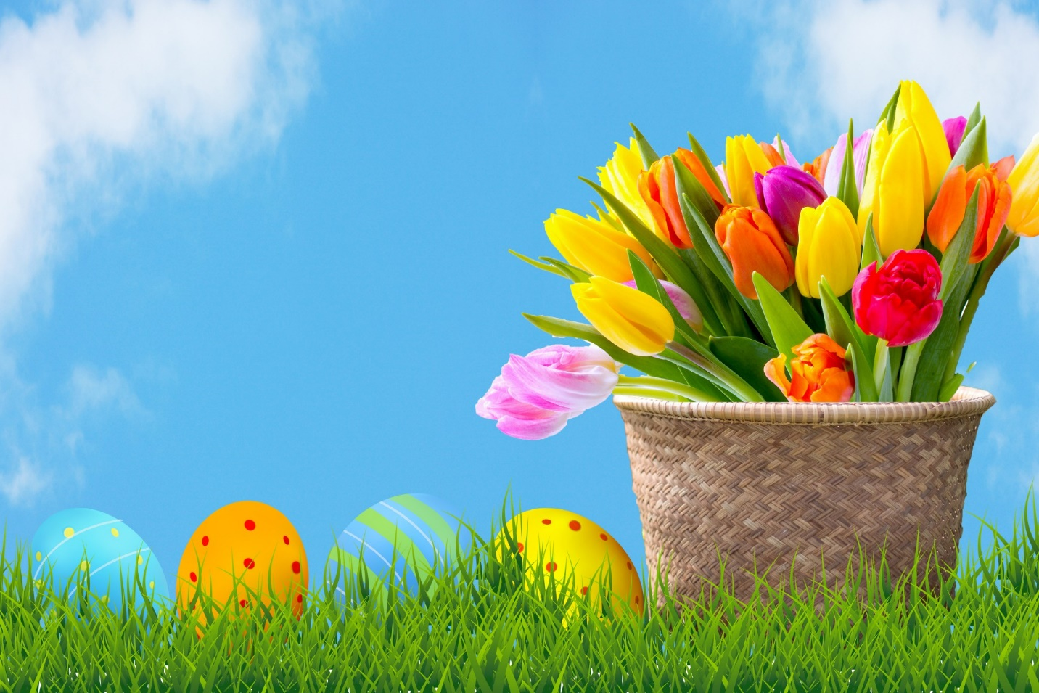

**CLASS NEWS**

**Mrs. Williams**

**Date: March 31, 2025**

**Math:**

- fractions

**Science/Social Studies:**

-life cycles

**Upcoming Events:**

**April 3rd –** Fun Run

**April 7th – 11th** - Book Fair in the Library

**April 18th – 22nd -** Spring Break #2