Mrs. Cannon’s Newsletter
November 11-15, 2024

New

Reading:
- R Controlled Vowel- or, ore, oar
- Character, Setting, Plot
- 5 W Questions (Who, What, When, Where, Why)
- Story Structure
- Character point of view

Word Study Words:
fork wore born before horn
sports store more roar oars

High Frequency Words:
long through upon was some
them work when now out

Math:
- Addition strategies to 100

Language:
- Adjectives

Social Science:
- Lady Liberty
- Scholastic News

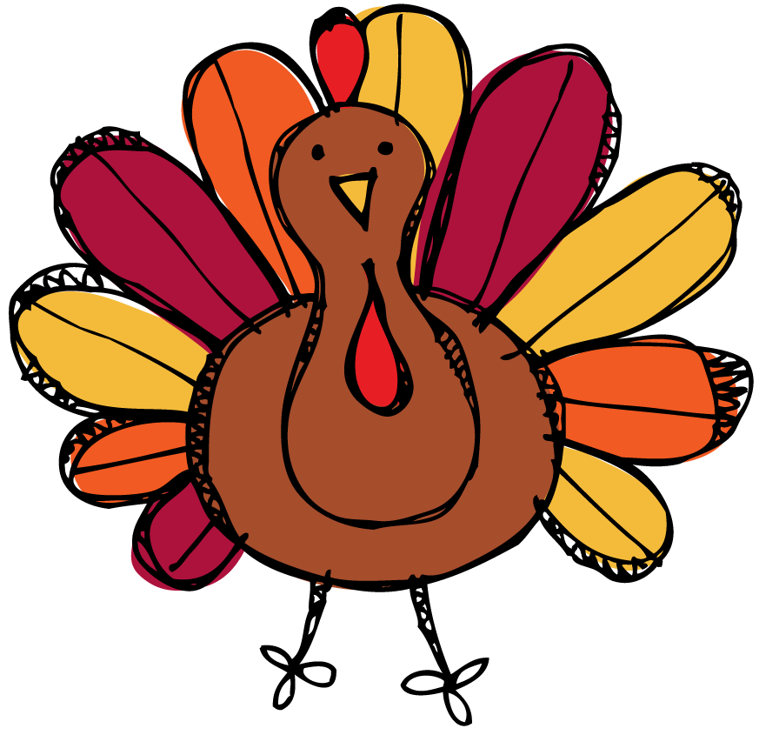
this week’s focus



Upcoming Events & Important Info

Student of the Week
Oliver
(If your child is student of the week and you would like to send in treats for the class, please send them in on Friday.
- PLEASE SEND EXACT CHANGE FOR SNACK. ($0.75 or $1.50) I do not have change to give back.
- PE: 11:20-112:05
- Lunch: 12:26-12:51
- Please label any money sent in (ex. -snack, field trip, etc.)
- Your child must wear tennis shoes or closed toe shoes to PE EVERYDAY!

- Wonderful Wednesday (special snack)- Wednesday for $2.00 (only send money on this day)
- Veteran’s Day- No School Nov. 11th
- Math Night- Nov. 12th
- Progress Reports- Nov. 14th
- Thanksgiving Lunch- Nov. 20th at 12:10
- Thanksgiving Break- Nov. 25th-29th (No school)

Reminders

