Crab Orchard Elementary

Home of the

Tigers



2022-2023

Student-Parent Handbook

**Table of Contents**

Welcome letter from Crab Orchard Faculty and Staff pg. 2

Crab Orchard History, Mission, Vision, Motto pg. 3

Crab Orchard Beliefs and Inspirational Quotes pg. 4

Non-discrimination Clause/Anti-Discrimination Statement pg. 5

Website/Facebook pg. 6

Daily Procedural Informatiion

School Hours pg. 7

Code of Conduct pg. 7

School-wide Positive Behavior Program pg. 7

Attendance letter pg. 8

Attendance policy pg. 9-12

Make-up work due to absence pg. 13

Breakfast/lunch prices pg. 13

Bus conduct pg. 13-15

Dress Code pg. 16, 17

General Information

2022-2023 School Calendar pg. 18

2022-2023 Assessment Calendar pg. 19

Ahera Asbestos Management Plan Notice pg. 20

Corporal Punishment pg. 20, 21

Discrimination/Harassment & Bullying/Intimidation pg. 21, 22

Drug-free/Tobacco-free School pg. 23-25

Emergency Preparedness Plan pg. 25

Extra-Curricular Activities pg. 25

Field trips pg. 25, 26

Grades pg. 26

Gym Shoes pg. 26

Head Lice pg. 27

Homebound Instruction Procedures/504/Due Process pgs. 27-37

Inclement Weather pg. 38

Lockers pg. 38

Medical Information pg. 39-42

Money/Valuables/Other Items pg. 43

Motorized Vehicles pg. 43

Parental Notification pg. 43-45

Personal Communication Devices (cell phones) pg. 45, 46

Phone Use pg. 47

RTI pg. 47, 48

Selling of Items pg 48

Special Education Services pg. 48

Student sign-in/sign-out pg. 49

Visitors pg. 49

Withdrawal Procedures pg. 49

Zero Tolerance Offenses pg. 50, 51

Contact Information pg. 51

Crab Orchard Elementary Title I School Information pg. 52-55

School/Parent Compact pg. 56

Signature Page pg. 57

Crab Orchard Elementary is dedicated to provide the best learning environment for our students. Our school is one in which we all should take pride and assume responsibility to ensure continued success and growth.

The success of our school depends on positive collaboration between home and school. We must have an effective partnership between parents, guardians, and school. You are the most essential part of your child’s education and it is important we build a strong relationship in order to best serve your child’s educational needs. We invite you to visit the school often, take part in school activities, and show an interest in your child’s progress. We will make every effort to communicate with you through newsletters, notes, emails, texts, and phone calls. Please don’t hesitate to contact us if you have questions, concerns, or compliments at 931-484-7400. Working together we can and will make a difference in the lives of our students!

This handbook has been written to clearly communicate information, policies, and expectations established for the safety of our students and the smooth operation of the school. We hope this handbook plays its part in helping you as a student or parent have an enjoyable and productive school year.

This is **YOUR** school. Be **PROUD** of it and take **PRIDE** in it!! Give it your

**BEST**!!

Welcome to the 2022-2023 school year!!!

Sincerely,

Crab Orchard Faculty and Staff

**Crab Orchard Elementary History**

Crab Orchard Elementary opened its doors in 1973. The school received an addition in 2001. Our new construction opened in the Fall of 2019, which resulted in 20 new classrooms, new gym and cafeteria.

Our school mascot is a Tiger, with our school colors being blue, white, and orange.

Crab Orchard Elementary is a school-wide Title I school, which enables us to use Title I funds to enhance educational opportunities for all students.

**Crab Orchard Elementary Mission**

P – Partnership with parents and community

A – Accept the diverse needs of all students

W – Work to enhance intrinsic motivation and personal responsibility

S – Strive to become life-long learners and productive members of society

**Crab Orchard Elementary Vision**

We are the TIGERS! **T**eam members tirelessly **i**ncreasing **I**ntelligence, **G**ratitude, **E**ffort, **R**esponsibility, and **S**uccess in ourselves, our students, and our team.

**Crab Orchard Elementary Motto**

A place to Imagine, Learn, Create, and Achieve!

At Crab Orchard Elementary, we believe learning is a lifelong process in which students are expected to take personal responsibility. Learning must take place in a nurturing, safe environment that recognizes the diversity of individuals while assuring equity for all.

Crab Orchard Elementary will strive to provide challenging educational opportunities that will develop the skills needed in order for students to serve their community and society, and to achieve personal success.

Through the education of our students, Crab Orchard Elementary is committed to developing, improving, and advancing the community.

“Life is like a camera.

You focus on what’s important.

Capture the good times.

Develop from the negative.

And if things don’t work out,

Take another shot.”

“No matter how educated, talented, rich, or cool you believe you are,

**How you treat people ultimately tells all**. Integrity is everything.”

“Kindness beings with the understanding that we all struggle.”

“Take chances, make mistakes. That’s how you grow.” Mary Tyler Moore

“Be the reason someone believes in the goodness of people.”

Karen Salmansohn

“Advice from a Sunflower:

Be bright, sunny, and positive. Spread seeds of happiness. Rise, shine, and hold your head high.”

**“YOU HAVE A CHOICE EACH AND EVERY SINGLE DAY.**

Choose to feel blessed. Choose to feel grateful. Choose to be excited. Choose to be thankful. Choose to be happy.”

The Essence of Life

**SPEAK TO CHILDREN AS IF THEY ARE THE WISEST, KINDEST, MOST BEAUTIFUL AND MAGICAL HUMANS ON EARTH, FOR WHAT THEY BELIEVE IS WHAT THEY WILL BECOME!!!!**

**Non-discrimination Clause**

Crab Orchard Elementary does not discriminate on the basis of race, color, national origin, religion, sex, age, or disability in admission to or access to, or treatment or employment in, its programs and activities. The system will be in compliance with the regulations implementing Title VI of the Civil Rights Act of 1994, Title IX of the Educational Amendments of 1972, The Americans with Disabilities Act (ADA) of 1990, and Section 504 of the Rehabilitation Act of 1973. Any person having inquiries concerning the system's compliance with the regulations implementing Title VI, Title IX, or the Americans with Disabilities Act (ADA) is directed to contact the Cumberland County Schools at 931-484-6135.

**Anti-Discrimination Statement of Cumberland County Schools**

It is the policy of the Cumberland County Schools to provide an environment free of discrimination and harassment of an individual because of that person’s race, color, national origin, age (over 40), sex, pregnancy, religion, creed, disability or any other category protected by state and/or federal law. The Cumberland County Schools appeals process is referenced in BOE Policy 5.5011. The Cumberland County Schools contact person is Federal Programs Director Angela Randolph @ 368 Fourth Street, Crossville, TN 38555. Phone number 931-484-6135.

**. Declaraci6n de lucha contra la Discriminaci6n Las Escuelas del Condado de Cumberland**

. Es la politica de las escuelas del condado Cumberland proveer un ambiente libre de discriminaci6n y acoso a las personas debido a su raza, color, nacionalidad, edad (mayor de 40), sexo, embarazo, religion, creencias, desabilidades, 0 cualquier otra categoria protegida por el estado y/o las leyes federales. EI proceso de apelacion de las escuelas del condado Cumberland es referenciado en BOE politica # 5.5011. La persona de contacto en las escuelas del condado Cumberland es la directora de los Programas Federales,

Angela Randolph. 386 Fourth Street, Crossville, Tennessee, 38555. Numero detelefono # 931-484-6135

**Please visit our school website (https://cos.ccschools.k12tn.net) and Crab Orchard PTO Facebook page for updates throughout the school year.**

**Daily Procedural Information**

**School hours**

The school day is from 7:45-2:45. **THE SCHOOL BUILDING WILL OPEN AT 7:00 FOR STUDENTS.**

A school designee will be in the office from 7:00am to 4:00pm daily.

## **CODE OF CONDUCT**

Students should adhere to the following Code of Conduct during daily school hours and during any before and/or after school sponsored events:

Be Cooperative.

Be Responsible.

Be Caring.

Be Honest.

Be Respectful of Others.

Be Fair.

Be a Good Citizen.

Use Manners.

**School-Wide Positive Behavior Program**

It is the goal of Crab Orchard Elementary to have positive behavioral and social interactions with our students. This in return will lead to more educational growth. In an effort to meet this goal, we have put in place a school-wide positive behavior program. This program will equip students with meaningful tools that will ensure lasting success and change within the school environment and throughout the students’ life. This year we will be incorporating Stephen and Sean Covey’s 7 Habits of Highly Effective People into our SWPB program. You will find more information about our program in your registration packet.

Attendance

“Encouraging regular school attendance is one of the most powerful ways you can prepare your child for success—both in school and in life. When you make school attendance a priority, you help your child get better grades, develop healthy life habits, avoid dangerous behavior and have a better chance of graduating from high school.

When students are absent for fewer days, their grades and reading skills often improve—even among those students who are struggling in school. Students who attend school regularly also feel more connected to their community, develop important social skills and friendships, and are significantly more likely to graduate from high school, setting them up for a strong future.

But when kids are absent for an average of just two days of school per month—even when the absences are excused– it can have a negative impact. These absences can affect kids as early as Kindergarten.

For example, young elementary school students who miss an average of just two school days per month often have difficulty keeping up with their peers academically and tend to fall behind in reading. But when students are able to read on grade level by the end of third grade, which is when kids transition from learning to read to reading to learn, they are three to four times more likely to graduate high school and attend college, post-graduate, or professional development classes than their peers who struggle with reading.” (The Importance of School Attendance – absencesaddup.org)

**Please carefully read the Attendance Policy set by the Cumberland County School Board, which is located on the following pages (pages 9-12):**

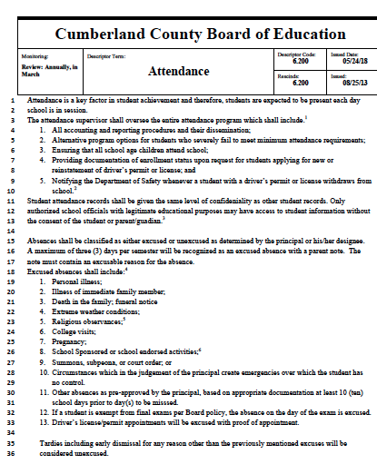

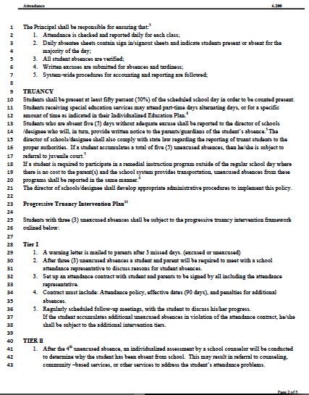

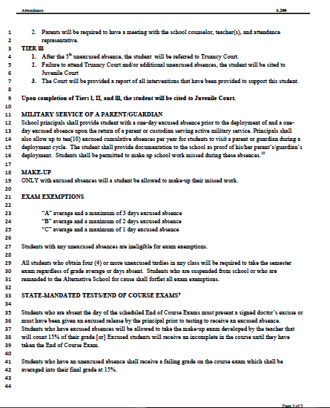

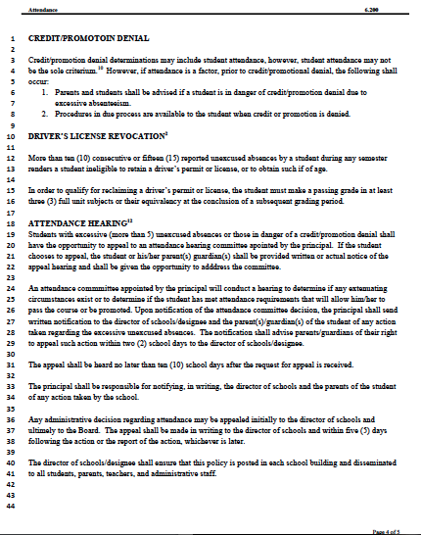

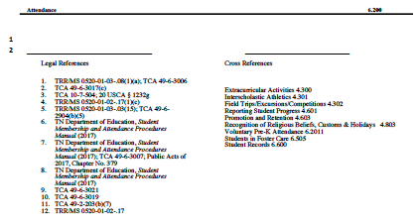

**Make-up Work due to Absence**

Make immediate plans to do all make-up work due to absence. Normally, all make-up work must be made up in a period of no less than three (3) days nor greater than the number of days missed, if more than three. If this work is not completed within the time limits, the student may receive a zero (0). Make-up work may be obtained upon the return of student(s) from previously planned days out of school for trips, vacation, etc. Students who are ill may complete make up work upon their return to school. Parents may feel free to pick up work for sick student(s) but please call by **9:00A.M.** and make arrangements to pick it up at the end of the day so as not to interrupt class time and to give teachers time to gather make-up work. The student will be graded on work completed.

**Breakfast and Lunch Prices**

Crab Orchard Elementary participates in the universal free breakfast and lunch program. All Crab Orchard students receive free breakfast and lunch.

Visitors: $4.05

## **BUS CONDUCT**

Procedures for changes in regularly scheduled transportation

Should a change in a student’s regularly scheduled transportation become necessary, a written authorization from the parent/guardian must be turned into the school. This includes requests for students to ride home on another bus with friends or relatives. This note must be signed by a school representative and presented to the bus driver when boarding the bus.

What the note should include:

* Student’s name
* Address for newly requested destination
* Contact name and phone number for newly requested destination
* Parent/Guardian’s name and phone number should a question arise

### Use of Video Cameras on school bus

Video cameras may be used to monitor student behavior on school vehicles transporting students to and from school or extracurricular activities. Video surveillance shall be used only to promote the order, safety and security of students, staff and property.

**Student Responsibilities On the Bus**

* Understand that riding a school bus is a privilege, not a right.
* Arrive at the bus stop five minutes prior to scheduled pick-up time
* Stay at least ten feet off the road, yet visible to the driver, while waiting on the bus
* Cross in front of the bus where you can see the driver and the driver can see you, and only after the driver has indicated it is safe to cross
* NEVER run in front of or behind the bus, even if you have dropped something.
* Unsafe items (i.e. knives, and/or sharp instruments) are not allowed on the bus.
* Hair spray, aerosol deodorant and/or perfume should not be used on the bus.
* Cell phones and other electronic items are permitted on the bus unless it becomes a distractions or problem. It is then up to the discretion of the driver to direct that the device be put away.
* The bus driver is the sole authority on the bus. Follow the bus drivers’ instructions the first time they are given. Exercise appropriate passenger behavior on the bus at all time.
* Absolutely no misbehaving, yelling or moving out of seats while the bus is in motion. This can be highly distracting to the bus driver and potentially hazardous to the safety of all passengers.
* Eating food or candy, chewing gum, drinking liquids, smoking and/or possession of illegal substances or obscene materials is not allowed on the bus.
* Respect other’s rights, safety and comfort on the bus.
* Profane, abusive, or vulgar language, gestures, or threats will not be tolerated.
* Fighting, pushing, shoving and/or vulgar language, gestures, or threats will not be tolerated.
* The emergency door is to be kept obstruction-free and accessible at all times.
* Open windows with permission from the driver. NOTHING may be extended out a bus window. Shouting out the bus window is not allowed.
* When the bus comes to a stop, keep hands, feet and other objects out of the aisle, to help ensure other passengers board/exit safety.
* Report any damage on the bus to the driver. Intentional damage to a bus will result in disciplinary consequences, including restitution.

**Bus Conduct Reports**

If a student violates his or her responsibilities while riding the bus, appropriate actions will be taken as follows:

1st Offense: Warning and parent notification

2nd Offense: Parent notification and 3 day bus suspension

3rd Offense: Parent notification and 5 day bus suspension

4th Offense: Parent notification and 10 day bus suspension

5th Offense: Parent notification and bus suspension for remainder of semester

Disciplinary records shall be filed in the school office and made available to parents or students, whichever is appropriate. In elementary grades, a copy of the report shall be sent home to parents.

The principal must obtain written parental permission before corporal punishment is administered. A form will be offered by the administration at the time of enrollment each year.

**Dress Code**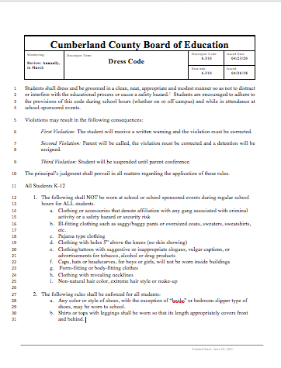

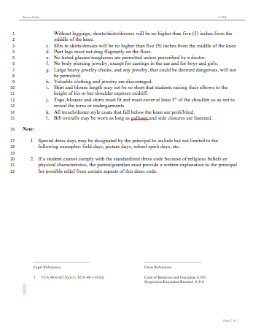

**General Information**

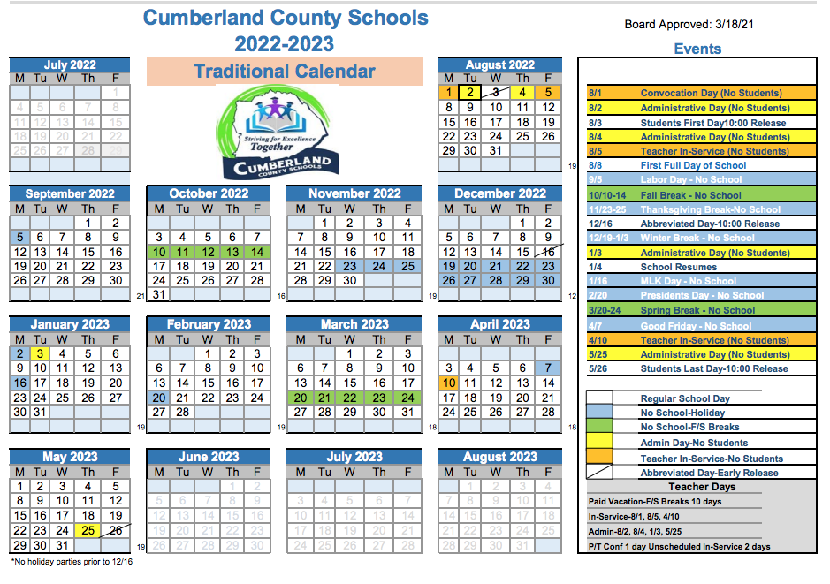

**Crab Orchard Elementary will participate in several Assessments this year. Please see the Cumberland County Schools website (**[**www.ccschools.k12tn.net**](http://www.ccschools.k12tn.net)**) under assessment information for a specific list of assessments and dates.**

**Ahera Asbestos Management Plan**

**../Asbestos%20Plan.pdf**

**Corporal Punishment** (CCBP 6.314)

Any principal, assistant principal, or teacher may use corporal punishment in a reasonable manner against any student for good cause in order to maintain discipline and order within the public schools in accordance with the following guidelines:

1. Corporal punishment may be administered only after other less stringent measures have failed, or if the conduct of a student is of such nature that corporal punishment is the only reasonable form of punishment under the circumstances;
2. The instrument to be used in administering corporal punishment shall be approved by the principal;
3. Corporal punishments shall be reasonable;
4. Corporal punishment shall be administered in the presence of another professional employee;
5. The nature of the punishment will be such that it is in proportion to the gravity of the offense, the apparent motive and disposition of the offender, and the influence of the offender’s example and conduct on others; and
6. In determining the use and degree of corporal punishment, consideration will be given to the age, sex, size, and physical and emotional condition of the child.

A disciplinary record shall be maintained and shall contain the name of the student, the type of misconduct, the type of corporal punishment administered, the name of the person administering the punishment, the name of the witness present, and the date and time of punishment.

Disciplinary records shall be filed in the school office and made available to parents or students, whichever is appropriate. In elementary grades, a copy of the report shall be sent home to parents.

The principal must obtain written parental permission before corporal punishment is administered. A form will be offered by the administration at the time of enrollment each year.

**Discrimination/Harassment and Bullying/Intimidation**

Students shall be provided a learning environment free from sexual, racial, ethnic and religious discrimination/harassment. It shall be a violation of this policy for any employee or any student to discriminate against or harass a student through disparaging conduct or communication that is sexual, racial, ethnic or religious in nature. The following guidelines are set forth to protect students from discrimination/harassment.

Student discrimination/harassment will not be tolerated. Discrimination/harassment is defined as conduct, advances, gestures or words either written or spoken of a sexual, racial, ethnic or religious nature which:

1. Unreasonably interfere with the student's work or educational opportunities; or

2. Create an intimidating, hostile or offensive learning environment; or

3. Imply that submission to such conduct is made an explicit or implicit term of receiving grades or credit; or

4. Imply that submission to or rejection of such conduct will be used as a basis for determining the student's grades and/or participation in a student activity.

**Bullying/Intimidation**

Students shall be provided a safe learning environment. It shall be a violation of this policy for any student to bully, intimidate, or create a hostile educational environment for another student. Bullying and intimidation are defined as either physically harming a student or damaging his/her property, knowingly placing the student in reasonable fear of such, or creating a hostile educational environment. The policy addresses conduct taking place on school grounds, at any school-sponsored activity, on school-provided transportation, or at any official school bus stop immediately before boarding and immediately following de-boarding.

Alleged victims of the above-referenced offenses shall report these incidents immediately to a teacher, counselor, or building administrator. Any allegations shall be fully investigated by a complaint manager (as set forth in Student Concerns, Complaints and Grievances 6.305).

The privacy and anonymity of all parties and witnesses to complaints will be respected. However, because an individual's need for confidentiality must be balanced with obligations to cooperate with police investigations or legal proceedings to provide due process to the accused, to conduct a thorough investigation, or to take necessary action to resolve a complaint, the identity of parties, and witnesses may be disclosed in appropriate circumstances to individuals with a need to know.

A substantiated charge against an employee shall result in disciplinary action up to and including termination. A substantiated charge against a student may result in corrective or disciplinary action up to and including suspension.

There will be no retaliation against any person who reports harassment or participates in an investigation. However, any employee who refuses to cooperate or gives false information during the course of any investigation may be subject to disciplinary action. The willful filing of a false report will itself be considered harassment and will be treated as such.

An employee disciplined for violation of this policy may appeal the decision by contacting the Federal Rights Coordinator or the director of schools through the director of human resources. Any student disciplined for violation of this policy may appeal the decision in accordance with disciplinary policies and procedures.

This policy shall be published in the parent/student handbook distributed annually to every student.

Building administrators are responsible for educating and training their respective staff and students as to the definition and recognition of discrimination/harassment.

**Drug-Free School**

In order to protect the rights of students, to safeguard the learning environment, and to contribute to a “Drug Free” community, the Board’s plan for dealing with alcohol and drugs shall include the following:

**1.** Appropriate ways for handling alcohol/drug-related medical emergencies.

**2.** Guidelines for reporting alcohol/drug incidents and illegal activities.

**3**. Guidelines for referral of students who may have an alcohol/drug problem and/or are considered "high risk" to agencies and other sources of appropriate help.

* Effective working relationships with appropriate community agencies, such as alcohol/drug service providers, law enforcement agencies and judicial officials.

Through the use of state guidelines the director of schools shall be responsible for:

**1.** Developing and implementing an appropriate curriculum on alcohol and drug education for students;

**2**. Providing adequate information and training for all staff personnel that are appropriate with their responsibilities.

**3.** Implementing the relevant portions of the Drug-Free Youth Act.

**4**. Developing administrative rules and guidelines for the school system to effectively respond to alcohol and drug situations that may occur at school or school-sponsored events.

**5.** Providing notification to parents and students that is compliance with this policy is mandatory.

Students will not consume, possess, use, sell, distribute or be under the influence of illegal drugs or alcoholic beverages in school buildings or on school grounds at any time, in school vehicles or buses, or at any school sponsored activity, function or event whether on or off school grounds. This includes but is not limited to abuse of inhalants and prescription drugs.

Disciplinary sanctions will be imposed on students who violate standards of conduct required by this policy. Such sanctions will be consistent with local, state, and federal laws, up to and including suspension/expulsion as well as referral for prosecution. Completion of an appropriate rehabilitation program may also be recommended.

Information about drug and alcohol counseling and rehabilitation programs will be made available through the school office.

**Tobacco-Free Schools**

It is the policy of the Board to discourage the use of tobacco products by all employees and students.

All uses of tobacco and tobacco products, including smokeless tobacco, are prohibited in all school district buildings. Smoking is prohibited in any public seating areas, including but not limited to, bleachers used for sporting events, or public restrooms.

Employees will not use tobacco products at any time while in the presence of children. Employees may not use tobacco or tobacco products, including smokeless tobacco, when directing any class or student activities or when present at such activities even though they may be held after school hours. This also extends to field trips and athletic events at locations away from school.

Tobacco products may only be used outside buildings in a specific area designated by the principal or the Director of Schools. On school campuses, the designated area shall be away from the view of any students and shall not be within fifty feet (50') of any entrance to any building.

Students enrolled in the district's schools are not permitted to use tobacco or tobacco products, including smokeless tobacco, at any time they are engaged in any school related activity or while on school grounds.

The use of tobacco or tobacco products, including smokeless tobacco, will be prohibited in all vehicles, owned, leased or operated by the district.

Any student who possesses tobacco products shall be issued a citation by the school principal, their designee or resource officer. The director of schools, in cooperation with the juvenile court and the appropriate local law enforcement agency, is responsible for developing procedures for issuance of citations which shall include the form and content of citations and methods of handling completed citations.

Parents and students shall be notified of this citation requirement at the beginning, or time of enrollment of each school year.

Signs will be posted throughout the district's facilities to notify students, employees and all other persons visiting the school that the use of tobacco and tobacco products is forbidden.

The following notice shall be prominently posted (including at each ticket booth) for elementary or secondary school sporting events:

***Law in seating areas and in restrooms prohibits smoking***.

The principal and staff shall ensure enforcement of this policy at all times.

**Emergency Preparedness Plan**

Crab Orchard Elementary has an Emergency Preparedness Plan on file in the front office.

**Extra-Curricular Activities**

Students are encouraged to participate in the wide variety of clubs, organizations and activities available at Crab Orchard Elementary. Some include: Archery, Band, Basketball, Beta, Cheerleading, Choir, Cross Country, Fitness Club, FFA, 4-H, Middle School Cheerleading, Middle School Football, Middle School Softball, Middle School Volleyball, Reading Club, Run Club, Science Club, Teen Skills, and Writing Club. All students participating in clubs are expected to follow school rules. Crab Orchard also offers a variety of enrichment opportunities throughout the year.

Any student, or group of students, wishing to form an organization must have permission from the principal.

**FIELD TRIPS**

Throughout the school year students at Crab Orchard Elementary are given the opportunity to participate in a variety of school trips. Some of these are open to all students, while others will have certain requirements to meet before a student can participate.

All students (any student) at Crab Orchard Elementary can be denied a school-sponsored trip for any of the following reasons:

⋅ Behavior and/or poor attendance.

⋅ Failure to return all forms, monies, etc. within designated time frame.

⋅ Failure to meet requirements of the specified trip.*

⋅ Failure to return completed permission slip with valid signatures and contact information.

⋅ Failure to pay necessary fees. *

The teacher/school/administration will make sure students have been given all requirements/forms with enough time to comply with established guidelines.

*Permission slips- even on trips open to all students in the group, the permission slip MUST be returned on time with all information completed, as well as any money required.

*Qualifications-On trips needing certain requirements to be met for the trip, (for example honor roll) if a student does not meet these, the student will not attend.

**Grades**

Grades are reported every nine weeks. Midterm reports are sent at the four and a half week period of each nine weeks to keep parents informed. We use the same grading scale used by all Cumberland County Schools.

A - Outstanding 92.5 - 100

B – Good 84.5 - 92.4

C – Satisfactory 74.5 - 84.4

D – Needs improvement 69.5 - 74.4

F – Unsatisfactory Below 69.4

**gym shoes**

Students will need a pair of gym shoes with non-marking soles. Parents may want to buy white soles to make sure the shoes won’t leave marks.

**head lice**

Lice are a problem in all public schools. It is a myth that only unclean people get lice. Any person who comes in contact with another person who has lice can get them. Ordinary shampoo and soap have little or no effect on lice. We screen regularly at school. Students who are found to have lice must stay home and be treated before returning to school.  **Once a student is treated for head lice he/she must be cleared by the school nurse before returning to class.** School Board Policy sets maximum of **three (3) days** to be excused for lice infestations and subsequent treatments.

**Homebound Instruction Procedures/504 Child Find/Due Process**

Homebound placement is instruction provided at home, hospital, or related site to children with disabilities. The purpose of homebound instruction is to provide medically involved students, both long-term and short-term, with a program of academic instruction. Such instruction is provided so that the student’s time of confinement need not be a loss of educational experience, nor academic credit. For long-term illnesses, such instruction is made available so that the student may participate in a planned, sequential, educational program designed to meet his/her individual needs at home or in the hospital. The result should be an educational program parallel to the one provided in the school setting.

Eligible students are provided instruction parallel to the instructional program currently offered in the typical classroom situation for his/her age and/or grade level as determined by the homebound teacher, parent, and school personnel. Adjustment in such curriculum and instruction will be made upon the recommendations of the homebound teacher in accordance with the individualized needs of each student.

Homebound instruction is one of the most restrictive educational placements for school-age children and is only appropriate when a disabled student's physical or mental condition makes placement with other students prohibitive. Homebound instruction is not to be confused with home schooling. A homebound student is a child who has a medically diagnosed physical or mental disabling condition or health impairment that confines the child to a home or hospital and whose activities are restricted for a minimum of ten (10) consecutive school days.

The following procedures will be followed for Homebound Services for Cumberland County School students:

1. Homebound forms requesting homebound services for a student must be received from a doctor. Date of services can begin no earlier than date of doctor’s signature on form. Any homebound forms received to schools should be faxed or sent to the Homebound/SPED office the day they are received.
2. All forms must be complete and approved by Homebound Director, including parent signatures on the homebound application procedures form, prior to services being provided.
3. A copy of all homebound forms will be sent back to the school attendance clerk. For students on an IEP or Section 504 Plan, a copy of the homebound form will be sent back to the student’s special education case manager to place with the current IEP or Section 504 Plan.
4. For Special Education Students, an IEP or Section 504 Team at the school will meet on an individual basis to determine what services a student needs after the following are met:

* only upon certification by a licensed doctor of medicine or osteopathy that a child with a disability needs a homebound placement,
* the child is expected to be absent from school due to a physical or mental condition for at least ten (10) consecutive school days, and
* the child can receive homebound instruction in a homebound placement without endangering the health of personnel providing it.

1. For students suspected of having a disability, the District will conduct an evaluation prior to determining eligibility for a 504 plan. If a student is determined eligible for a 504 plan while on homebound, a 504 plan will be developed by the homebound instructor, classroom teacher, parent, and school 504 coordinator. A copy of the 504 plan will be sent back to the home school Section 504 Coordinator.
2. Homebound services must be reviewed every thirty days and a new doctor’s note received. Special Education students placed on homebound for behavior may only receive homebound services for one thirty day period in a school year.
3. Prior to the student returning to school, another IEP meeting or 504 meeting will be held to transition the student back to school and determine if services or accommodations will be needed. 504 plans may be terminated at that time if no additional accommodations or services are needed. If the student continues to need a 504 plan, then it will be turned over to the school level 504 Coordinator. The school 504 Coordinator will be responsible for distributing the plan to teachers and scheduling an annual review of the 504 plan, or more frequent as needed.

**504 Child Find for Student**

The Rehabilitation Act of 1973, commonly referred to as Section 504, is a nondiscrimination statute enacted by the United States Congress. The purpose of the Act is to prohibit discrimination and to assure that disabled students have educational opportunities and benefits equal to those provided to nondisabled students.

An eligible student under Section 504 is a student who (a) has, (b) has a record of having, (c) is regarded as having, a physical or mental impairment which substantially limits a major life activity such as learning, self-care, walking, seeing, hearing, speaking, breathing, working and performing manual tasks.

If you believe your child qualifies for this program through any disability, which interferes with their learning, please contact the office to speak with our 504 Coordinator.

Crab Orchard Elementary School’s 504 program coordinator is Marcy Harelson. She can be reached at 931-484-7400.

Complaints of Disability Discrimination may be made orally or in writing.

**Cumberland County Schools Parent/Student 504 Rights**

**In Identification, Evaluation, and Placement**

The following is a description of the rights granted to students with a disability by Section 504 of the Rehabilitation Act of 1973, a civil rights statute, which prohibits discrimination against persons with a disability in any program or activity receiving federal financial assistance. The intent of the law is to keep you fully informed concerning decisions about your child and to inform you of your rights if you disagree with any of these decisions.

You have the right to:

1. Have your child take part in, and receive benefits from public education programs without discrimination because of his/her disability;

2. Have your school district advise you of your rights under federal law;

3. Receive notice with respect to identification, evaluation, or placement of your child;

4. Have your child receive a free appropriate public education. This includes the right to be educated with non-disabled students to the maximum extent appropriate. It also includes the right to have the school district make reasonable accommodations to allow your child an equal opportunity to participate in school and school-related activities;

5. Have your child educated in facilities and receive services comparable to those provided non- disabled students;

6. Have your child receive special education and related services if s/he is found to be eligible under the Individuals with Disabilities Education Act or Section 504 of the Rehabilitation Act;

7. Have evaluation, education, and placement decisions made based upon a variety to information sources, and by persons who know the student, the evaluation data, and placement options;

8. Have transportation provided to and from an alternative placement setting at no greater cost to you than would have been incurred if the student were placed in a program operated by the district;

9. Have your child be given an equal opportunity to participate in nonacademic and extracurricular activities offered by the district;

10. Examine all relevant records relating to decisions regarding your child’s identification, evaluation, education program, and placement;

11. Obtain copies of education records at a reasonable cost, unless the fee would effectively deny you access to the records;

12. A response from the school district to reasonable requests for explanations and interpretations of your child’s records;

13. Request the amendment of your child’s educational records if there is reasonable cause to believe that they are inaccurate, misleading, or otherwise in violation of the privacy rights of your child. If the school district refuses this request for amendment, it shall notify you within a reasonable time, and advise you of the right to a hearing;

14. File a local grievance;

15. Request voluntary mediation or an impartial hearing related to decisions or action regarding your child’s identification, evaluation, educational program or placement. You and the student may take part in the hearing and have an attorney represent you. Written hearing requests must be submitted to the 504 Coordinator/designee of the local school system and include the following information:

* The reason for the request;
* A suitable time for the hearing: morning, afternoon, evening;
* Two possible dates for the hearing; and
* Whether the hearing will be closed or open to the public

The hearing must be held no less than fifteen (15) days and no more than thirty (30) days from the time you asked for the hearing, unless you agree otherwise, or the impartial hearing officer grants a continuance at the request of one of the parties.

Reasons for the request:

1. Denied identification, evaluation or educational placement of persons who, because of a disability, need or are believed to need special education or related services.

2. Placed in a setting which is not the least restrictive environment.

3. Denied appropriate services due to inaccessibility of programs.

4. Denied modifications to regular education program because of identified disability.

5. Denied participation in extracurricular and nonacademic activities because of disability.

16. Ask for payment of reasonable attorney fees.

The person in Cumberland County Schools who is responsible for ensuring compliance with Section 504 is:

Special Education Supervisor

931-484-3301

**Cumberland County Schools Due Process Hearing Procedures**

Section 504 of the Rehabilitation Act of 1973 provides the right to an impartial due process hearing if a parent wishes to contest any action of the Cumberland County Schools with regard to a child’s identification, evaluation, and placement under Section 504. This provision is found within 34 CFR §104.36. If a parent/guardian requests a Section 504 hearing with Cumberland County Schools, the parent/guardian has the right to personally participate and to be represented at the hearing by an attorney or advocate at the parent’s expense.

Contested actions or omissions that are appropriate for a Section 504 hearing with Cumberland County Schools should involve identification, evaluation, or placement issues involving a child who has or is believed to have a disability.

**Request for Due Process**

A parent/guardian who wishes to challenge Cumberland County Schools action or omission with regard to the identification, evaluation, or placement of a student, who has or is believed to have a disability as defined by Section 504, shall make a written request for a due process hearing to Cumberland County School’s Section 504 coordinator. If a request is received orally, it should be reduced to writing or the parent/guardian should be provided a form to reduce the request to writing. The written request must make clear that the parent is seeking a due process hearing under Section 504 before an impartial Section 504 hearing officer. The written request must be made on a form provided by Cumberland County Schools for that purpose. If the intent to seek a due process hearing is not clear from the face of the request, Cumberland County Schools Section 504 coordinator may contact the parent to clarify the request and ascertain whether the parent wishes to initiate a Section 504 due process hearing. The coordinator may also assist the parent in clarifying any questions regarding due process rights under Section 504. Timelines for the appointment of a hearing officer will not begin until it is clear from the parent/guardian’s request for due process that the dispute at issue is regarding the Section 504 identification, evaluation or placement of a child. If after such communication, Cumberland County Schools is still unsure whether the parent is requesting a due process hearing under Section 504, Cumberland County Schools shall initiate due process procedures, and appointed hearing officer will hold a pre-hearing conference to decide whether the parent is seeking a due process hearing under Section 504, and whether the hearing office has jurisdiction to entertain the claims and issues raised by the parent.

**Hearing Officer**

Cumberland County Schools will appoint an impartial hearing officer to preside over the hearing and issue a decision. Such appointment will be made within fifteen (15) days of the date of receipt of a clear request for a due process hearing. The hearing officer will be hired by Cumberland County Schools as an independent contractor at no expense to the parent. The hearing officer that is appointed shall not be a current employee of Cumberland County Schools, and shall not be related to any member of Cumberland County Schools local board of education. The hearing officer need not be an attorney, but shall be familiar with the requirements of Section 504 and Cumberland County Schools hearing procedures under Section 504. The District’s choice of an impartial hearing officer is final and may not be presented as an issue at the due process hearing, since such an issue would not relate to the identification, evaluation, or placement of a disabled child under Section 504. If a parent/guardian disputes the impartiality of the appointed hearing officer, s/he may raise such issue in a review of the hearing officer’s opinion by a court of competent jurisdiction or in a complaint to the Office for Civil Rights. The regional office which covers Tennessee is: U.S. Department of Education Office for Civil Rights - Atlanta | 61 Forsythe Street, SW, Suite 19T70 | Atlanta, GA 30303 | (404-974- 9406).

**Scheduling of Hearing**

The appointed hearing officer shall issue an Order Setting Hearing Date to the parent/guardian and Cumberland County Schools Section 504 coordinator in writing. Such Order shall set a date for the hearing to be held within fifteen (15) days of the date of issuance of the hearing officer’s Order. The Order shall also set forth a mutually agreeable time and place for the hearing.

**Continuances**

Upon a showing of good cause, the hearing officer, at his/her discretion may grant a continuance of the hearing date and set a new hearing date by issuing a written Amended Order Setting Hearing.

**Legal Representation at Hearing**

Cumberland County Schools will not have legal representation at the hearing unless the parent notifies Cumberland County Schools that they will have legal representation. If a parent/guardian is represented by a licensed attorney at the due process hearing, s/he must inform Cumberland County Schools Section 504 coordinator and the appointed hearing officer of that fact, in writing, at least seven (7) calendar days prior to the hearing date, or the hearing can be continued upon Cumberland County Schools request.

**Pre-Hearing Conference**

The hearing officer may order a Pre-Hearing Conference during which the parent/guardian or his/her representative will state and clarify the issues to be addressed at the hearing. The Pre-Hearing Conference will also serve to resolve preliminary matters, clarify jurisdictional issues, and answer the parties’ questions regarding the hearing process. The Pre-Hearing Conference can be held via telephone or in person depending on the Hearing Officer’s decision based on the convenience to both parties.

**Dismissals**

If, after the Pre-Hearing Conference, the hearing officer finds that the parent, as a matter of law, alleges and/or raises no factual claims or legal issues that come within his/her jurisdiction as a Section 504 hearing officer, s/he may dismiss the hearing and issue an order to that effect explaining the basis for such finding.

**Hearing**

The hearing shall be conducted in an informal, non-adversarial manner. The parties shall address the hearing officer by name (i.e. Mr. or Ms.). The hearing shall be closed or open to the public as the parent/guardian’s request. The federal nor the Tennessee Rules of Evidence or Procedure will apply. The hearing officer may reasonably limit testimony and introduction of documentary exhibits for reasons or relevance.

**Recording**

Instead of a formal written transcript produced by a court reporter, the entire due process hearing will be tape-recorded. The parent/guardian may obtain a copy of the tape-recording, at his/her request. In order for an accurate recording to be made, the parties and witnesses shall introduce themselves at the beginning of their presentations. If a parent/guardian proceeds to a review of the due process hearing decision to a court of competent jurisdiction, Cumberland County Schools will prepare a written transcript of the hearing tape-recording to be offered to the court as an exhibit.

**Witnesses**

Witnesses will present their information in narrative form, without the traditional question and answer format of legal proceedings. Cross-examination of witnesses will not be allowed, but a party may request that the hearing officer, at his/her discretion, ask a witness a certain question.

**Format of Presentation**

Each side will have an equal amount of time to present their positions to the hearing officer, who will make the determination as to time constraints based upon the issues involved. The parent/guardian will present its case first, by making an opening statement, which outlines the parent/guardian’s position on all issues, presenting personally, calling additional witnesses, and making a closing argument. Cumberland County Schools will present its side next. All of the preceding may be done either personally or through counsel, except for personal presentations or statements. At the end of Cumberland County Schools presentation, the parent/guardian may offer a short response to Cumberland County Schools case.

**Submission of Documentary Exhibits**

As part of their presentations, the parties may submit any reports, evaluations, correspondence, notes, or any other documents that may support their positions and that the hearing officer will admit at his /her discretion. Exhibits submitted to the hearing officer by either party must be marked. The hearing officer may, in the exercise of his/her discretion, reasonably limit the number of documents to be submitted for his/her review, as well as the number of witnesses and the length and/or scope of their presentations or statements.

**Closing Argument/Briefs**

The hearing officer may allow or request written closing arguments summarizing and characterizing the information presented at the hearing; and provide legal authority in support of each party’s position. The hearing officer will set time lines for their submission at the conclusion of the hearing.

**Decision**

The hearing officer may make an oral ruling at the conclusion of the hearing or take the case under advisement; but, in all cases, the hearing officer shall issue a written opinion addressing and ruling on all issues raised by the Petitioner, indicating what corrective action, if any, Cumberland County Schools must take. Formal findings of fact and conclusions of law are not required. Any issue or claim raised by the parent/guardian that is left unaddressed by the hearing officer in his/her decision will be deemed to have been denied. The hearing officer should include in his/her decision that the unaddressed issues/claims have been denied. The decision must be issued within forty-five (45) days after the date the Request for a Due Process Hearing is received by the district. The hearing officer may not award attorneys’ fees as a part of the relief granted to a parent/guardian or the district.

**Review Procedure/Appeal**

If the parent/guardian is not satisfied by the decision of the hearing officer, s/he may seek review of the hearing decision in a court of competent jurisdiction (generally the closest federal district court).

**Complaints to the Office for Civil Rights (OCR)**

A parent/guardian may file a complaint with the Office for Civil Rights (OCR) if s/he believes that Cumberland County Schools has violated any provision or regulation of Section 504. The filing of a complaint does not affect the hearing process or the time lines set forth above. OCR addresses Section 504 complaints separately and independently of the local hearing process, in accordance with the guidelines set forth in OCRs Case Processing Manual. A parent/guardian should contact OCR or consult its Case Processing Manual concerning timeframes for filing OCR complaints.

The OCR office for Tennessee is located at:

Atlanta Office Office for Civil Rights U.S. Department of Education

61 Forsyth St. S.W., Suite 19T10

Atlanta, GA 30303-8927

Telephone: 404-974-9406

FAX: 404-974-9471; TDD: 877-521-2172

Email: OCR.Atlanta@ed.gov

The OCR National Headquarters is located at:

U.S. Department of Education Office for Civil Rights

Lyndon Baines Johnson Department of Education

Bldg 400 Maryland Avenue, SW Washington, DC 20202-1100

Telephone: 800-421-3481

FAX: 202-453-6012; TDD: 877-521-2172

Email: OCR@ed.gov

**Cumberland County Schools**

**Request for Section 504 Due Process Hearing**

Student’s Name: ______________________Date of Birth: ________________

Student’s Address: ______________________________________________________________ ________________________________________________________________

School: __________________________________________________________

Parent/Guardian’s Name:_______________________________________________________

Parent/Guardian’s Address:_____________________________________________________

Parent/Guardian’s Phone Number(s):________________________________________________

I am requesting that a Section 504 Due Process Hearing be scheduled regarding the following issues:

□ Section 504 identification: ________________________________________________________________ ________________________________________________________________________________________________________________________________□ Section 504 evaluation: ________________________________________________________________________________________________________________________________________________________________________________________________

□ Section 504 placement: ________________________________________________________________ ________________________________________________________________________________________________________________________________

_____________________________________________ __________

Parent/Guardian/Authorized Representative Signature Date

Return this form by FAX or MAIL to:

Special Education Dept.

368 4th Street

931-484-3301

**Inclement Weather**

If we have to dismiss school early due to inclement weather, we must know how your child is to go home. **Please take time to fill out the inclement weather procedure form in your child’s registration packet.**

The Cumberland County Schools System has a plan in place for the safety of all children and staff in the event of a tornado watch and/or tornado warning. We are in constant contact with the local Weather Service and County Emergency Management Agency that tracks the storms. Your assistance is needed in our effort to make sure our full attention is directed towards securing the safety of our children and staff. Please follow the procedures listed below if you hear a tornado watch or warning for our county during school hours:

* **Do not telephone the school** – our limited phone lines must be clear to communicate with Emergency Management Agency and Central Office. School personnel have specific responsibilities to attend to student/teacher needs.
* **Tune in to local radio or T.V. stations** – Media outlets Radio: FM 105.7, 93.3, 102.5, AM 1330, 1490, TV Knoxville Channel 10, 6, Fox 17, Nashville Channel 5.
* **Do not come to the school unless student pick up is requested** – This will allow staff to attend to the children during a “take cover” due to a tornado warning.
* **If the school goes into take cover, they have been notified of the severity of the storm** – no students or staff will be allowed to leave the campus for their safety during the most dangerous time.

We do understand your concerns, but want to assure you that the safety of **All** the children is our main concern.

**Lockers**

Each 7th and 8th grader will be assigned a specific locker for use during the school year. Remember, this is a possession of the school being loaned to the student. A key or combination lock should be purchased for your child’s locker. A key or the combination for your child’s lock will be given to his/her homeroom teacher in case of emergency.

**Medical information**

A school nurse is on the campus each day. Medication may **NOT** be brought to school or taken home by any student. **A parent or guardian must bring the medicine in its original bottle and must sign papers for the dispersal of this medication. Parents must also pick up any unused medication**. Medication must be kept in the clinic and administered by the school nurse or the person designated by the principal to give medication in the nurse’s absence.

The school clinic is operated by a school nurse. Parents are called if their child has a fever or appears to be suffering from an illness or injury. **To ensure prompt notification, it is critical that all emergency forms are current.**

**Crab Orchard Elementary has a written cardiac plan on file in the nurse’s office.**

**Immunization Requirements:**

Effective July 1, 2010

Tennessee Department of Health has issued new immunization rules and a new Official Certificate that is required for entry into school.

* There will only be ONE official certificate of immunization form that must be filled out by medical providers for parents to bring to school prior to entry of their child into PreK or Kindergarten. This form is ONLY available from your physician or health department.
* For Children entering **7th grade**, immunization boosters are required. (Tdap booster and varicella)
* For children who are **NEW ENROLLEES in a TN school,** there are new immunization requirements prior to enrollment.

YOUR CHILD WILL NOT BE ALLOWED TO ENROLL IN SCHOOL UNTIL THE IMMUNIZATION RECORDS ARE UP TO DATE. **Please check with your local physician or health department to update all vaccinations and information.**

**You will have ten days from the first day of school to get correct immunization form to school. If not provided, your child will not be able to attend school until the problem is resolved.**

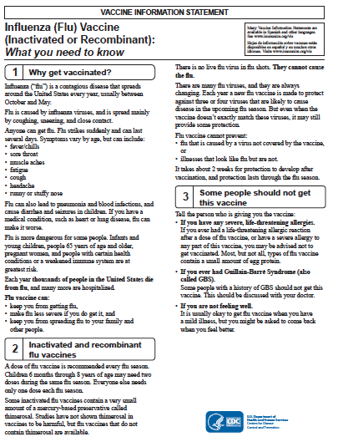

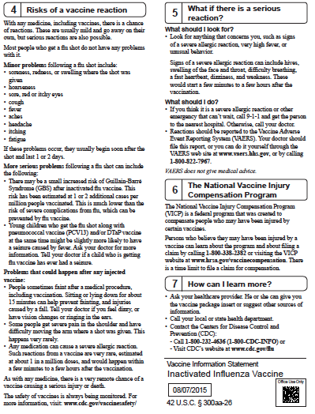

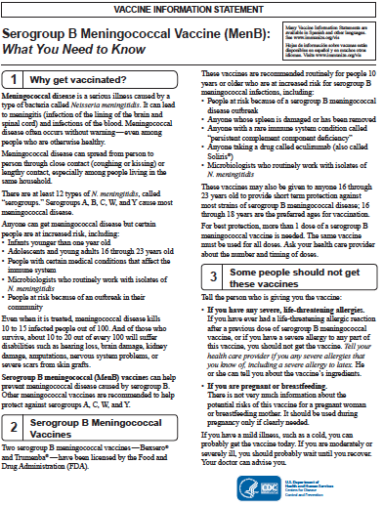

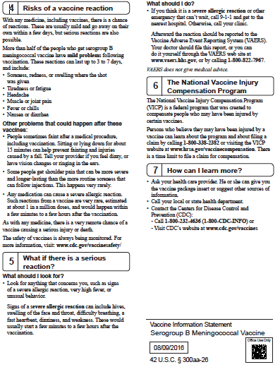

Cumberland County Board of Education

Coordinated School Health

Student Health Screening Passive Permission 2022-2023

Dear Parent or Guardian,

Throughout the school year we will be providing **FREE** health screenings for the Cumberland County students in grades Pre-K, K, 2, 4, 6, 8, 9th through 12th, and Lifetime Wellness.  We conduct these FREE screenings in order to identify students who may have a health risk in order to bring awareness to the student and parent/guardian. The data only (not the student name) is sent to the TN State Department of Education.  The Cumberland County Health Department, Lion’s Club, community health care providers, and trained school personnel will be assisting with these screenings with strict adherence to the confidentiality of each child and adolescent screened. We may screen children for one or more of the following:

B.M.I. (Body Mass Index) Hearing Scoliosis

Vision Blood Pressure

Height/ Weight Asthma

If we screen your child and find any alterations from a normal screening, as defined by Center of Disease and Control (CDC), we will contact the parent/guardian concerning this matter.  There are **NO CHARGES** for these services.

Please feel free to contact your school nurse or the CSH Coordinator should you have any questions.  Thank you for allowing your child to participate as we promote a healthy lifestyle to our students in Cumberland County.

Respectfully,

Marsha Polson, RN Coordinated School Health Supervisor

Email: [mpolson@ccschools.k12tn.net](mailto:mpolson@ccschools.k12tn.net)

931-484-6135

_______________________________________________________________________

**If you do NOT want your child to receive a FREE health screenings, please write a note stating you do NOT want your child screened for the specific test, sign, date, and return to the school nurse.**

**Money/Valuables/Other Items**

The school will not be responsible for lost or stolen items. Students should not bring large amounts of money or valuable items to school or to school functions. Students may not bring iPODS, MP3 players, personal laptops, PDAs, CD players, skateboards, laser pointers or any other type of toy to school unless prior approval has been given by the teachers. Shoes with wheels are not to be worn at school during the school day or at school functions.

**Motorized Vehicles**

No student will be allowed to drive any type of automobile or motorized vehicle to school. Unauthorized vehicles found on school campus will be towed at owner’s expense. Vehicles on school property are subject to search.

**Parental Notification**

**Mission Statement**

The mission statement for the Cumberland County School System is to empower each student with the skills to be a productive citizen. Parents play a vital role in this mission. The Board encourages parental involvement and strives to keep parents informed of their rights.

**Notification**

* The Cumberland County School System does not discriminate on the basis of race, sex, color, religion, national origin, age, or handicap in the provision of educational opportunities, activities, or other administered programs.
* Parents have the right to request information pertaining to the professional qualifications of their child’s teacher(s). Teaching certification can be found by accessing the Tennessee Department of Education Teacher Licensing website ([www.state.tn.us/education/Iichome.htm](http://www.state.tn.us/education/Iichome.htm)) or by contacting the Central Office at 931-456-8347. Parents may also request the qualifications of a paraprofessional that provides educational assistance to their child.
* Parents must receive notification if a teacher that is not highly qualified is teaching their child for 4 or more consecutive weeks in core curriculum subject.
* Parents will have access to system/school report cards as developed by the State Department of Education and available (usually in late fall of each year) through the state department website ([www.state.tn.us/educ](http://www.state.tn.us/educ)), at the school, and/or at Central Office.
* Parents will be informed if their child is enrolled in a school identified for improvement, corrective action, or restructuring. An explanation of what this means, reasons for the identification, academic comparisons with other schools in the district and state, steps being taken to improve achievement, and how the parents can become involved will be addressed.
* Parents will be given the option to transfer their child to another public school or to obtain supplemental educational services if the school fails to meet adequate yearly progress.
* Parents will receive academic results for mid-reporting periods, end of reporting periods, TCAP Achievement results in grades 3-8, writing assessment in grades 5,8,and 11, and End-of-Course and Gateway Exams in a timely manner as required by local Board policy and the Tennessee Department of Education.
* Parents can visit the state’s website ([www.state.tn.us](http://www.state.tn.us)) to access a description of the Tennessee Curriculum Standards, assessments, and proficiency levels students are expected to meet.
* Parents of secondary school students have the right to request that their child’s name, address, and telephone number not be released to a military recruiter without their prior written consent.
* Parents of a student identified as limited English proficient (ELL- English Language Leaner) will be notified in a timely manner of their child’s level of English proficiency, their child’s opportunity to participate in an ELL program, details of the program, and the right to waive participation.
* Title I Schools: A written parental involvement policy will be developed jointly with and distributed to parents of children participating in the Title I programs. The parental involvement policy is printed in the school’s handbook and a copy is available in the school’s office. An annual meeting will be held to inform parents of the school’s participation and status in programs funded under the No Child Left Behind Act.
* A school-parent-student compact that outlines the responsibilities of each party for improved student academic achievement will be distributed and agreed upon annually.
* Federal law affords parents and students, over 18 years of age, certain rights regarding educational records. The school board policy relating to student privacy and parental access to information is available in the school board policy manual located at each school and Central Office.
* Students and parents are encouraged to participate in safe and drug free school programs/activities. If parents object to these programs/activities, they may submit a written request to the principal that their child does not participate.
* Information pertaining to the rights granted by federal law to students with disabilities may be obtained by contacting the Special Education Department of the Cumberland County School System at 931-484-3301.

SPED WEBSITE:

[http://ccschools.k12tn.net/ specialediweb/sped//home. html](http://ccschools.k12tn.net/%20specialediweb/sped//home.%20html)

* The Cumberland County School System has the responsibility to locate, identify, and evaluate all children ages 3 to 22 years that are suspected of having a disability. If you have any questions or concerns please contact the Special Education Director at 931-484-3301
* School health requirements, policies and procedures can be obtained from the Cumberland County Health Department, the school principal or the school nurse.
* Students attending a persistently dangerously public school or students who become victims of a violent criminal offense while in or on the grounds of a public school that they attend are provided the opportunity to transfer to a safe public school within the local education agency.
* A program or activity funded as part of the 21st Century Community Learning Center that provides before or after school activities must be evaluated to assess its effectiveness. The results of the evaluation(s) are available upon request at the Federal Programs Department at 931-456-8347.

**Personal Communication Devices (Cell Phones)**

A student may possess a personal communication device such as a pager, cellular telephone, personal digital assistant (PDA), or any similar type device, in school, on school property, at after school activities, and at school-related functions, provided that during school hours and on a school bus the personal communication device remains off and concealed from view.

At no time will any student utilize a personal communication device in an attempt to undermine instructional practices or violate an individual's privacy. This does not restrict the use of communication devices as an instructional tool to be used at the discretion of the teacher.

Possession of a personal communication device by a student is a privilege, which may be forfeited by any student who fails to abide by the terms of this policy. Violations of this policy may result in disciplinary action against the student and confiscation of the personal communication device. Student consequences for violating the cell phone policy are as follows:

**First Offense –** Phone taken up and student’s parent must come and pick up the phone.

**Second Offense** – Phone taken up and keep for three days and parent must come and pick up the phone.

**Third Offense** – Phone taken up and keep for one week and parent must come and pick up the phone.

Any student possessing a personal communication device shall assume all responsibility for its care. At no time shall Cumberland County School System be responsible for preventing the theft, loss or damage to personal communication devices brought onto its property.

**Crab Orchard Student Personal Technology Use Guidelines:**

We embrace the potential that personal technology devices (cell phones, tablets, iPods, etc.) can be used as a technological learning tool in the classroom and encourage teachers to implement their use into lessons when appropriate.

**Crab Orchard Guidelines:**

* Personal technology, should be turned off and kept out-of-sight during all instructional and class time activities, except under the direction of a teacher or administrator for ***instructional purposes.*** This means that students will not be permitted to have personal technology devices out during morning or afternoon bus duty, lunch, special area, bathrooms or in the hallways during regular school hours.
* No cell phone or other personal technology may be used **for communication purposes** except under the direction of a teacher or administrator for instructional purposes.

Therefore, students are to refrain from using cell phones to make calls, text, Snap-Chat, take pictures/video, or use any form of Social Media during regular school hours unless otherwise permitted by their teacher or other school staff.

* In the event of illness or emergency, students will be directed to use the phone in the Front Office or Nurse’s office to call parents. At no time should a student use personal technology, without the knowledge or permission of school staff, to contact a parent.
* Students who receive a School Wide Positive Behavior Pass for personal technology devices will be allotted a special day and time to use their device. Passes will be returned to their teacher upon their expiration of the pass.

**Phone Use**

School phones are for emergency use only, and students may only use the phone in the office. Emergency calls do NOT include forgotten lunch money, forgotten items, permission to stay after school, or permission to go home with another student. Teachers, students, and parents are expected to make arrangements for after-school activities or to cancel after-school activities in advance-not the day of an activity. If a student must call home due to illness, office personnel will make the call to the parent.

**If you need to notify the school of alternate arrangements for how your child will go home, please try to contact the front office before 2:00 p.m.**

**RTI (Response to Intervention) Services**

Response to Instruction and Intervention (RTI2)

“To empower each student with the skills to be a productive citizen” is the mission statement of Cumberland County Schools. It is our goal for all students to have the resources and instruction necessary to reach their full potential while receiving a free appropriate education.

In compliance with No Child Left Behind, and the Individuals with Disabilities Education Improvement Act, Cumberland County schools are dedicated to meeting the needs and services for all students to receive the best quality education through programming for the individual student. The school system adheres to a policy of non-discrimination in educational programs and activities while striving to provide equal educational opportunity for all students as required by Section 504 of the Rehabilitation Act of 1973, which prohibits discrimination based on disability.

The school system embraces the Response to Instruction and Intervention Framework (RTI2) model, now part of educational law for the state of Tennessee, as a system of service delivery that uses evidence-based interventions, monitoring and evaluation for on-going tracking of individual students in making informed decisions about the student’s educational and behavioral programming needs. This framework provides students who do not respond to instruction with increasingly intensive levels of intervention. Each school is dedicated to meeting the requirements of the Response to Intervention Framework Model through the School Intervention Team’s oversight of procedures and fidelity of implementation. If you feel your child is in need of additional intervention, please contact the school office to speak with our school RTI2 Coordinator.

**Selling of Items**

The only selling of items at school will be through the school bookstore, cafeteria, concessions, school/club fundraisers, or other school activities. Students will not sell anything at school unless it is a fundraising item. No extortion or trading of items will be allowed.

**Special Education Services**

Cumberland County Schools offers special education services to students with physical disabilities, emotional problems, learning disorders and speech, and hearing and visual impairments. Services are also provided for students in need of homebound assistance. If your child receives early intervention service as an infant or toddler up to age three, and may still need special education, your service coordinator will assist you with transition planning and making a referral to Preschool Special Education. If your preschool-aged child did not receive early intervention services, but has some delays or lags in development such as difficulty in talking, moving around, thinking or learning or is facing physical or behavioral challenges-you, or professionals who know your child may make a referral to the Cumberland County School Preschool Special Education who will assist you in completing the referral process. Cumberland County Schools are committed to finding students suspected of having disabilities as early as we can. Children with disabilities that impact their learning have the right to a free appropriate public education from the time they turn three years old until they are twenty-one.

**Student sign-in/sign-out**

**Students that arrive after 7:45 or leaving before 2:45 will be marked tardy. If arriving after 7:45, an adult or guardian should sign in students.** Should a student need to leave before 2:45, they must be signed out of the school building by a parent or guardian. Excused tardies or early checkouts are for doctor or dentist appointments. In order for a doctor’s appointment to be excused, the physician must sign a written excuse that must be turned in to the attendance office. (Students may give the excuse note to their teacher who will turn it in to the attendance office.) Students may be released to another adult designated by the parent, only if the parent or guardian sends a note. **Anyone picking up a student must bring their driver’s licenses into the office**. Verification of identity will be asked for. **Please, remember that this is for your child’s safety and no other reason.**

**Visitors**

**Please understand that our utmost concern is for the safety of your child.**

In order to ensure everyone’s safety, we must adhere to the following and we appreciate your support!

All visitors and parents should use **only** the main front entrance. All visitors to our school, including parents, **MUST** check in at the office. Sales-persons must obtain permission from the director of schools to visit schools.

If parents wish to speak with the teacher, we ask that you send a note or leave your phone number with the receptionist and the teacher will contact you as soon as possible. From 7:30 until 2:45 all of our teachers are on duty and cannot leave their classrooms unattended. We try desperately not to interrupt this instructional time.

**Withdrawal Procedures**

A student is not withdrawn unless a parent or guardian comes to school and completes the appropriate forms. Please allow time for teacher, cafeteria, and library to be contacted to verify all accounts are cleared.

**Zero Tolerance Offenses**

In order to ensure a safe and secure learning environment, the following offenses will not be tolerated:

Weapons and Dangerous Instruments

Students shall not possess, handle, transmit, use or attempt to use any dangerous weapon in school buildings or on school grounds, or in school vehicles and/or buses, or off the school grounds at a school-sponsored activity, function, or event at any time.

Dangerous weapons for the purposes of this policy shall include, but are not limited to a firearm or anything manifestly designed, made or adapted for the purpose of inflicting death or serious bodily injury or anything that in the manner is use or intended to use is capable of causing death or serious bodily injury.

Violators of this section shall be subject to suspension and/or expulsion from school.

**Firearms** (as defined in 18 U.S.C. § 921) 3

In accordance with state law, any student who brings or possesses a firearm on school property shall be expelled for a period of not less than one (1) calendar year. The director of schools shall have the authority to modify this expulsion requirement on a case-by-case basis.

**Drugs**

In accordance with state law, any student who unlawfully possesses any drug, including any controlled substance or legend drug, shall be expelled for a period of not less than one (1) calendar year. The director of schools shall have the authority to modify this expulsion requirement on a case-by-case basis.

**Battery**

In accordance with state law, any student who commits battery upon any teacher, principal administrator, any other employee of the school, or school resource officer shall be expelled for a period of not less than one (1) calendar year. The director of schools shall have the authority to modify this expulsion requirement on a case-by-case basis.

**Notification**

When it is determined that a student has violated this policy, the principal of the school shall notify the student’s parent or guardian and the criminal justice or juvenile delinquency system as required by law.

**Contact Information**

**Child Advocacy Group Contact Information**

In addition to the state and local resources available to parents and children, there are many agencies and organizations that offer support, information, training and help in advocating for persons with disabilities in Tennessee.

A few of these organizations are listed below:

**The Arc of Tennessee** is on the Internet at <http://www.thearchtn.org/>.

Or 1-800-835-7077

**Support and Training for Exceptional Parents** is on the Internet at

<http://www.tnstep.org/>

**Crab Orchard Elementary**

Principal: Debbie Beaty

Asst. Principal: Marcy Harelson

Phone: 931-484-7400

Fax: 931-456-5655

**Cumberland County Board of Education**

Phone: 931-484-6135

**Tennessee Department of Education Contact Information**

Answers to many questions and much helpful information may be obtained from the State Department of Education by calling 1-888-212-3162 or visiting:

http://www.state.tn.us/education/topic/special-education-legal-services

**Crab Orchard Elementary Title i school**

Crab Orchard Elementary is a school wide Title I school, meaning that all students receive benefits from this federal program. Our Title I goal is to increase the achievement of all Crab Orchard students in all areas and more specifically in Language Arts and Mathematics. This achievement is to measured through the amount of increase of performance level reslts on the Achievement Test.

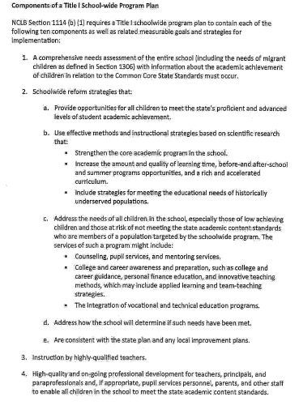

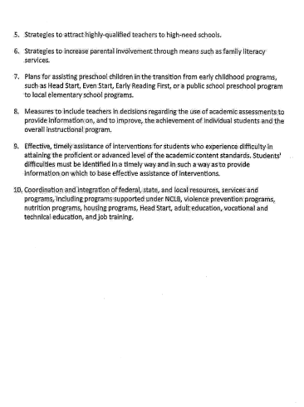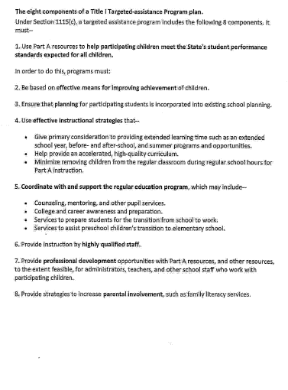

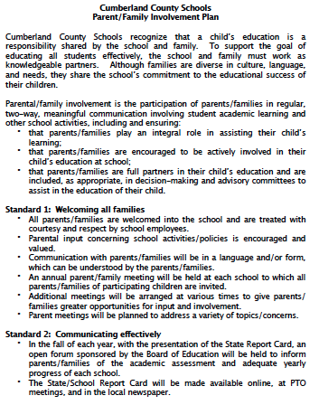

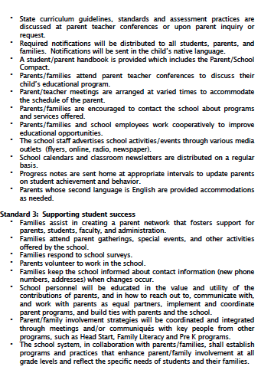

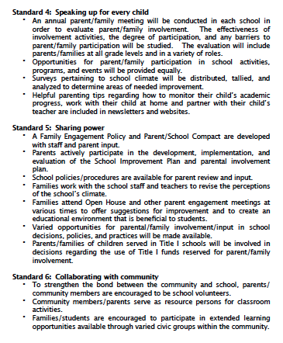

# Crab Orchard Elementary School-Parent Compact

Dear Families,

We value your role in working to help your child achieve high academic standards. Our COE student handbook can be found on our school’s website. If you would like a printed copy of the handbook, please call the school office. The following is an outline of some of the ways you and the school staff can build and maintain a partnership to share the responsibility for supporting your child’s learning.

*School’s Responsibility:*

* Provide high quality curriculum and learning materials
* Provide you with assistance in understanding academic achievement standards and assessments and how to monitor your child’s progress
* Provide opportunities for ongoing communication between you and teacher through, at a minimum:
  + Annual parent-teacher conferences
  + Frequent reports regarding your child’s progress, and opportunities to talk with staff, volunteers, and observe.

*Family’s Responsibility:*

* Encourage your child to attend school regularly
* Encourage your child to show positive school behavior
* Review your child’s homework
* Monitor television watching and encourage positive use of your child’s extracurricular time
* Volunteer in your child’s school and classroom, if possible
* Attend parent-teacher conferences and participate, when appropriate, in decisions relating to your child’s education

Please review the School-Parent Compact with your child. This Compact may be discussed with you during a parent-teacher conference as it relates to your child’s progress.

please sign below that you have read and discussed the school/parent compact with your child. Tear out this page and return it to your child’s teacher as soon as possible so that your child Will receive credit for it.

I have read and discussed the compact with my child.

___________________________________________

Parent/Guardian Signature

__________________________________________

Child’s Name and Homeroom teacher

**Please check the appropriate circle:**

**Ο** *I* **give my permission** for my child’s picture and name to be put in the newspaper and on the school’s website for items at Crab Orchard such as student of the month and other awards. At times, pictures of students may also appear on the school’s Facebook page or the teacher’s personal page.

**Ο** **I** **DO NOT give my permission** for my child’s picture and name to be placed in the newspaper or on the school’s website.