
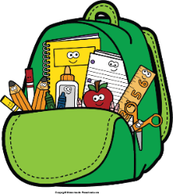
Mr. Marks’ Messages
December 1st-5th, 2025
Assessments
Thursday Assessments: grammar quiz, weekly math quiz
Friday Assessments: Spelling Test, Reading Test
Reminders
- Friday, December 5th- Special Snack
- Friday, December 12th- Class Pictures
- Friday, December 19th- Early Dismissal (11:30)
- We will be collecting cereal boxes for the food drive this week
- Please check your child’s binder daily for important information, homework, and their behavior chart.
Reading Story and Skills:  Story: My Community and Me  Phonics/Fluency:  Long /e/ spelled -ie, -y, -ey, ee, and ea  Writing:  Informational writing  Text-Based Comprehension:  Main Idea and Details  Grammar/Language:  Comparative adjectives and articles |  | Vocabulary Words  - courteous: polite  - develop: to bring into being slowly  - discover: to see or find out for the first time  - evolve: to develop or grow slowly  - fascination: the state of feeling intense interest in something  - gain: to get  - relies: to trust; depend  - role: the part played by a person or thing in relation to others  - running: to keep going or happening; to continue  10. true: faithful to someone or something; loyal
Math  Topic 8  Lesson 1-4  Students will learn to count coins. We will count pennies, nickels, dimes, and quarters. We will also solve problems with coins. Study guide on Thursday and test Friday. |  |  |  | Social Studies/Science  Science:  We will continue our unit on National Holidays. This week we will focus on Christmas. We will begin a packet on Christmas Around the World.
Spelling Words:
- field  - lady | - money  - breeze |  | - stream  - baby |  | - speech  - brief | - monkey  10. teach

