
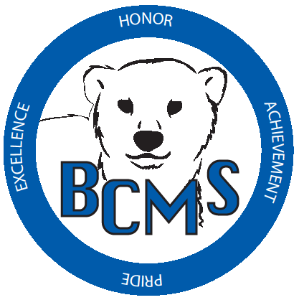
Bracken County Schools
348 West Miami Street

Brooksville, KY 41004
606-735-2523- phone 606-735-3640- fax
“Changing the world, one student at a time.”
Bracken Co. Schools Gifted and Talented Instructor Checklist & Recommendation

Student Name: ____________________________ Grade: ___________ Date: ______________
Name of Instructor completing checklist: _______________________________________
Signature: ______________________________________ Contact Phone #: ______________

VISUAL AND PERFORMING ARTS: DRAMA
A. Indications (check all that apply):
- Observed strengths in the area of drama
Explain: _________________________________________________________________
- Has won an award in drama (in or out of school)
Award: _________________________________________________________________
B. Has had a part in a play (in or out of school)
Explain: _________________________________________________________________
C. Additional information that you believe is relevant. (Please Attach)
D. Drama Checklist (Please complete below)

(MUST BE COMPLETED FOR RECOMMENDED STUDENTS)
Please check the characteristics which accurately describe the TYPICAL behavior of this student.

☐ Eager to participate in classroom plays or skits
☐ Effectively uses voice, gestures, and facial expressions to communicate feelings
☐ Commands and holds the attention of a group while speaking
☐ Able to evoke emotional responses from listeners – can get people to laugh, frown, feel tense, etc.
☐ Can imitate others – is able to mimic the way people speak, talk, gesture
☐ Readily shifts into the role of another character
☐ Imaginative – has a strong sense of fantasy
☐ May daydream at times
☐ Sensitive to beauty – attends to aesthetic attributes of things
☐ Seems to pick up skills in drama without instruction
☐ Invents new techniques, experiments
☐ Sense of humor – sees humor in situations others do not see
☐ Sees minute details in performances
☐ High in sensory sensitivity
☐ Uses drama to express experiences or feelings
☐ Appears reflective or idealistic

Additional Comments- See Back:

Bracken County Schools
348 West Miami Street

Brooksville, KY 41004
606-735-2523- phone 606-735-3640- fax
“Changing the world, one student at a time.”

Bracken Co. Schools Gifted and Talented Instructor Checklist & Recommendation (Continued)

Level of performance:

Special strengths and weaknesses:

Needs caused by giftedness:

Ability to work independently and focus responsibility on specific area:

Other comments:

