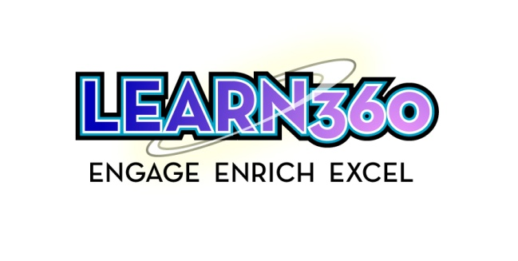

2017-2018 Order/Renewal Form

FAX Mail
this form to both numbers to ensure that your service is not interrupted. Purchase Orders to:
Greg Ricci . . . . . . . . . . . . . . . . . . . . . . . . . . . . . . . (212) 313-9443 Region 8 Education Service Center
Region 8 Education Service Center at . . . . . . . . .(260) 423-0031 1027 W Rudisill Blvd #17
Attn: Chris Gamble or email to cgamble@r8esc.k12.in.us Fort Wayne, IN 46807
2017-2018 Annual Cost
Access Terms 1 Year $ 682.50 per building
2 years $ 1,296 (No Annual Increases and 5% Disc. off total)
3 Years $ 1,842 (No Annual Increases and 10% Disc. off total)

Renewal Buildings
District Name | Building Name | Renewing? | # of Years  (circle one) | Building Contact Name | Building Contact Email | Enrollment
 |  |  | 1 2 3
 |  |  | 1 2 3
 |  |  | 1 2 3
 |  |  | 1 2 3
 |  |  | 1 2 3
 |  |  | 1 2 3
 |  |  | 1 2 3
 |  |  | 1 2 3
 |  |  | 1 2 3

New Buildings
District Name | Building Name | # of Years  (circle one) | Building Contact Name | Building Contact Email | Enrollment
 |  | 1 2 3
 |  | 1 2 3
 |  | 1 2 3
 |  | 1 2 3

