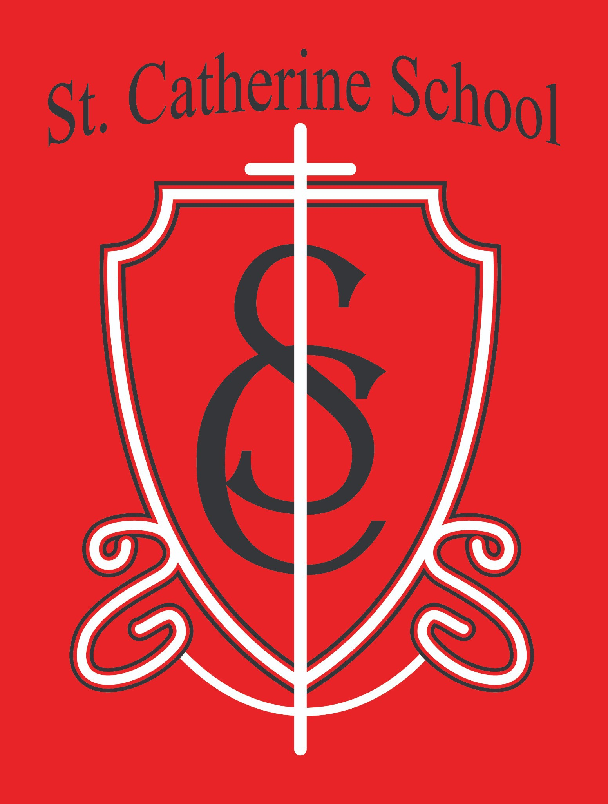

St. Catherine School Weekly Newsletter (Week of February 23-28)
https://www.stcatherine.k12.nd.us/parents

Principal's Message
Dear St. Catherine Families,
We had a wonderful Kindergarten Round Up on Friday, and I simply want to say thank you.
Thank you to the parents who attended, those who invited others, and especially to our teachers and staff who were such positive representatives of St. Catherine School. What families see when they walk through our doors is who we truly are — faith-filled, joyful, and intentional.
We had a great turnout, and I continue to pray specifically for open hearts to enrollment at St. Catherine School. I hope you will join me in that prayer. Catholic education forms not only minds, but souls, and we are grateful for every family who considers partnering with us.

Reminders

All School Mass – Thursday, March 5 at 10:30 AM (Guest Lunch to Follow)

Our March All School Mass will be held next Thursday, March 5 at 10:30 AM, with a guest lunch to follow.
If you plan to attend and join your child for lunch, please RSVP to Ms. Giesen in the school office by:
Calling 701-845-1453, or

Emailing terra.giesen@k12.nd.us

Tuition Assistance Information – Coming Soon

Early next week, I will send an email with details on applying for Tuition Assistance for the upcoming school year.
The application window will be open for two months.

If you are even thinking that, financially, it may be difficult to make St. Catherine School work next year, I strongly encourage you to review the application information. Our tuition assistance fund is generously supported by parishioners, community members, and alumni with the specific purpose of making Catholic education accessible.

No School – March 6 and March 9

There will be no school on Friday, March 6 and Monday, March 9. Please plan accordingly.

Winter Gear Reminder

We are at that time of year when we can go from snow to mud and back again in a single day. Please continue sending all winter gear with your child until further notice.
If conditions are extremely muddy, we may need to send winter gear home more often for cleaning and drying. Thank you for helping us keep students warm and comfortable during outdoor recess.

St. Catherine Spotlight
Our wonderful staff puts in a lot of extra time to make events like Kindergarten Round Up possible. Each need or task is met with offers of help from other staff members. I am so thankful to lead a staff that truly has SERVICE in their hearts.

The wonderful leadership of the 5th and 6th grade students during Kindergarten Round Up. They helped make it a fun day and were such positive representatives of our school!

Thank you to Colette Jenson (COF Director and Parent of 3 St. Catherine Alumni) and Brad Buck (Current Parent) for sharing their perspective on why they chose St. Kates for their families. We are so thankful for the trust that so many families have put in our educational value.



Stay Connected with St. Catherine School
📍 Address: 540 3rd Ave. NE, Valley City, ND 58072
Email: nicholas.lee1@k12.nd.us
📧
Phone: 1-701-845-1453
📞
Website: www.stcatherine.k12.nd.us
🌐
📘 Follow Us on Facebook: St. Catherine School on Facebook

“Inspiring excellence through faith, learning, and service.”

