Virtual Learning Directions - Reading

These are step by step instructions to help you and your child complete their assigned work for virtual learning this week!

To complete all assignments, follow the steps in the images below:

- Go to classroom.google.com

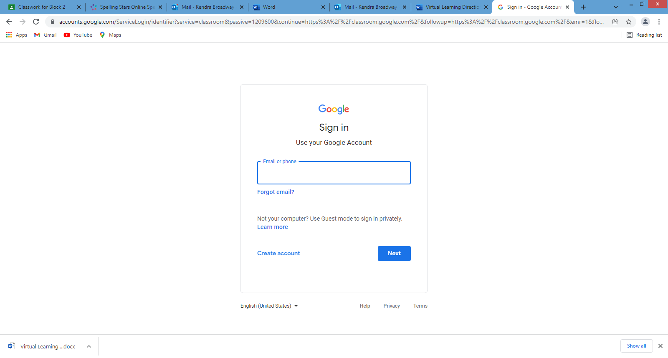

- If it is your first time logging onto your child’s google classroom account from that computer it will ask you to log in. To log in, use your child’s school email and password
  - Ex. Email – mccallister.####@student.acboe.net
Password – McCallister.####
(Your child’s Google email and password is located on the back of their binder. However, your child should have this email and password memorized by now.)

- Once you’ve logged into your child’s account you will click on either “Block 1” or “Block 2”

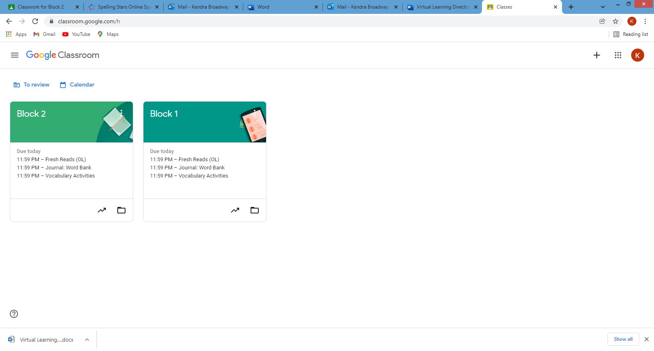

- When you have clicked on either ”Block 1” or ”Block 2”, to get to the assigned work you will click “Classwork” at the top of the screen.
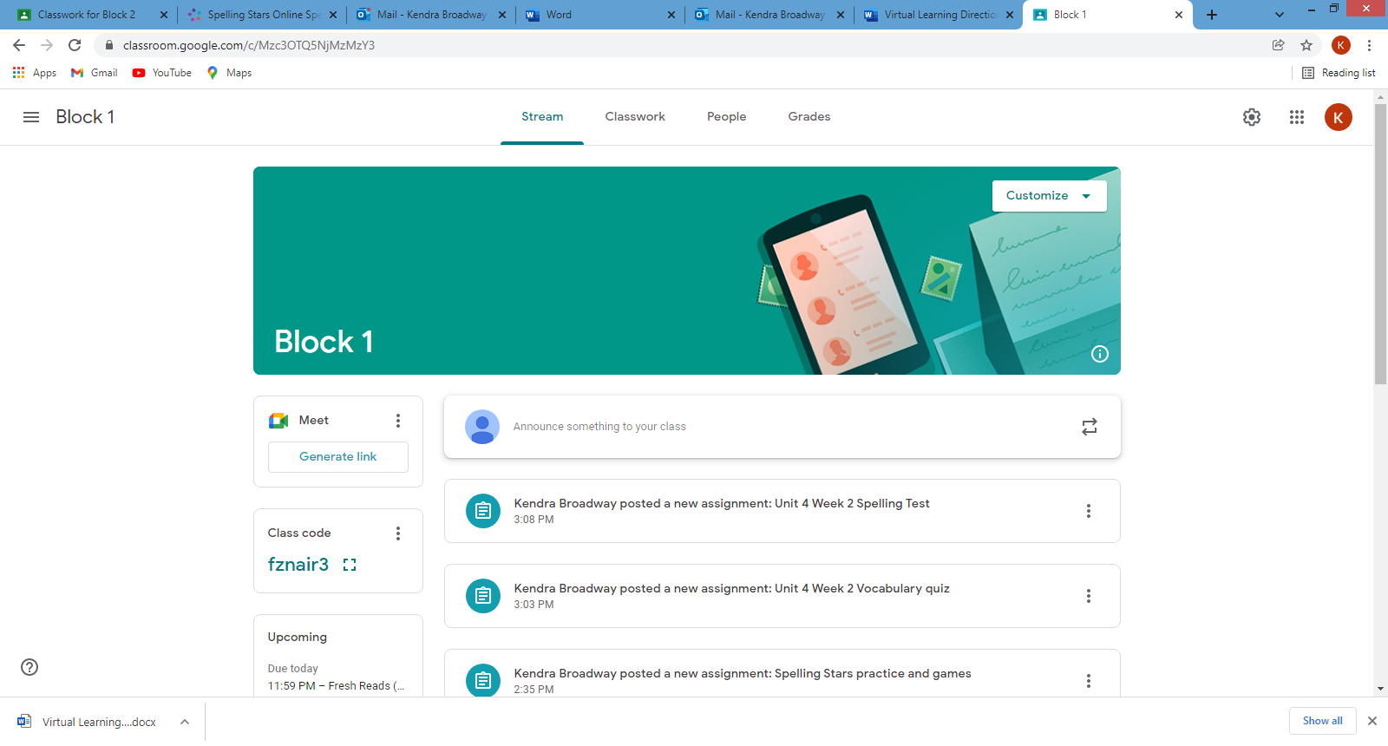

- This will take you to your child’s assignments for this week! Here, they will complete everything underneath the designated day.
- To complete each assignment you will click on each section underneath the day of the week and click the assignment in the box that pops up.
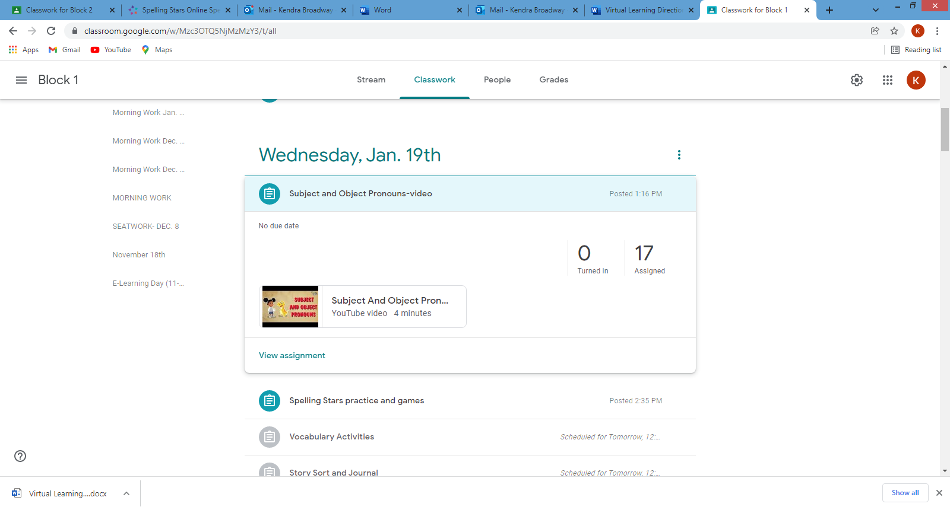

Please make sure your child completes these assignments as they will prepare them for the tests they will take on Friday.

You child will have 3 tests to take on Friday:
~Spelling test
~Unit 4 Week 2 vocabulary quiz
~Unit 4 Week 2 reading test

