Daniel Pratt Elementary School Transportation
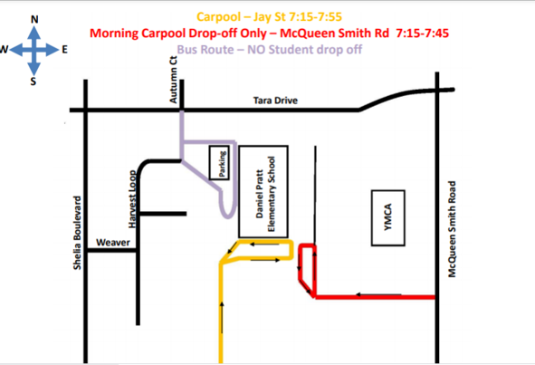
420 Harvest Loop Drive – Prattville, AL 36066

Morning Drop Off
No parking is allowed in the front parking lot until 8:00 a.m. Never drop your child off in the front parking lot or in front of the school building unless you are a walker. Walkers cannot not drive their children onto the school grounds.
Option 1 – Jay Street – The carpool drop off begins at 7:15 when supervision is present. The line starts at the Red Sign and ends at the Pink Sign. Please do not drop your children off when supervision is not present and make sure you are in between the Red and Pink signs. The Jay Street carpool drop off ends promptly at 7:55. If you arrive after 7:55 and the door is closed, walk your child to the front office to sign in.
Option 2 – McQueen Smith Rd – The Carpool loop drop off begins at 7:15 when supervision is present. The line starts at the fence of the basketball court and goes through the curve where sidewalk stops. Please drop off your child only between the start and ending points. The McQueen Smith drop off ends promptly at 7:45 a.m. There will be no supervision after 7:45 so it is imperative you do not drop your child off after 7:45.
Afternoon Pick Up
Carpool

Car Riders will be dismissed in the carpool line outside the gym beginning at 3:00. Carpool ends at 3:15pm. If carpool is over, you will need to come to the front office to sign your child out. No parents are to walk up to the carpool area. For the first two weeks of school, parents must have a piece of paper with your child’s name, teacher, and grade level visible in the windshield. A formal DPES label will be provided to all students within the first two weeks of school. Parents without the proper label will be pulled out of line to verify identification.

Walkers
Walkers will be dismissed from the front of the building at 2:55. All walkers will be led to the crossing guard at the corner of Tara and Harvest Loop or can follow the sidewalk down Harvest Loop. No student will be allowed to walk through the neighborhood gate alone. Students must be escorted by a parent.

For the safety of our students, no parent is to park in the front parking lot and walk up to the breezeway to pick up your child for afternoon dismissal. You are welcome to park on Tara Drive or Harvest Loop and walk to the designated area to pick up your child. All students who are walkers are considered dismissed from DPES at 2:55.

