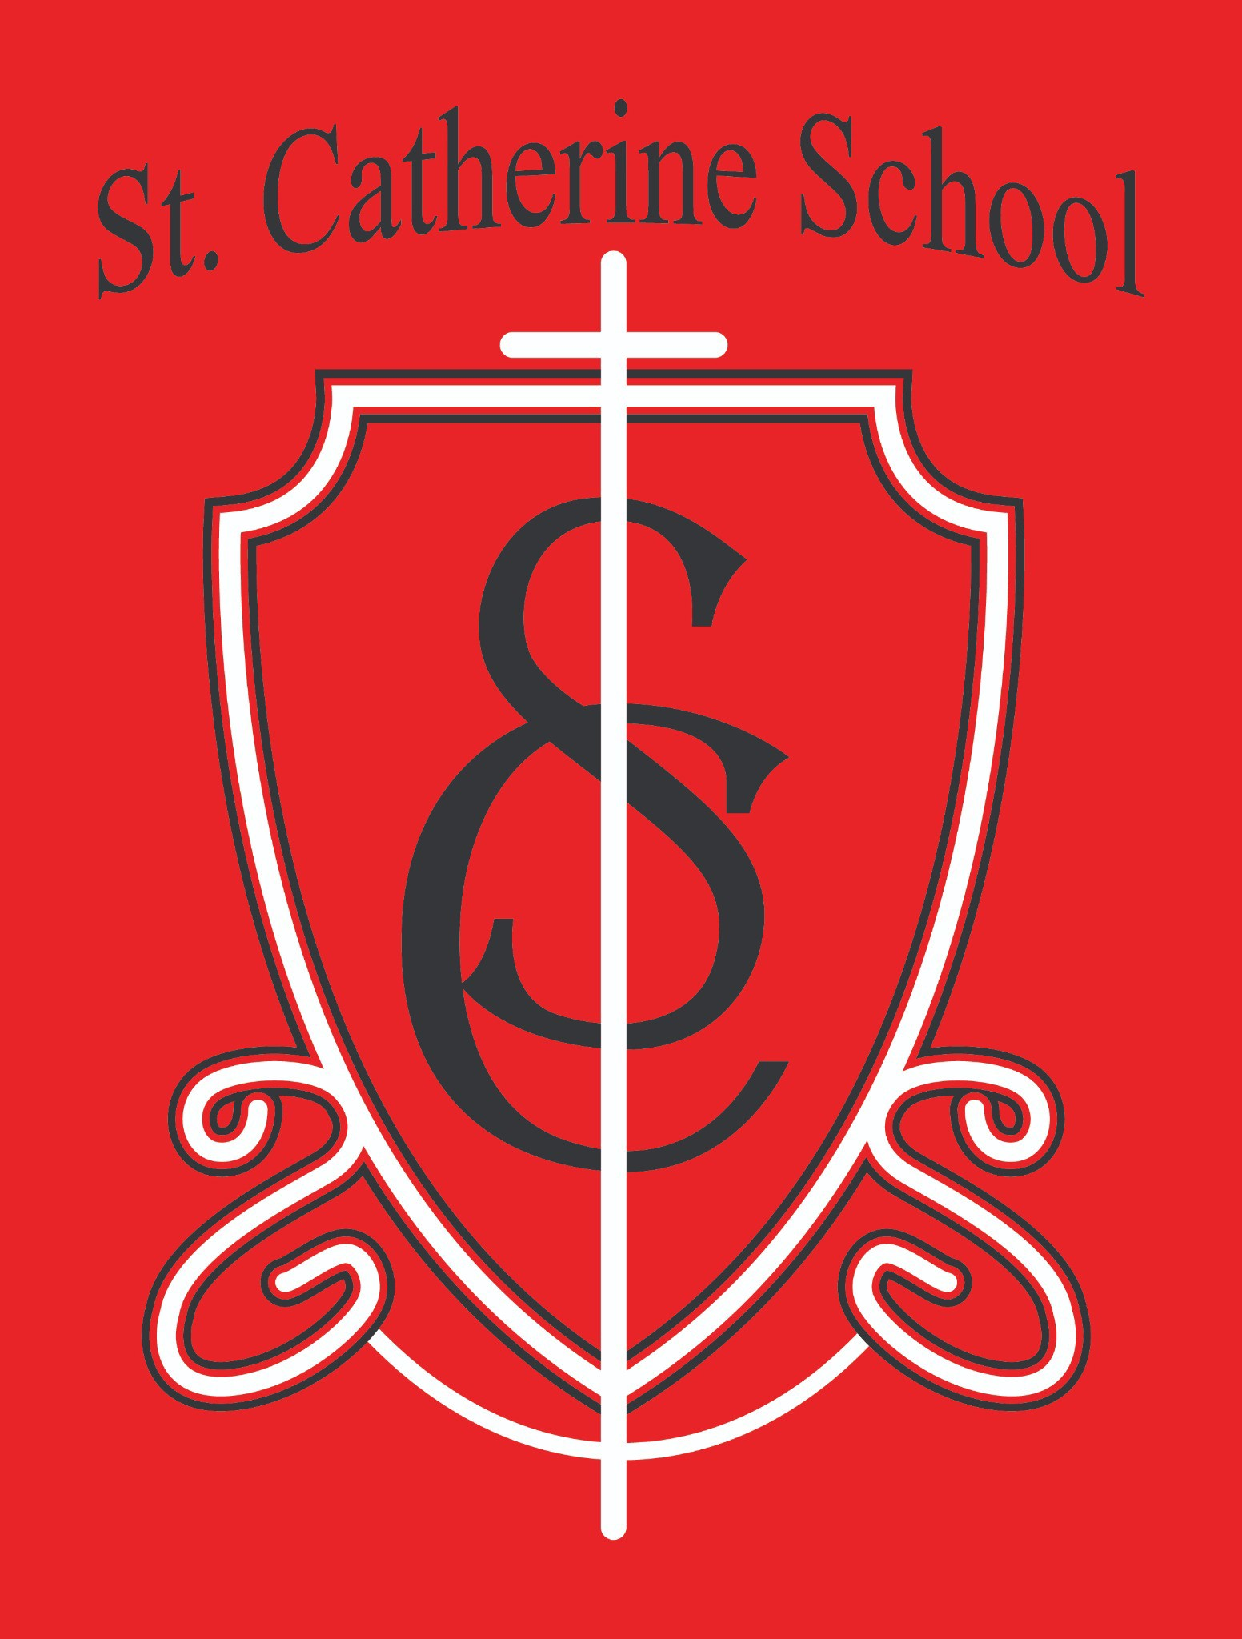

**St. Catherine School Weekly Newsletter** [**https://www.stcatherine.k12.nd.us/parents**](https://nam02.safelinks.protection.outlook.com/?url=https%3A%2F%2Fwww.stcatherine.k12.nd.us%2Fparents&amp;data=05%7C02%7CTerra.Giesen%40k12.nd.us%7Cc2d8253054a940fc706608dd582f5680%7Cdbbf782acef14af186c81f9201061db6%7C0%7C0%7C638763682543809541%7CUnknown%7CTWFpbGZsb3d8eyJFbXB0eU1hcGkiOnRydWUsIlYiOiIwLjAuMDAwMCIsIlAiOiJXaW4zMiIsIkFOIjoiTWFpbCIsIldUIjoyfQ%3D%3D%7C0%7C%7C%7C&amp;sdata=w%2BKvuToBPVoEFK3wiJ6RZzhMsQFHfcm8s%2Ffg0gFBn0U%3D&amp;reserved=0)

# Principal's Message

### Principal’s Reflection

A heartfelt thank you to the families who attended our Kindergarten Round-Up! Taking that first step in exploring a new school is a big decision, and I am grateful for those who took a chance on us. If you know of another family that might benefit from a Catholic education at St. Catherine School, please encourage them to reach out to our office. I am so thankful for the families who choose our school and want to empower as many as possible to make Catholic education a reality for their children.

### Daycare Update

Exciting progress is happening with our daycare project! This weekend, the lockers will be removed to make way for renovations. Bakkegaard and Schell have been working on updating the heating system in the basement, and new flooring will be installed soon.

We are also looking for volunteers to help with painting the downstairs hallway ahead of the four-day weekend in March. If you are willing to lend a hand, please let me know! Freshening up this space will make a big difference.

### Virtue of the Week: Temperance (March 3-14)

Our next virtue focus is **Temperance: Moderation**—balancing habits and avoiding excess. We will explore this through gratitude activities, discussions on balance in daily life, and limiting excess screen time. Our virtue saint is **Blessed Carlo Acutis**, who lived by the words:

*"For everything there is a season, and a time for every purpose under heaven."* (Ecclesiastes 3:1–7)

# Reminders

### ALL Snow Gear (Boots Included) is Coming Home This Weekend

We’re in what I call "Fake Spring." Things are muddy, and while some areas may be dry, I guarantee a child will find the last dirty snow pile or the biggest mud puddle. Please continue to send snow gear to school until I give the all-clear—this helps keep both their clothes and our school clean!

### March is Reading Month

A Reading Month calendar has been sent home. If you have any questions, please contact Mrs. Gulka.

### Lent Begins Next Week

Please take time to talk with your child about Lent—what it means to your family and why this season is important.

**Fat Tuesday (Feb. 13)** – Students may bring a snack; check with their classroom teacher if needed.

**Ash Wednesday (Feb. 14)** – School Mass will be at **12:10 PM**. Parents are welcome to attend, but there will be no guest lunch that day.

### Behavior Reminders

Every year around this time, I start to see an increase in office referrals. The warmer weather brings extra energy, and sometimes, not-so-great choices. Please remind your child to treat others with kindness and to make choices that reflect Jesus' love. We’ve had some recess, classroom, and lunchroom issues, and a conversation at home can go a long way in reinforcing positive behavior.

**St. Catherine Spotlight**

### Kids Heart Challenge



Congratulations to **Florence Silewski** for raising the most money in our school! A huge **thank you** to everyone who contributed—our school exceeded its fundraising goal! As a result, I got pied not once, but three times. All for a great cause (and no, that cause was not me eating whipped cream off my face).

### Thank You, Paul Donahue

For over 15 years, **Paul Donahue** has generously taken care of our pop can recycling, a small but impactful ministry that helps support our school. He often shares how much he prays for St. Catherine School. If you see him, please take a moment to thank him! If your family would like to take over this important role, please let me know.

Our Kindergarten Round-Up this week was a beautiful reminder of what makes St. Catherine School special. Hearing from both a current and a former parent reaffirmed the deep impact this school has on the families who choose it. Thank you for continuing to make our school a place of faith, learning, and community.

Blessings in this coming week!

-Mr. Lee

Stay Connected with St. Catherine School

📍 **Address:** 540 3rd Ave. NE, Valley City, ND 58072

**Email:** [nicholas.lee1@k12.nd.us](mailto:nicholas.lee1@k12.nd.us)

📧

**Phone:** 1-701-845-1453

📞

**Website:** [www.stcatherine.k12.nd.us](https://nam02.safelinks.protection.outlook.com/?url=https%3A%2F%2Fwww.stcatherine.k12.nd.us%2F&amp;data=05%7C02%7CTerra.Giesen%40k12.nd.us%7Cc2d8253054a940fc706608dd582f5680%7Cdbbf782acef14af186c81f9201061db6%7C0%7C0%7C638763682543829006%7CUnknown%7CTWFpbGZsb3d8eyJFbXB0eU1hcGkiOnRydWUsIlYiOiIwLjAuMDAwMCIsIlAiOiJXaW4zMiIsIkFOIjoiTWFpbCIsIldUIjoyfQ%3D%3D%7C0%7C%7C%7C&amp;sdata=Q2hKE1cazE3y1YAo7hqAe%2FxFIRoVemYH7b17GRrfXk4%3D&amp;reserved=0)

## 🌐

📘 **Follow Us on Facebook:** [St. Catherine School on Facebook](https://nam02.safelinks.protection.outlook.com/?url=https%3A%2F%2Fwww.facebook.com%2Fst.catherineschoolvc%2F&amp;data=05%7C02%7CTerra.Giesen%40k12.nd.us%7Cc2d8253054a940fc706608dd582f5680%7Cdbbf782acef14af186c81f9201061db6%7C0%7C0%7C638763682543843359%7CUnknown%7CTWFpbGZsb3d8eyJFbXB0eU1hcGkiOnRydWUsIlYiOiIwLjAuMDAwMCIsIlAiOiJXaW4zMiIsIkFOIjoiTWFpbCIsIldUIjoyfQ%3D%3D%7C0%7C%7C%7C&amp;sdata=Cu1Clbm00l1qQx5u7idd9eHeCM8%2FdCvbl3DQfGg7qVE%3D&amp;reserved=0)

*“Inspiring excellence through faith, learning, and service.”*