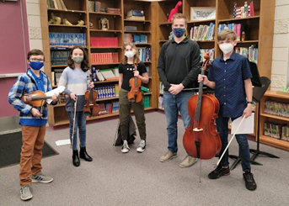
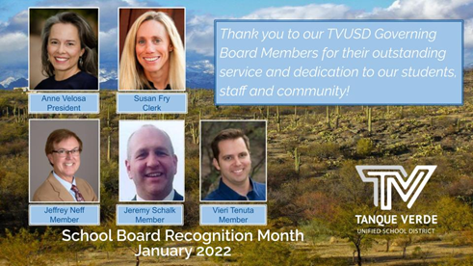
Nattiionall Schooll Board Recogniittiion Montth

TVUSD woulld lliike tto recogniize tthe iinvalluablle conttriibuttiions off our Governiing Board members tto our schoolls and communiitty tthrough ttheiir vollunttary serviice..They have gone ffar above and beyond normall schooll board serviice duriing tthe pandemiic..Theiir commiittmentt and dediicattiion has been unttiiriing,, and came att greatt personall challllenge and costt tto tthem iindiiviidualllly.. We are siincerelly tthankffull ffor ttheiir serviice tto our schooll diisttriictt,, and gratteffull tto tthem ffor ttheiir lleadershiip..

Governiing Board Meetiing Summary January 12, 2022

Sttudentt Presenttattiion - TVES Orchesttra Program

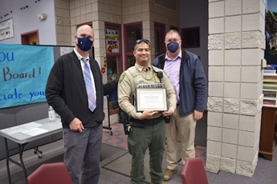

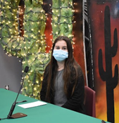
The January 12, 2022 Governing Board meeting was off to a great start with a Student Presentation by TVES Orchestra students, Noah M., Bennett J., Aubrey D. and Freya H. under the direction of Mr. Seth Murzyn. The musicians entertained the members of the board and public with a lovely, short concert. The meeting included two information and discussion items in addition to the business items, including the TVHS Recycling Program, presented by TVHS student Brett Lewis, and a Student Learning Update, presented by the Student Services Director, Ms. Tiffany Hodge.

Schooll Resource Offffiicer Recogniittiion

A special recognition of our outstanding Pima County Sheriff’s Department School Resource Officers was presented by Mr. Greg Miller with Dr. Scott Hagerman. Deputy Christopher Aquino and Deputy Lynsey Cole were recognized for their outstanding service to our TVUSD school community. Mr. Miller commented that although the SROs are there to support school safety, their work begins with
building relationships with students, staff and community members. Deputy Cole was unfortunately unable to attend.

Sttudentt Board Member Reportt

Board Members welcomed TVHS Senior Student, Lainie Radomsky, who will represent the TVUSD student body as the Student Board Member for the Spring Semester SY 2021-22. Ms. Radomsky’s report covered activities and events at Agua Caliente Elementary School and Tanque Verde High School.

Student Board Report - January, 2022

Superiinttendentt’’s Reportt
TVUSD Superintendent, Dr. Scott Hagerman, presented information about the Governor’s State of the State address, the current Pima County COVID-19 School Districts Data, issues related to COVID-19 mitigation, and a construction update.
Superintendent Report - January 12, 2022

Also included in the information provided to the board were the following items: Pima County Health Department -Weekly COVID Summary- January 2, 2022 (download)
State of Arizona Attorney General Opinion,Isolation/Quarantine of Students-December 17, 2021
Pima County Board of Supervisors (BOS)Resolution, Face Coverings -December 21, 2021
COVID-19 in Pima County SchoolsReport - December 22, 2021 (download) Pima County Health Department,School COVID Sanitary Measure - January 10, 2022
Education Bills, Arizona 55th Legislature - 2nd Regular Session,January 6, 2022

Governor’s State of the State

The Governor’s address related to education in Arizona, focused on school choice, and requiring curriculum to be available for review online.

COVID-19 Update

The Arizona Department of Health Services provides updates every Thursday at 9:00 a.m. The CDC updates nightly by county. As of the Tuesday, January 11th update, we had a 141% increase in Covid cases in Pima County. The TVUSD Dashboard is updated regularly. In comparison to other Pima County school districts, we are doing comparatively well.

Please see the board material links (above) for more detailed information.

TVUSD is implementing the “Test. Mask. Stay. Program” with a goal to not have to quarantine as many students. There have been issues with the implementation due to lack of testing supplies. However, this afternoon (1/12/22) we were able to get more rapid tests which we had run out of as of yesterday.

Construction Update

We’ve begun to see buildings going up after the completion of a long period of infrastructure work. We continue to have weekly supply chain issues, but things are progressing well throughout the district.

ACES - New Kindergarten Building pad is being poured.

EGJH - New Fine and Performing Arts Building roof is starting to go on. TVHS - Pad for the new Student Commons building is being poured. Renovation work at the former library building for the new Administration building is being completed.
TVES - New kindergarten Building steel framing is going up now.

IInfformattiion IIttems

TVHS Recyclliing Program

Brett Lewis, a Junior at Tanque Verde High School, presented information about the
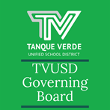
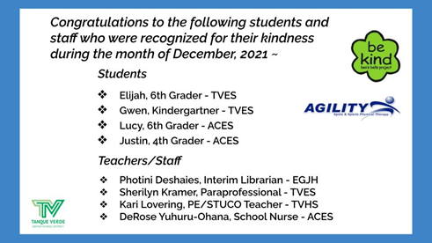
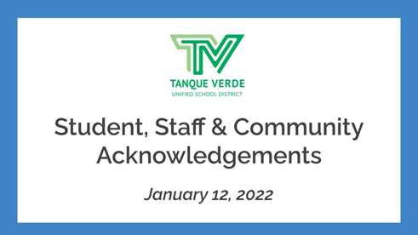
TVHS Community Beautification Committee’s Recycling Education Program which has been a resounding success at the High School. He would like to bring it to the three other schools in the district, and also incorporate some national recycling efforts.Sttudentt Learniing UpdatteThe January 12, 2022 Student Learning Update was presented by Student Services Director, Ms. Tiffany Hodge with Dr. Scott Hagerman. The full presentation may be viewed here: Student Learning Update - January 12, 2022Distance learning numbers- The number of students in distance learning continues to shift across grade levels. Ms. Hodge reported that we currently have a total of 33 students in remote learning district-wide, with changes occurring almost daily. The recent CDC recommended reduction to the 5 day quarantine period has helped affected students not to miss as much instructional time.Role of flex teachers- We have implemented a system where the flex teachers are working in tandem with classroom teachers, with parents supporting the process by taking an active role with their students.Academic support - Additional academic support is provided for students while in quarantine. Academic support is different at the elementary and secondary school levels. Please review the presentation for more detailed information (Please see link above).
Important Dates & InformatiionMon., January 17th - Martin Luther King Jr. Civil Rights Day NO CLASSES Wed., January 19th - TVES Kindergarten Roundup, 2:00-3:00 PM (VIRTUAL) Wed., January 26th - ACES Kindergarten Roundup, 2:00-3:00 PM (VIRTUAL) Wed., January 26th - Governing Board Meeting 6:00-7:30 PMWed., February 9th - Interim Grading Day K-8 EARLY RELEASE Wed., February 9th - Governing Board Meeting 6:00-7:30 PM Wed., February 23th - Governing Board Meeting 6:00-7:30 PMWed., February 24th - Thursday, February 25th - Rodeo Break NO CLASSESJanuary Events Calendar(revised 1/13/2022)Next Governiing Board Meetiing Date:The next Regular Meeting of the TVUSD Governing Board will be held on Wednesday, January 26th at 6:00 p.m. at the Tanque Verde Elementary School Library.Board Meeting Agendas and MinutesTVUSD Board Meeting Livestream LinkStudent, Staff & Communiity Acknowlledgments

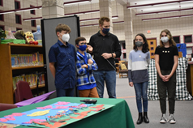
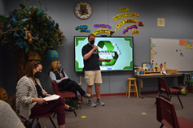
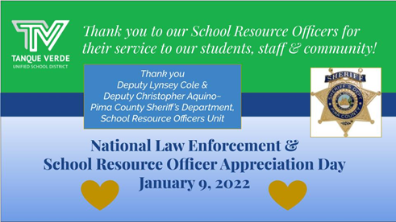
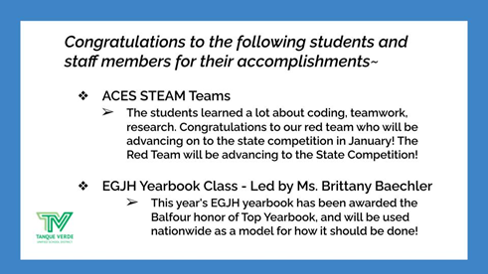
Photo Gallllery

Brett Lewis, TVHS Junior presents information about the TVHS Recycling Education Program

Board Members, Mrs. Anne Velosa and Mrs. Susan Fry, look at thank you cards given to them in celebration of National School Board Recognition month.

Board members were given appreciation gifts from our students and schools.
TVES Orchestra students with Director, Seth Murzyn

Board Member, Mr. Jeffrey Neff looks at a banner celebrating National School Board Recognition month.

Banner celebrating National School Board Recognition month

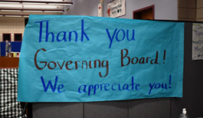
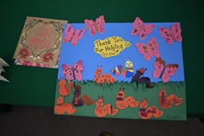
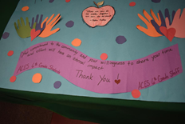
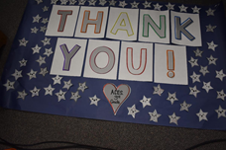
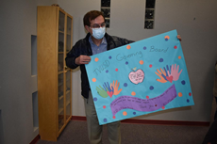
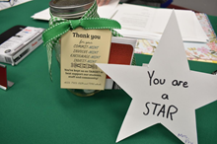
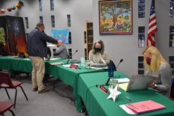
Banners celebrating National School Board Recognition month

Connect wiith us
Visit our website

