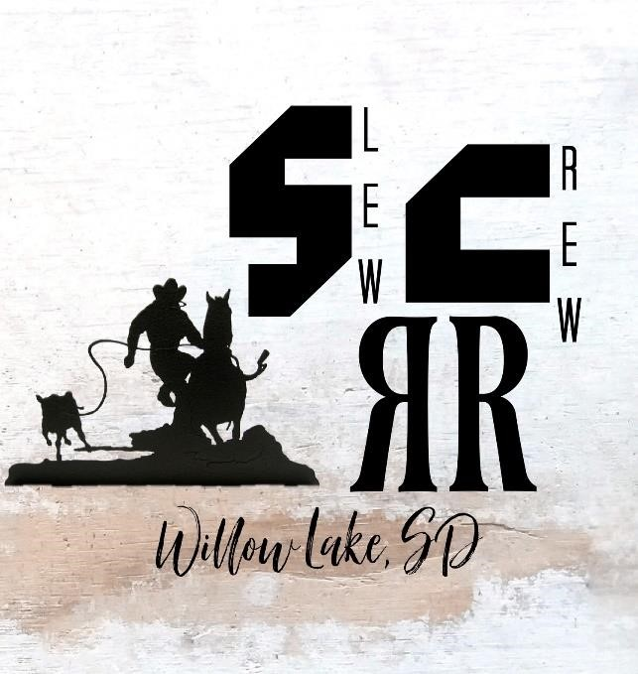

SLEW CREW RANCH
RODEO AGRICULTURAL
SCHOLARSHIP

REQUIREMENTS: HIGH SCHOOL SENIOR OF WILLOW LAKE
ATTENDING A FOUR
-
YEAR COLLEGE OR TECHNICAL SCHOOL.

Applicant

Name

Post
-
Secondary

Education

Program

Requirements
(

:
Mandatory One Page Essay
)

➢

Briefly describe
your education plans and/ or goals.

➢

Describe your agricultural background and/ or previous
agricultural experiences. (Living or working on a farm,
experience in a
g classes, or involvement in the FFA
program
.)

➢

Why agriculture has made a
n

impact in your life and
why you

make a great
candidate

for this scholarship
opportunity.

Scholarship is due by April 10, 2026 (Turn them into Mrs.
Nelson, so they can be transferred to our
committee to choose the
recipient

based off of your
essay.)

The recipient of this scholarship will be awarded $500
to their educational needs

in . The awards

will be presented to the winner of the scholarship

May 4

th

at the Awards Banquet.

CONTACT FOR
Q
UESTI
ONS
AND

INFORMATION

Colin Pommer
Cody Forbes

(605)881
-
5400

Goals Of This Scholar
sh
ip

It is one of our top p
r
iorities to
give back to our
community.
This is truly one of our ways to
give back to the youth of our
community pursuing the
agricultural ways of life that
we hold dearly.

(605)983-5701

