Calhoun R-VIII
2021-2022
Staff Handbook

Adopted July 19, 2021

DISTRICT GOALS
- To continue striving for excellence in all educational programs offered by the district.
- To provide a learning environment that will allow all students the opportunity to reach their maximum potential.
- To continue emphasizing development, articulation, re-evaluation and updating of curriculum in all subject areas and at each grade.
- To continue providing comprehensive programs to insure student competency and intellectual, social, physical, and career development.
- To continue improving staff performance thorough providing competitive salaries, comprehensive fringe benefits, evaluation systems, and professional growth opportunities.
- To raise the expectations of our students and standards for student achievement that will allow them to compete on a global basis.
- To assure minimum mastery of the basic skills by all students at each grade level.
- To encourage students and staff to utilize rapidly expanding technology and make available the opportunity to work with high tech equipment.
- To continue t serve those students with special needs and those students at risk of failure.
- To insure effective administration of the district thorough competent leadership, supervision, and management.
- To foster positive community relations with parents and patrons and to actively seek their participation in all phases of school life.

CALHOUN R-VIII EDUCATIONAL PHILOSOPHY
A philosophy of education is the foundation on which a school district is built and upon which the product of the school program is evaluated. The philosophy herein subscribed to by the Calhoun R-VIII Board of Education shall be a guide in determining the policies, rules, and regulations of the school district.
Recognizing each student as a unique individual, we believe that education should provide an opportunity for the maximum development of each individual within the limitations of his capacities. Through education, it is possible for the individual to discover and endeavor to achieve to the limits of his capacities.
We believe that in a democratic society, education must help the student realize his worth as an individual and should lead him toward becoming a productive member of society. Strong emphasis must be placed upon democratic values which are important for an effective and satisfying personal and social life.
We believe that the role of the teacher in the education process is to provide opportunities for the individual to achieve at the maximum level of his capacity, to create a learning situation in which the individual motivation for student learning is the stimulus for achievement, and to promote through teaching and example the principles of the democratic way of life.
We believe that parents/guardians have definite responsibilities in education. They need to have a basic confidence in the school, and they need to impart this confidence to the students. The parents/guardians may do this by cooperating to the fullest with the schools, by encouraging the student to give his best efforts to his daily school responsibilities, and by participating in school activities.
We believe that the student must have responsibilities in the educational program of his community. Most important of these is attitude. The student is obliged to come with an open mind, equipped with all the necessary materials, ready to fulfil the responsibilities in the learning process. The basic attitude should be that school is an institution of opportunity, staffed with trained personnel to help the student become a contributing member of society.
We believe that the foundation of the district’s educational program is based on the development of the competencies in the basic fundamentals of reading, oral, and written communication and mathematics.
It is therefor, the responsibility of the Calhoun R-VIII District to provide an educational environment for children of the district which will foster and accelerate their intellectual, physical, social, and career development.

GENERAL GUIDELINES
- (K-12) Each teacher shall report for duty in their classroom by 7:30 a.m. each morning. Classes begin at 7:45. Teachers will remain on duty until 3:45 p.m. each day. If you have morning duty, that will begin at 7:15 a.m. Hourly employees work hours will be determined on an individual basis. For the 4 day week, pay is based on 9 hour work days, so 7 a.m. to 4 p.m. or 7:15 a.m. to 4:15 a.m. or 7:30 a.m. to 4:30 p.m. These will be typical shift hours depending on needs of district.
- (ECC) Teachers need to be in their classroom ready to begin the day (i.e. have your drinks, go to the bathroom, etc.) before children begin to arrive for the day. Have your learning centers open and ready for the children to begin exploring when they walk in the door; parents are depending on the center being open on time so that they can get to their jobs for their scheduled time. If your schedule receives a 30 minute break, please exit the room and clock out as soon as your replacement arrives. It is important that we stay on schedule so that we can assure that staff is available to be in place on time for the afternoon. All staff must stay until their children have been picked up, room swept and vacuumed, trash/diaper genie taken out, tables/counters wiped off, and toys disinfected.
- (ECC) All staff must clock in and out using the tablets outside Heather’s office. If you receive a break, you must also clock in and out for that time. If you forget to clock in or out please contact Heather immediately.
- Unless special permission is given by the Administration, no teacher may leave prior to the end of the normal duty day.
- ALL STAFF are the employees of the Calhoun R-VIII School District and have a definite responsibility for the maintenance of good discipline, not only in their classroom, but through the building and on school grounds wherever they may be.
- The Board of Education will review certified staff during the month of March and non-certified during the month of April. Employment will be offered in accordance with Section 168.126 of the Public School Laws of Missouri.
- Salaries will be paid on a twelve-month basis with checks being issued once a month on the 20th of each month. In the event that the 20th is on a Saturday, Sunday, or holiday, pay checks will be issued on the last preceding workday. “Special Needs” forms may be picked up in the Superintendent’s office. The summer checks will be issued monthly once teachers have checked out through the administration.
- Staff are directly responsible to the Administration. They should take their complaints directly to the administration for adjustment, if the complaints are warranted and not by pass building administration to go to Superintendent or Board first.
- Staff should make requests for special janitorial services to the Superintendent.
- Staff may be assigned or reassigned positions and other responsible duties by the Administration for the general welfare of the school system.
- No parties or activities may be conducted on school premises without authorization from the office.
- The classroom and students, being the teacher’s prime responsibility, and warranting their full attention, shall be supervised at all times. This is for the benefit of the teachers, since lawsuits have been filed against teachers for negligence of duty.
- Any violation of board policies will be classified as insubordination of the board policies and will be grounds for termination of contract by due process of law.
- Cell phone usage: Staff should refrain from using cell phones during work hours and should use on break periods, between classes, or before/after school. They can be used for some school projects with administrative approval and common sense.
- The administrator or designee will handle all student discipline problems.
- All room repairs or custodial duties should be referred to the custodial staff or submitted through online work order. No repairs or custodial duties will be done if not requested through the proper channels.
- All purchases will require a purchase order. These can be picked up in the office. No one is to purchase items using the school’s tax number or name without a purchase order. No charges to the Calhoun Schools without prior approval.
- All calendar events will be scheduled through the office. All events must be approved in advance of being put on the calendar. All school events are of equal importance and will be scheduled on a first come basis. All cancellations will be scheduled on open dates only. Other events using school facilities will be scheduled around the school schedule. Once an event has been scheduled, there is not to be another event scheduled in conflict.
- Can’t fit everything into one handbook, so please understand not everything that is enforceable is written in the handbook, all staff members are accountable for district board policies, regulations and state laws.

OUTSIDE USE OF SCHOOL BUILDING
- Public school buildings are primarily erected for the use of the public schools and shall not be used for any purpose that will conflict with such use. However, in order that the school plant may properly serve the community, the Board of Education will grant the use under the following conditions:
- The group must be organized with sufficient financial standing to provide proper supervision and to assume full responsibility for any damage done to the school property.
- Groups using school property shall be responsible for any preparation necessary, such as setting up chairs and tables, and shall also see that facilities used are left in as clean and orderly manner as found.
- a. GYM- $15.00 per hour group rate minimum two (2) hours. This must be pre-paid with a contract and roster of group members provided at the time of payment.
b. CAFETERIA /MULTI-PURPOSE ROOM- $10.00 per hour.
4. No alcohol or tobacco products on the premises are allowed on school grounds.
5. Special arrangements may be made for patrons with specific medical needs.
B. School groups and organizations have priority on the use of buildings provided the give at least one week advanced notice.
C. Facilities will not be rented to individuals or groups for profit making activities. (This does not apply to club, civic groups, etc. when funds are used for community improvement).
E. Groups wishing to use the school facilities should contact the Superintendent. Rental contracts must be signed in advance of using the facilities. Unusual requests will be referred to the Board of Education for a final decision.
F. School property and equipment may not be loaned for non-school purposes except by approval of the Superintendent of Schools.
G. The Board of Education reserves the right to deny the use of school facilities to any person or group that does not abide by the Board’s rules.
CLASSROOM MANAGEMENT PLAN
(K-12) This policy is designed to standardize the management of the classrooms in both the Elementary and Secondary buildings. However, each classroom will have unique requirements that will have to be addressed by the teacher. Each teacher should exercise in-class behavior management before sending a student to the office, UNLESS it involves student safety. If a student is sent to the office, the teacher is required to contact their parent or guardian.
Classroom rules are in addition to the school rules printed in the student handbook. Classroom management plans are to augment or duplicate them. A copy is to be on file in the principal’s office and a copy kept with lesson plans for a substitute to use.
(ECC) Praise and positive reinforcement of good behavior must be consistently used with all children as a method to build the child’s self-esteem and encourage self-control. Conflict resolution will be used with all children when necessary. Experienced teachers can recognize the possibility of potential behavior problems before they occur, and can therefore redirect the child’s behavior before it becomes a problem. There are times, however, when a child’s inappropriate behavior continues after these techniques have been utilized. When this occurs, the child should be moved to an area where he/she can regain control of themselves. The teacher or the assistant may need to assist them with calming strategies. Sometimes, things such as play dough or books can help. When the child has regained control, use encouraging words to reinforce positive choices, and that time, the child may return to the group. If the child is unable to regain self-control after a length of time, or if the behavior is becoming increasingly violent or disruptive, you may need to remove the child from the classroom and contact the director. Any time that this occurs, the incident needs to be documented, signed by the parent and the center director, and placed in the child’s file. Regardless of the behavior(s), the goal of all center staff is to assist each child in the development of self-control and positive interaction with both other students and adults. In serious cases, a meeting may need to be scheduled with the parent, the classroom teacher, and the center director, and a behavior plan may be put in place. Bringing a child to either Becca or Heather for behavior issues should be the last resort as opposed to out of frustration.
REPORTING LEAVE
(K-12) Teachers are expected to notify the appropriate building secretary in advance when they will not be at work. When one becomes unexpectedly ill, Elem/HS teachers must call Kayla at (660) 351-2051 by 6:00 a.m. or at school after 7:00. When the teacher knows in advance they will be absent, prior notification is expected. A teacher will submit a substitute request form to the office in advance of the absence except in cases of unanticipated illness and an absence form will be turned in upon returning. Utilizing Monday’s for appointments and personal things is encouraged. Personal/Advance leave will be granted on a first come/first serve basis and will be approved based on availability of subs. There are days that a staff member will not be approved to be absent from school, without extenuating circumstances. These days are the first two weeks of school, the last two weeks of school. Leave before or after scheduled calendar breaks will be handled on an individual basis and may or may not be approved depending on the circumstance. Staff may not schedule any days off when there is a scheduled program evaluation/observation.
(ECC) If you are ill, you need to let Heather Hollinger know between 5:30 – 6:00am. If you are sick for more than one day, you MUST call in EACH DAY unless you have a doctors’ note stating that you will be gone multiple days. The note must have a return date. If you do not call in, it will be assumed that you will be there for your shift! If you text or leave a voicemail, you must make sure that you receive an answer. If you do not receive a reply, it is best to assume that the text/voicemail was not received. In case of no response make sure you call and make voice contact. Facebook is NOT an acceptable means of communication when calling in sick to work and will not be acknowledged as a call in! Heather can be reached at (660) 525-1427(cell). If you need to schedule a day off, you will need to do so with as much advanced notice as possible; scheduled days off are subject to the ability to get a substitute and are not guaranteed. There are days that a staff member will not be approved to be absent from school, without extenuating circumstances. These days are the first two weeks of school, the last two weeks of school. Leave before or after scheduled calendar breaks will be handled on an individual basis and may or may not be approved depending on the circumstance. Staff may not schedule any days off when there is a scheduled program evaluation/observation.
PREPARATION FOR SUBSTITUTE TEACHER
- Master class schedule
- Classroom rules and management plan
- All seating charts (if applicable)
- The location of the teacher’s materials
- Classroom procedures and rules
- Enough of a daily plan to allow a continuation of as normal activity as possible
- Supplementary work
GRADING SCALES
GRADING SCALE – K-2nd Grade and Elementary Specials
- Outstanding (O)
- Satisfactory (S)
- Improvement Needed (N)
- Unsatisfactory (U)
- Skill not introduced at this time (X)

3rd- 12th GRADE
Grade | Percentage | Grade Points  (Non-Weighted) | Grade Points  (Weighted)
A | 100-95 | 4.00 | 4.50
A- | 94-90 | 3.66 | 4.16
B+ | 89-88 | 3.33 | 3.83
B | 87-82 | 3.00 | 3.50
B- | 81-80 | 2.66 | 3.16
C+ | 79-78 | 2.33 | 2.83
C | 77-72 | 2.00 | 2.50
C- | 71-70 | 1.66 | 2.16
D+ | 69-68 | 1.33 | 1.83
D | 67-62 | 1.00 | 1.50
D- | 61-60 | 0.66 | 1.16
F | 59-50 | 0.00 | 0.00

A grade report of the grade or mark earned in each subject and/or area in which the student is enrolled will be issued to the students quarterly.
The parent or guardian of any student having a grade “D” or below by the end of the fifth week of any grading period shall receive written notification. Kindergarten through 5th grade will be expected to make notification to parents about any student who needs improvement in any area.
Teachers of Jr. and Sr. High will provide each student with a breakdown as to what factors will be included in grading, i.e. value of tests, homework, class participation, etc. A copy will be furnished to the office for informational purposes. Reasonable homework requirements for students will be established by the teaching staff.

EMERGENCY INFORMATION
* (K-12) See Also Calhoun R-VIII Emergency Procedures Manual, (ECC) See Also Emergency Plan in Room
All emergency information will be reported via intercom system.
- FIRE
- Exit building via posted evacuation routes. All students & staff in each building will meet at the playground.
- Take emergency bucket.
- Remove roster from emergency bucket.
- Verify all students are present; Use Green card to indicate all students are Present. Use Red card to indicate missing one or more students.
- Remain outside until the all clear is sounded.

- TORNADO
- Move students to designated area.
- Ensure students assume the kneeling position, with head down and hands covering the head.
- Find roster in emergency bucket and verify all students are present; Use Green card to indicate all students are Present. Use Red card to indicate missing one or more students.
- Await all clear signal.

- EARTHQUAKES
- Remain in classroom and place students under their desks
- After earthquake stops, evacuate students, via fire evacuation routes.
- Find roster in emergency bucket and verify all students are present; Use Green card to indicate all students are Present. Use Red card to indicate missing one or more students.
- Check for injuries and account for all students.
- Do not re-enter the building and remain away from power lines.

- LOCK-DOWN/ INTRUDER ALERT
ALERT: Initial Alert may be a gunshot, PA announcement, etc… Avoid code words.
LOCKDOWN: If evacuation is not a safe option, barricade entry points. Prepare to Evacuate or Counter if needed.
INFORM: Communicate real time information on shooter location. Use clear and direct language using any communication means possible.
COUNTER: As a last resort, distract shooters ability to shoot accurately. Move toward exits while making noise, throwing objects, or adults swarm shooter.
EVACUATE: Run from danger when safe to do so using non-traditional exits if necessary.

EVALUATION
Teachers will be evaluated using DESE Model Evaluation System. This is a comprehensive educator evaluation system with a purpose: to grow teachers and improve schools. DESE brings together classroom observation with multiple measures of effectiveness designed to record feedback, start meaningful conversations, and provide high-quality resources for educator growth and development. More information regarding teacher evaluation can be found on the Missouri Department of Elementary and Secondary Education website.
PROFESSIONAL ORGANIZATIONS
Faculty members are encouraged to join other professional organizations, i.e. MSTA, NEA. Dues for some of these organizations may be withheld voluntarily. (Check with central office). Other professional organizations are available to the teacher’s special discipline.
CALHOUN STAFF ASSOCIATION (CSA)
Calhoun Staff Association (CSA) is an organization for ALL staff at Calhoun School District, i.e., Administration, Teachers, Paraprofessionals, Service Staff, etc. The CSA meets at least quarterly for an official meeting. CSA offers to the employee the opportunity to be part of a united voice, the opportunity to network with other coworkers, the opportunity for fellowship, and to be recognized for employment. Annual dues are $10.00 and are voted on annually. Dues along with fundraising provide scholarships for graduating students, parting gifts for employees, recognitions, etc. and organizational operating expenses. Members of CSA can be members of MSTA, NEA, or other professional organization of their choice, however, CSA is connected to MSTA (Missouri State Teachers Association) for the annual Teacher of the Year and Associate of the Year awards. CSA members must be a member of MSTA to be on the ballot for these awards as the winners are entered into the Central Region MSTA Teacher/Associate of the Year Awards.
FIRST/SECOND YEAR TEACHERS
First/Second year teachers are required to have a mentor-teacher assigned by the Administration. Contact Administration for more information.
STAFF RESIGNATION AND ABSENCES
When a staff member submits to the Board of Education a letter of intent to resign from a position in which said employee agreed to perform services to the Calhoun R-VIII School District, the Calhoun R-VIII Board of Education will consider each request upon an individual basis. The Calhoun R-VIII Board of Education may impose the following stipulations:
- A certified teacher resignation may be granted after a suitable replacement is secured for the position affected.
- In cases where the teacher or administrator indicated that he/she will not honor a contract and the resignation occurs in the time period listed below, the following assessment may be made upon the teacher/administrator before the Calhoun R-VIII Board of Education will agree to accept the resignation:
  - 30 days after signing of contract- 2% of the total salary of the person who resigned
  - 60 days after signing of contract- 3% of the total salary of the person who resigned
  - 90 days after signing of contract- 4% of the total salary of the person who resigned

CALHOUN R-VIII SCHOOL DISTRICT PERSONNEL SERVICES
Absences, Leave, and Vacation General Attendance Policy 4310
Regular attendance is essential in providing District students with a high quality of instruction. Eligible certificated staff will have available eleven (11) days leave per year cumulative to fifty days.
When employees are absent more than ten (10) days in any semester or more than fifteen (15) days per school year, their absence is considered excessive. The Superintendent/ designee will review each incident of excessive absence and may require the employee to provide medical documentation or may consider disciplinary actions up to and including termination.
Leave Policy/Regulation 4320
The Board of Education shall adopt regulations for the following types of leave for District employees:
- Sick Leave/ Personal Leave
  - For all full time certified or non-certified personnel, 11 leave days per year. Unused leave days will rollover and become accumulated to a total of 50 days. Leave will be rolled over into the next year.
  - Any staff member, once accumulating fifty (50) leave days, will be paid for all unused leave days accumulated over fifty (50) at the end of the year. The rate will be $60.00 per day. Upon termination or resignation an employee will be reimbursed at a rate of $60.00 per day for each day accumulated over 50. Upon termination or resignation an employee will not be reimbursed for any leave that is under the accumulation of 50 total days. Upon retirement from the Calhoun R-VIII School District, an employee will be reimbursed at a rate of $60.00 per day for each leave day which is accumulated.
  - There are days that a staff member will not be approved to be absent from school, without extenuating circumstances. These days are the first two weeks of school, the last two weeks of school. Leave before or after scheduled calendar breaks will be handled on an individual basis and may or may not be approved depending on the circumstance.
- Bereavement Leave
  - The Board of Education shall provide three (3) days leave for staff members who have had a death of a family member. Family members shall include: spouse, parents, in-laws, grandparents, siblings, children and grandchildren. In addition, the Board will provide (1) day for these family members (of the first degree only) aunts, uncles, cousins, nephews, and nieces.
  - These days will not be subtracted from leave accumulated, nor will pay be deducted. Other days needed for this reason will be deducted from accumulated leave.
- Long Term Leaves and Absences
  - The Board of Education recognizes that the personal welfare and the professional growth of its employees may require occasional extended absences from duty. Therefore, the Board may grant the following long-term leaves of absence under specified conditions.
Extended Leaves of Absence
The Board may grant leave, maternity leave, sick leave, and military leave in accordance with RSMO 168:122. This includes putting a teacher on a part time teaching schedule. It will be for no longer than a period of one (1) year, subject to renewal from year to year. Temporary part time employment and military service shall not be counted as continuous full time service in computing tenure but shall not impair the tenure previously acquired by a teacher under Section 168.102 and 168.130. Any of the aforementioned will be granted under the following conditions:
- A change in status, leave of absence, full to part time service shall be based upon a written request of the employee and the recommendation of the Superintendent.
- The Board of Education shall be able to make satisfactory arrangements for the performance of the ordinary duties of the applicant during the period of which the leave of absence is requested.
- The leave of absence shall be without pay by the school district unless the employee is using sick and/or personal leave days which may be paid.
- The Board of Education or the Superintendent may request a physician’s certification attesting to the extended illness or disability. The certification must state the reason for the extended leave. A release from the physician will be required to return to work. The Board of
Education or the Superintendent may request a second physician’s opinion.
Support Staff Short-Term Leave and Absences
The following leaves with pay will be accorded full-time support staff employees:
- Sick leave (see above policy)
- Bereavement leave (see above policy)

- Family and Medical Care Leave (See Policy and Regulation 4321)
Specific provisions of the various types of District leave are described in Regulation 4320.
The Board of Education recognizes that leaves of absence are occasionally necessary due to family or medical reasons. The District has adopted detailed procedures to ensure compliance with the Family and Medical Leave Act of 1993 (FMLA). As provided by District regulations, eligible employees are entitled to use up to twelve (12) workweeks of unpaid leave for family and medical reasons. The Board of Education has designated the Superintendent to act as FMLA Compliance Officer. As part of its compliance program, the District will notify each employee of the name, address, and telephone number of the District’s FMLA Compliance Officer and will provide a statement of commitment to adhere to FMLA regulations. The FMLA Compliance Officer will regularly evaluate the District’s FMLA compliance to ensure fair and equitable opportunities for all eligible employees.
FERPA ANNUAL NOTIFICATION
Each year the Calhoun R-VIII School District is required to give notice of the various rights accorded to parents or students pursuant to the Family Educational Rights and Privacy Act (FERPA). Parents and students have a right to be notified and informed. In accordance with FERPA, you are notified of the following:
RIGHT TO INSPECT: You have the right to review and inspect substantially all of your education records maintained by or at this institution.
RIGHT TO PREVENT DISCLOSURES: You have the right to prevent disclosure of education records to third parties with certain limited exceptions. It is the intent of this institution to limit the disclosure of information contained in your education records to those instances when prior written consent has been given to the disclosure, as an item of directory information of which you have not refused to permit disclosure, or under the provisions of FERPA which allow disclosure without prior written consent.
One exception which permits disclosure without consent is disclosure to school officials with legitimate education interests. A school official is a person employed by the school district as an administrator, supervisor, instructor, or support staff member (including health or medical staff and law enforcement unit personnel); a person serving on the school board; a person or company with whom the school district has contracted to perform a special task (such as an attorney, auditor, consultant, or therapist); or a parent, student or volunteer serving on an official committee, such as a disciplinary or grievance committee. A school official has a legitimate educational interest if the official needs to review an education record in order to fulfill his or her professional responsibility.
RIGHT TO REQUEST AMENDMENT: You have the right to seek to have corrected any parts of an education record which you believe to be inaccurate, misleading or otherwise in violation of your rights. This right includes the right to a hearing to present evidence that the record should be changed if this institution decides not to alter the education records according to your request.
RIGHT TO COMPLAIN TO FERPA OFFICE: You have the right to file a complaint with the Family Policy Compliance Office, U.S. Department of Education, Washington, D.C., 20202- 4605, concerning the Calhoun R-VIII School District's failure to comply with FERPA.
RIGHT TO OBTAIN POLICY: You have the right to obtain a copy of the written policy adopted by the Board of Education of the Calhoun R-VIII School District in compliance with FERPA. A copy may be obtained in person or by mail from: (Superintendent).

CONFIDENTIALITY
There are many things that occur within the center that we are not allowed to share outside of the center. Being a school based program, we fall under the Family Educational Rights and Privacy Act (FERPA) (20 U.S.C. 1232g; 34 CFR Part 99), a law that protects the privacy of student education records. The law applies to all school districts and programs within the school districts that receive funds under the U.S. Department of Education. All children’s records are to be kept strictly confidential. Any child should never be discussed between any staff that does not have direct contact with the child, any other parents or grandparents, or anyone outside of the district. Names, telephone numbers, and addresses should never be shared with anyone outside of the district for any reason. Working in a small community has many advantages, but at the same time, can become very difficult. Often times, people will ask about a certain child and/or family in the center, primarily out of concern. However, please remember that under no circumstances should any child/family be discussed with anyone who is not a parent or legal guardian of the child. No exceptions! You may answer general questions about your building or district. If you are uncertain of how to answer a question, please defer the question to the administration.

TECHNOLOGY/SOCIAL MEDIA
We live in a day of technology and social media. While those can be a great asset and wonderful resource tools to enhance your classroom lessons and curriculum planning, but please be aware of how you incorporate technology usage into your classrooms. Be aware of who views your social media pages. While you will get requests from parents to be on your page, we advise using discretion. You are NEVER allowed to post pictures of the children in your classroom on your personal social media page or send pictures to classroom parents if they contain any child other than their own! If you have pictures of an activity that you are doing in your classroom, and you would like them posted on Social media, please send to your administrator for posting on official district social media. When creating posts or sending pictures home PLEASE make sure and include parents/children equally; favoritism CANNOT be shown. Office and administration will be responsible for posting pictures of special events within the district on Facebook pages. Jessica Iuchs can post them on the Calhoun R-VIII School District website. You will be required to fill out a Technology Usage Form Annually in order to be able to get district e-mails and log in to the district server.

Calhoun R-VIII Early Childhood Center Only
Dress Code
Teachers and Office Staff are expected to dress in a professional manner. This includes jeans (with little to no distressing/no holes where skin or patches can be seen through them), leggings or jeggings so long as your top is tunic length, skirts/dresses must be no more than 4 inches above the knee, sleeveless shirts/tank top straps must be at least 3 inches wide, sandals are acceptable as long as they are not rubber/shower shoe type, no workout apparel, no graphic tees/sweatshirt/hoodies unless they are Calhoun Schools, no shorts. If you question whether or not it would be deemed appropriate err on the side of caution.
Kitchen and Custodial Staff are allowed to wear tees that are school appropriate both in language, suggestion, and graphic, leggings/jeggings as long as your top is tunic length, jeans (with little to no distressing/no holes where skin or patches can be seen through them), and make sure footwear is appropriate for the job you are doing.
Remember you are working with children and spend a lot of the day bending over to talk to children at their level, therefore be mindful of how low cut your tops are. We also reserve the right to inform you at any time if we feel that any part of your attire is inappropriate. If your clothes are deemed inappropriate in any manner you will be required to clock out and go home and change (that time will be deducted from your pay).

Professional Development
All staff will be required to attend the necessary training to meet licensing and Head Start. Cost of professional development will be covered by the school district.
Curriculum
The center has incorporated Pinnacle curriculum for all classes within the center. Daily schedules should reflect age appropriate learning centers to include: free art, manipulatives, large motor skills, music, science, mathematics, literature, writing, dramatic play, and a quiet area. Teaching of daily lessons should be a team effort between both teachers in the classroom. Both teachers should know the lesson plan for each day, and what the learning centers, art projects, group activities, and special activities that will be taking place will be. If one teacher is going to be gone, the lesson plan should be available and planned out for your co-teacher. Weekly lesson plans must be posted in the classroom and a weekly newsletter must go out to the parents. Open communication must be kept with families at all times and communication log must be filled out for all phones calls and correspondence other than general every day conversation.
Classroom Inventory
Teachers are responsible every year for updating their classroom inventory list; personal items that are purchased with the teacher’s money for the classroom must be listed on a separate inventory list that will be used upon leaving employment with the district. All keys associated with the building must also be turned in at the same time as checkout. Checkout will take place on the staff member’s last day no later than 3:30pm (staff will not be allowed to enter the building after their last day to finish collecting items). Final check can be held until all school property has been checked in or paid for.
Cleaning the Classrooms
Classrooms must be kept clean, neat, and uncluttered at all times. Doors may not be blocked at any time due to fire safety codes. They must meet licensing, Department of Health and Sanitation, and State Fire Codes. They must be swept and mopped daily, rugs must be vacuumed, and all toys sprayed with a disinfectant solution each day. Cleaning of the centers/classroom throughout the day is a team effort between both teachers. The daily cleaning duties MUST be shared equally between both teachers! Keep in mind that the parent’s first impression of the center is often based upon the appearance of the classrooms.
Walks
When field trips are planned (this includes walking field trips in town or on the nature trail behind the center), please make sure of the following:
If you are planning to leave school property (a walking trip through the neighborhood, etc.) a note must be sent home and one posted in the classroom 24-hours in advance. The nature trail behind the playground is on school property and will not require notice, however, if you know in advance, a note to parents stating that you will be on the trail and requesting appropriate walking shoes is recommended. If a parent does not want a child to participate in the event, they are responsible for finding alternate care during the time of the event. All trips must be age-appropriate and relative to the children. You MUST carry your First-Aid/Emergency backpack with you ANY TIME that you leave the classroom. (This includes playing on the playground) Headcounts cannot be stressed enough. Headcount before you leave, periodically throughout the outing, and upon returning to the classroom. You MUST make sure that the center director is aware any time that you leave the property or go on the trail. If the center director is unavailable, please let the center secretary know. Always leave a note posted in your classroom as to your whereabouts, even if you are going out to the playground.
For any field trips requiring a bus, you must have written permission, as special arrangements must be made. Any child under 3 years old is required to be in a car seat on the bus. These trips must be approved by the center director in advance.

Incident Reports
When a child has an accident, the following steps must be followed:
- The teachers will assess the injury and decide what treatment will be required.
- The center director must be contacted immediately of any accidents that involve a head injury, broken bones, severe cuts or bruises, excessive bleeding, loss of teeth, or any other accident that will require outside medical attention.
- Parents will be informed by phone of any severe injuries.
- An incident form must be filled out and signed by the director and the parent and placed in the child’s file.
When a child is ill, the following steps must be followed:
- The teacher will assess the child. If a fever is present, if the child has a rash, is vomiting, or is having diarrhea, the child must be sent home immediately.
- If a child is excessively tired, lethargic, or in general doesn’t feel good, shows none of the above symptoms, but is unable to participate in regular classroom activities, the teacher may allow the child go to the quiet area for an amount of time that seems reasonable. If the child is then unable to return to regular classroom activities, the child may then be sent home.
- If a child needs to be sent home, the director must be notified.
- Parents will be contacted and the parent will be expected to make arrangements to have the child picked up as soon as possible.

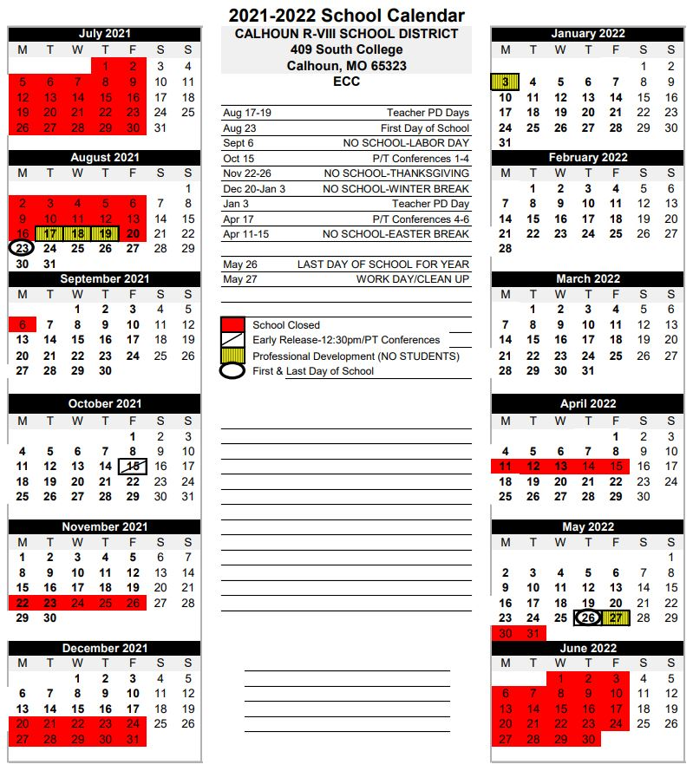
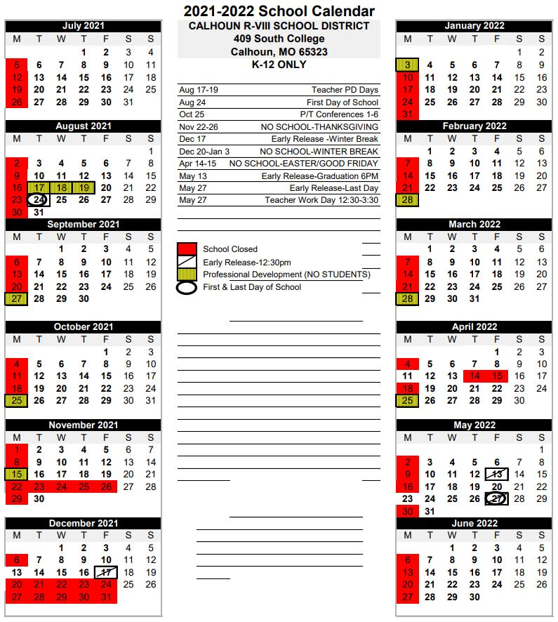
2021-2022 DISTRICT PAY DAYS
July 20, 2021
August 20, 2021
September 20, 2021
October 20, 2021
November 19, 2021
December 20, 2021
January 20, 2022
February 18, 2022
March 18, 2022
April 20, 2022
May 20, 2022
June 20, 2022
July 20, 2022

Calhoun R-VIII
Acceptable Use Policy 2020-2021
(Technology User Agreement)

Note: This Policy was adopted from the Calhoun R-VIII board policy PR 6320.
The complete document is attached and also available for viewing at the web site below or in the Superintendent’s Office.
http://www.moconed.com/regulation.php?action=ind&polID=1220&catID=7

I understand that my use of the district’s Internet, network, hardware, and software is a PRIVILEGE, not
a right. I understand that my use of the district's technology is not private and that the school district may
monitor my use of district technology, including but not limited to accessing browser logs, e-mail logs,
and any other history of use. I consent to district interception of, or access to, all communications I send,
receive, or store using the district's technology resources, pursuant to state and federal law, even if the
district's technology resources are accessed remotely.

Use of technology resources in a disruptive, inappropriate or illegal manner impairs the district’s mission,
squanders resources, and shall not be tolerated. Therefore, a consistently high level of personal
responsibility is expected of all users granted access to the district’s technology resources. Any violation
of district policies or procedures regarding technology usage may result in temporary, long-term, or
permanent suspension of user privileges. User privileges may be suspended pending investigation into the
use of the district’s technology resources.

Users may be disciplined, suspended, expelled, or terminated for violating the district’s technology
policies and procedures. Any attempted violation of the district's technology policies or procedures,
regardless of the success or failure of the attempt, may result in the same discipline or suspension of
privileges as that of an actual violation. The district will cooperate with law enforcement in investigating
any unlawful use of the district's technology resources.

I have read the Calhoun R-VIII School District Technology Usage Board Policy and administrative
regulations. I agree to abide by their provisions and understand that violation of these provisions may
result in disciplinary action taken against me.

___________________________________ ___________________________________ __________
(Signature) (Printed Name) (Date)

___________________________________ ___________________________________
(Parent/Guardian Signature - if under 18) (Parent/Guardian Printed - if under 18)

