

Houston County High School Course Syllabus
Introduction to Business & Technology

Instructor Contact Information Office Hours/Tutorials
Diane Byington email: diane.byington@hcbe.net 7:20 a.m. – 7:50 a.m.
Room #705 phone: (478) 988-6340 3:00 p.m. - 3:30 p.m.
Tutoring available by appointment

Course Title: Introduction to Business & Technology

Course Description:
Introduction to Business & Technology is the first course in the Business Accounting pathway. The course provides an overview of business and technology skills required for today's business environment. Emphasis is placed on developing proficient fundamental computer skills required for all career pathways. Students will learn essentials for working in a business environment, managing a business, and owning a business. Employability skills are integrated into activities, tasks, and projects throughout the course. After mastery of the standards in this course, students should be prepared to earn an industry recognized credential: Microsoft Office Specialist for Word Core Certification.

Business Accounting Pathway Courses Must Be Completed in the Order Listed Below:
*Introduction to Business & Technology (1st Level)
*Financial Literacy (2nd Level)
*Accounting I (3rd Level)

Students who complete the Business Accounting Pathway will be eligible to test and earn the following industry recognized credential:
* Business Financial Management Certificate - NOCTI (National Occupational Competency Testing Institute)

First Semester Second Semester
Unit 1: Effective Communication/Presentation Skills/PPT Unit 6: Entrepreneurship and Leadership
Unit 2: Introduction to Technology Unit 7: Business Ownership
Unit 3: Word Processing Unit 8: Marketing
Unit 4: Excel/Money Management Unit 9: Management and Human Resources
Unit 5: Accounting Unit 10: Risk Management

Students are highly encouraged to join Future Business Leaders of America (FBLA). FBLA is co-curricular with all Business and Computer Science classes (Standard FIN-BII-12). This means students will complete FBLA activities and assignments, that are integrated into each unit, as part of their grade. To become an active member of FBLA, students will fill out a membership application, pay $30 annual dues, (includes a T-shirt), and attend monthly meetings. Active FBLA members are eligible to compete in region and state competitions

Course Materials Needed:
Students will access all course materials through Google Classroom and Canvas LMS (Spring)

Computation of High School Grades:
Grades will be calculated for each of the following components to determine a numerical grade:

Daily Assignments 15%
- Standards-based Instructional Tasks:
  - Classwork, instructional tasks, observations
Minor Assessments 20%
- Standards-based Instructional Tasks:
  - Formative quizzes, and instructional tasks with rubrics
Major Assessments 45%
- Standards-based Instructional Assessments:
  - Unit Tests, Unit Projects, Research papers, Research presentations
Final Exam 20%

Final Numeric Grade

Term | Report Name | End of Grading Period
S1 | 6 Week Progress | September 13, 2023
S1 | 12 Week Progress | November 2, 2023
S1 | End of Semester | December 20, 2023

Term | Report Name | End of Grading Period
S2 | 6 Week Progress | February 20, 2024
S2 | 12 Week Progress | April 10, 2024
S2 | End of Semester | May 22, 2024

Make-up Assignments:
- Students who miss classwork, tests, or examinations from an excused absence shall complete the missing work within five school days after he or she returns to school.

- Any assignments or projects given prior to days of absence are due immediately upon the first day of a student’s return. However, in extenuating circumstances, this may be extended.

- It is the responsibility of the student to determine what they have missed and to complete all missing assignments within five school days for full credit.

Late/Missing Work Procedure:
Assignments will not be accepted after the progress report cut-off dates:
- (9/13/23, 11/2/23, 12/20/23, 2/20/24, 4/10/24, 5/22/24).
- A late penalty of 5 points per day, for up to five days, may be implemented.

Make-up Work After Absences:
Students shall make up work missed during absences for any of the following reasons:
A. Participation in school-sponsored activities such as field trips or other designated events
B. Personal illness
C. Medical requirements
D. Family illness
E. Death of a family member
F. Observance of a religious holiday
G. Orders of government agencies
H. Hazardous conditions
I. Suspension (ISS and OSS)

Students are responsible for all make-up work from excused absences.
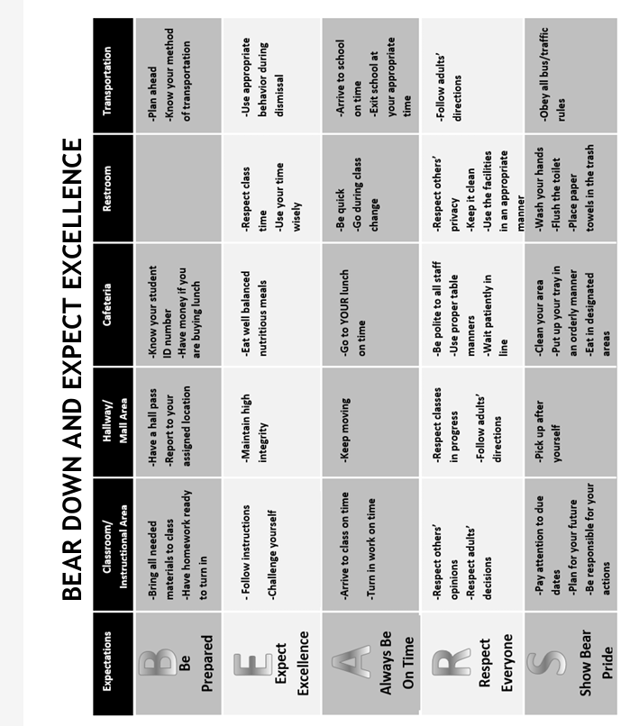
Classroom Norms and Behavioral Expectations

- The Houston County Code of Conduct applies to all students.

Cheating/Plagiarism Procedure:
Any student suspected of cheating/plagiarism will be assigned discipline in accordance with the student handbook.

Classroom Internet Acceptable Use Policy:
Use of the Internet must be in support of education and research and consistent with the educational objectives of the Houston County School System. The use of the Internet is a privilege, not a right, and inappropriate use will result in cancellation of those privileges. Any student user not complying with the Houston County School System Internet Acceptable Use Agreement shall lose Internet privileges for a period of not less than one week.

*Disclaimer: This course syllabus serves as a general outline of the expectations and responsibilities of students; all information contained in the course syllabus is subject to change. Any changes will be announced, and a revised syllabus shared with students and their parents/guardians.

By completing this form, you acknowledge that you have read and understand the class expectations, course details, and policies and will adhere to the procedures needed to be successful in the Intro to Business & Technology classroom.

- I understand the Intro to Business & Technology Course Syllabus is located on the Google Class files page.
- I understand I may request a paper copy of the syllabus.
- I have reviewed the syllabus with my child, and we are aware of the grading procedures, expectations, and other course requirements.
- I understand the criteria for his/her grading determination.

Parent/Guardian Signature Date

Parent’s E-Mail Address Parent’s Daytime Phone #

I agree, to the best of my ability, to fulfill my commitment as a student.

Student Signature Date

***An electronic copy of the syllabus is on the Google Classroom files page and my Website - A hard copy will be provided upon request***

