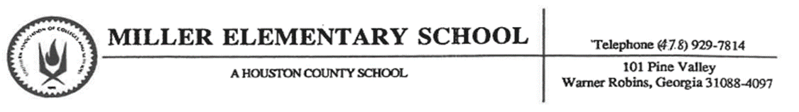

Minor Office Incident Referral (MIR)

Student Name:_______________________________ Date:_____________ Grade:____________
Location of the Incident:______________________ Teacher: ____________________

 | Level 2
 | Talking out without permission (Chronic) | Using inappropriate language or gestures
 | Getting out of seat without permission (Chronic) | Inappropriate behavior
 | Refusal to do classwork/participate (Chronic) | Disrespect to staff member
 | Playing with toys, supplies | Aggressive or rough play
 | Not keeping hands, feet and object to self | Throwing objects
 | Name calling | Cheating on school work or test
 | Class disruption (Chronic) | Other:
Teacher Comments:

1st MIR
Teacher confers with student about expected behavior
Student receives think time sheet and reflective points
Teacher uploads Minor Referral into Dojo
Consequences at home

2nd MIR
Teacher confers with student about expected behavior
Student receives think time sheet and reflective points
Teacher uploads Minor Referral into Dojo AND Conferences with parent via phone
Student walks half of break to reflect on expected behavior

3rd MIR
Teacher confers with student about expected behavior
Student receives think time sheet and reflective points
Teacher uploads Minor Referral into Dojo AND Conferences with parent via zoom or in person
Student walks all of break to reflect on expected behavior

4th MIR
Teacher confers with student about expected behavior
Student receives think time sheet and reflective points
Teacher uploads Minor Referral into Dojo AND Conferences with Teacher and Principal or Assistant Principal
Student receives a Major Office referral, walks all of break to reflect on expected behavior and is placed on a Behavior tier

Number of MIRs______________________________ Month______________________________________
Please return PFI by (Date): __________________ Teacher Signature: __________________________
Parent Signature: ____________________________ Student Signature: __________________________

