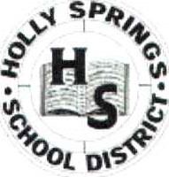
Holly Springs Intermediate School
655 South Maury Street
Holly Springs, MS 38635
Phone: 662.252.2329 Fax: 662.252.5185
Vikki Marion, Principal
Holly Springs Intermediate’s Inclement Weather Remote Learning Plan
Dear Parents,
If we have inclement weather at any time, students still will be obligated to log on for remote learning. Students will only be counted present by logging on to the school website-https://intermediate.hssdk12.org/and logging into their homeroom class.

Students must:
- Follow their regular class schedule by logging into those teachers’ Google Meet classroom. Students have been trained on this process and know wh
- Log in by 7:45 a.m.
- Wear school uniform shirt.
- Camera must be on, mic must be off and must have all material needed for the class.
- They must be in a well-lit area of the house where it is quiet. The camera must be focused on the student at all times.
All students must meet the criteria above or risk being removed from the class by the teacher and marked absent from the class. All absentees will be reported to truancy. Students are expected to complete all work and interventions by the deadline given by each teacher. Students will receive grades for their work.
Please contact the school on Friday, January 12, 2024, if you do not have internet access or available hotspot.
If you have any questions about our report learning plan, please feel free to call the school during a regular day or if you have questions during inclement weather you may email
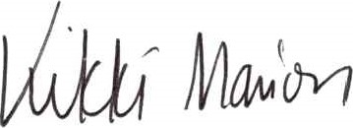
Vikki Street-Marion
Principal

