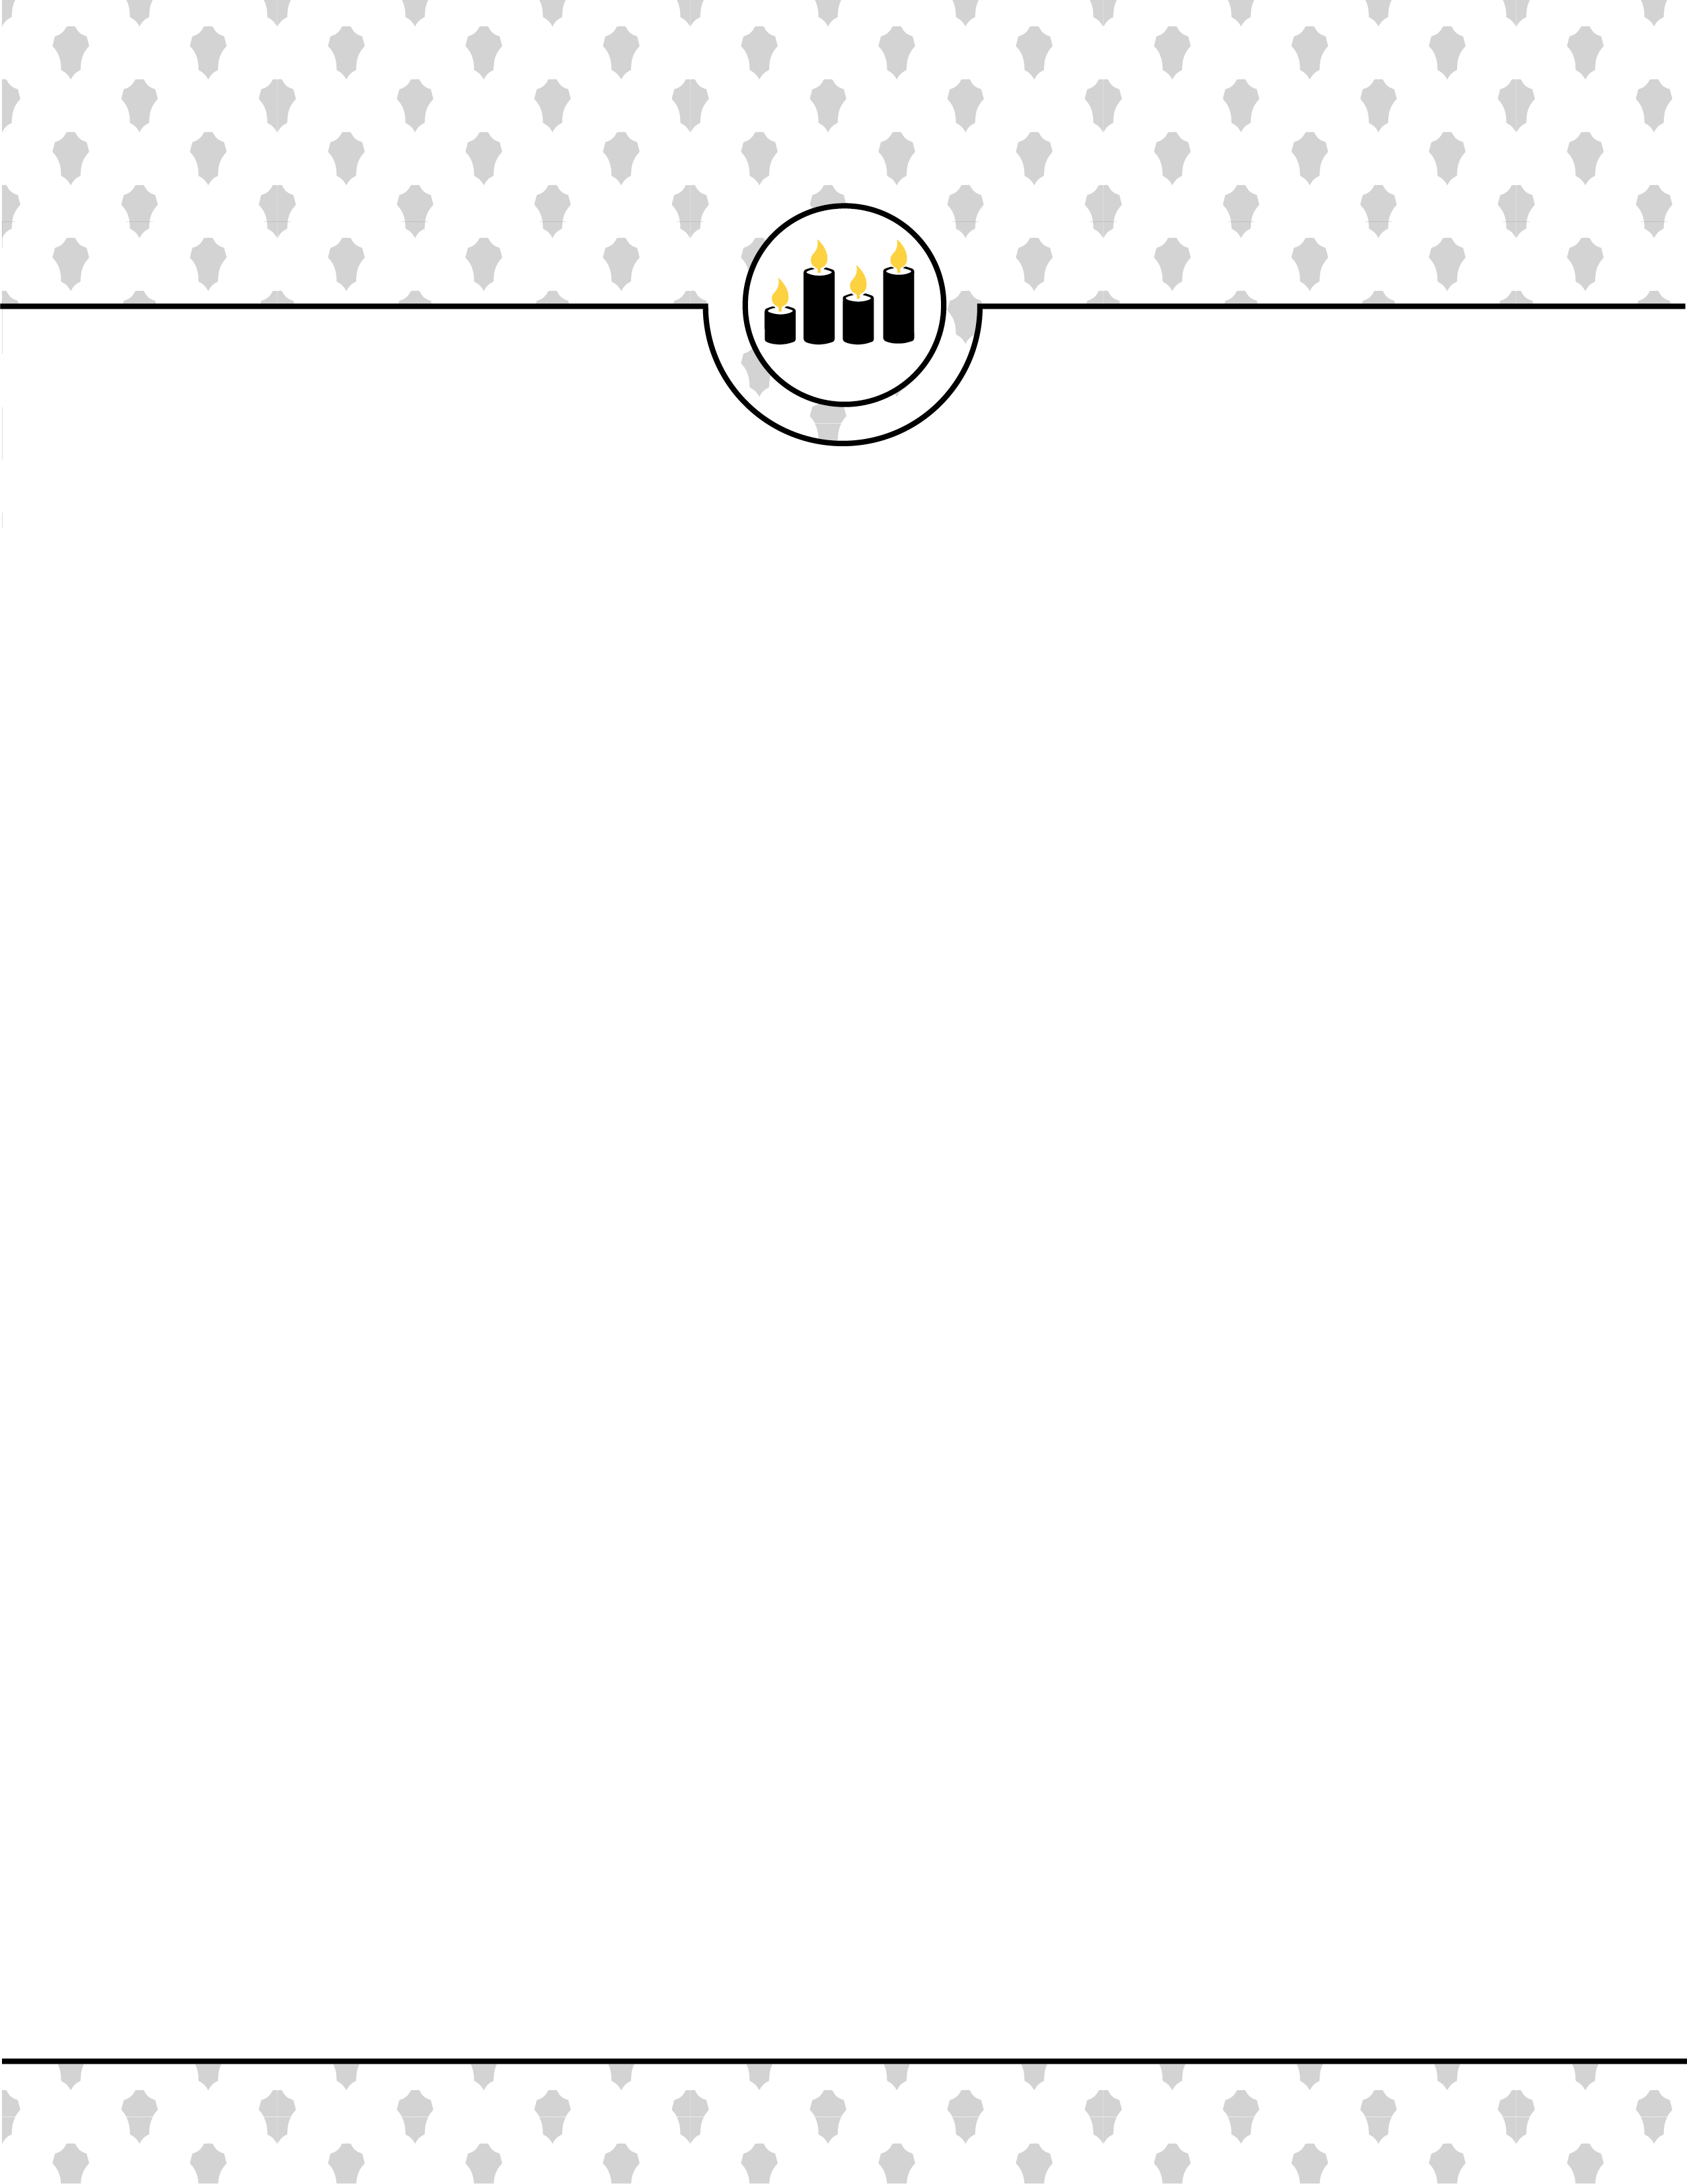



**1**

**MEMBERSHIP AGREEMENT –htarver@sumter.k12.al.us**

**MEMBERSHIP AGREEMENT**

The purpose of National Beta Club is to promote academic achievement, character, leadership, and service at Sumter Central High School. This membership agreement provides the standards of membership and consequences if the standards are not upheld.

# STANDARDS OF MEMBERSHIP

All students must be performing at or above grade level in order to be eligible for membership. The academic requirements for membership in the National Senior Beta club are a 3.25 GPA or all As.

The service requirements for membership in the National Senior Beta club are a minimum of 15 hours. The character and behavioral requirements for membership in the National Senior Beta club are no disciplinary referrals, suspensions, or alternative school placement. Students must also submit two teacher recommendation surveys before membership can be granted.

# LOSS OF MEMBERSHIP

A member of this National Senior Beta club may be put on probation or dropped from membership for the following reasons.

* If he/she is absent without a justifiable reason from 3 regular consecutive meetings.
* If his/her academic record falls below As and Bs.
* If he/she fails to attain at least 15 service hours without a justifiable reason.
* If his/her character and behavior record receives any Class II + offenses or multiple Class I.

When a member is put on probation, they can be added back on the active school roster upon meeting requirements again. When a member is dropped from membership, a record of this action shall be relayed to the National Office of National Senior Beta immediately. Students place on probation will receive a letter of awareness. Students whose character requirements fall below standard, will be subject probation and a meeting to decide further actions.

PARENT/GUARDIAN

DATE

STUDENT DATE