Mrs. Daniel’s Newsletter
March 21-25, 2022
Grammar (contractions), Reading Skills,
Spelling (vowel patterns), and Vocabulary Tests: Thursday

NO HOMEWORK ON MON. & TUES. NIGHT (ACAP)
March 28-April 1: Spring Break
Thursday, April 14: e-learning day
Friday, April 15: Weather Day (NO SCHOOL)
Tuesday, April 19: Math ACAP in the a.m.
Monday, April 25: Progress Reports Issued
Monday, March 21: Report Cards Issued
Tuesday, March 22: Reading ACAP in the a.m.
Friday, March 25: Honor Roll; Spirit Day;
Special Snack

Reading Story and Skills:  Story:  The Signmaker’s Assistant  by Tedd Arnold  Text-Based Comprehension:  main idea and details, inferring  Phonics/Fluency:  vowel patterns  (aw, au, au(gh), al)  Grammar:  contractions |  | Vocabulary Words  (these words will be tested each week):  - afternoon – the time of day between noon and night  - blame – to say that something is someone’s fault  - idea – a thought or an opinion  - important – having a great meaning  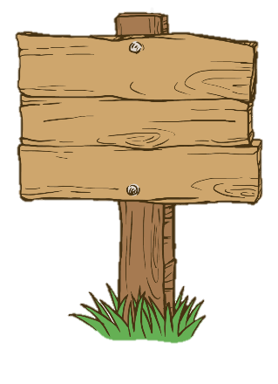  - signmaker – someone who makes  signs or public notices  that give information  - townspeople – people living  in a town
Math  Topic 9: Numbers to 1,000  Lesson 4: Read and Write 3-Digit Numbers  Lesson 5: Different Ways to Name the Same Number  Lesson 6: Place-Value Patterns with Numbers  Lesson 7: Skip Count by 5’s, 10’s, 100’s, to 1,000  On Friday, we will take a weekly assessment. |  |  |  | Social Studies/Science  This week  we are  finishing  our unit  on plants.
Spelling Words: No bonus words this week.
- talk  - because  - August | - caught  - draw  - walk |  | - chalk  - auto  - taught |  | - thaw  - fault  12. launch

