Agenda – Regular Board Meeting
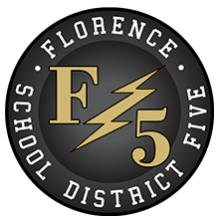
Florence County School District Five Board of Trustees
152 East Marion Street, Johnsonville, SC
Monday, October 24, 2022, 7:00 p.m.

- Call to Order, Welcome, and Pledge of Allegiance

- Confirmation of Notice to Media

- Approval of Agenda

- Public Forum

5. Consent Agenda
A. Minutes – September 26, 2022 – pp. 1-3
B. Monthly Financial Statement – September 2022 – pp. 4-5

6. Regular Agenda
A. Superintendent’s Report
1. Academic Updates – Mr. Brian Goins
2. Upcoming Events and Updates

7. For Action Agenda
A. Second Reading of Policy IHBF (Medical Homebound Instruction) – p. 6

8. Executive Session Agenda
A. Personnel Resignation

9. Reconvene in Open Session with Action if Necessary from Executive Session

10. Adjournment

Joshua B. Timmons, Chairman

The Morning News/NPO
WMBF-TV
WPDE-TV
WBTW News
www.fsd5.org

