Jr. Vikes Football & Cheer 2023
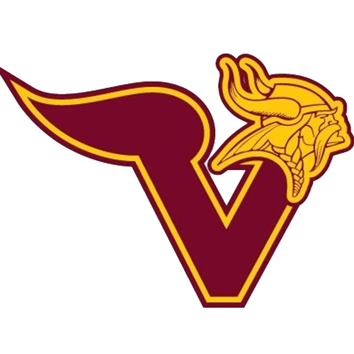
Dear Parents,

Sportsmanship

Respect

Team Spirit

Commitment

Confidence

Integrity
The 2023 Jr. Vikes Football & Cheer season is approaching. For prospective athletes, our program is based on having fun, developing skills and being a part of the Voorhees Viking legacy. We work with the Voorhees High School to prepare athletes for their academic and athletic journey.
- Football & Cheer is open to students in grades K-8 (see website for details)

- Summer camps available for athletes and fun events planned for the entire family

- We are currently preparing for an exciting season and looking for volunteers to help get our Football Players and Cheerleaders back on the field!

- Are you interested in coaching, being a board member or volunteering in other capacities?

- Be a part of tradition and join the Viking Family

Football & Cheer EARLY BIRD Registration ends April 30th!
Visit www.jrvikes.com for more information and REGISTER TODAY!

IT'S A GREAT DAY TO BE A VIKE!

