August: Getting to know your field site
This month, you’ll be visiting your field site, taking some photographs, and documenting your visit electronically. Please visit your site for at least 30 minutes by yourself without interruption from devices or people you know. This first visit should be during daylight hours so you can get some clear pictures.

PLEASE NOTE:
- Field experiences often require you to take photos or audio on your device (or, let’s be honest, your phone/tablet/etc.).
- If you leave this assignment to the last moment and you have audio-visual problems, it still counts as late!
- Please make sure you give yourself enough time this month to work your way through any tech challenges.

Put on some sunscreen (and insect spray, if you are so inclined).
Bring:
- a backpack or other bag with your charged device
- your lab notebook
- two black or dark blue pens
- some way to set an alarm for 20 minutes (watch, small clock, personal device, your school device if you know how, your friend watching TV who sets her kitchen timer and then calls you after 20 minutes, etc.)
- (optional) an old towel to sit on
- Look out for poison ivy and then sit on the ground (on your towel, if you prefer). No park benches, lawn or camping chairs, etc. You will be sitting in this exact same spot several times this year, so pick one that has an attractive view of your field site.
- Make a new entry in your lab notebook called August Field Experience.
- Put your lab notebook in your lap with an uncapped pen.
- Set your timer for 20 minutes. Verify that it is counting down.
- While the timer is going, don’t look at it.
- No, really, don’t look at your timing device.

- For these 20 minutes, alternate between observing your site and writing. I’m leaving how you do this up to you and what’s happening in your brain and at your site, but obviously I have some ideas:
  - Use words, not sketches here. You’ll do plenty of sketching, including for this assignment (see below).
  - You are probably not going to know the names of most plants or animals/insects or who is making many of the sounds. That’s quite acceptable.
  - If you’re not used to sitting and listening and watching, this may be very, very hard. Like everything, practice makes better.
  - You might like to write down what you notice as you notice it -- and/or you might notice what’s happening in your own head: What questions come up? What emotions are you experiencing?
- When the timer goes off, write down one word that describes how you are feeling.
- Find something of interest to you... (SKETCH THIS IN YOUR LAB NOTEBOOK)
- Take the field site pictures required for this assignment on a device of your choosing.
  - You’ll submit at least three photographs at your site: one of where you’re sitting and two of what you can see when you are sitting there. Give us the “big” picture view instead of focusing on details.
- Write END at the end of your notes.

- Go inside and do a tick check!
- When you return to a clean place with reliable internet, open a new document.
- Follow the instructions below to complete your assignment.

Before the due date of this assignment, please use Google Classroom to submit a PDF that contains…
- A reflection (200 words minimum). I’m leaving this first one open. Comment on what you see or hear, what you experience, what questions you have, or pick another format.
- A screenshot (not a link!) of your field site on Google maps (maps.google.com). Search for a nearby address and then “drop and drag” a pin so it is easy to see your site’s exact location.
- At least three photographs at your site: one of where you’re sitting and two of what you can see when you are sitting there.
- Picture(s, if more than one page) of your notes from your notebook at sufficiently high resolution and contrast that the words can be read. You may need to zoom in for the sketch and response.

To make a PDF from a Google Doc:

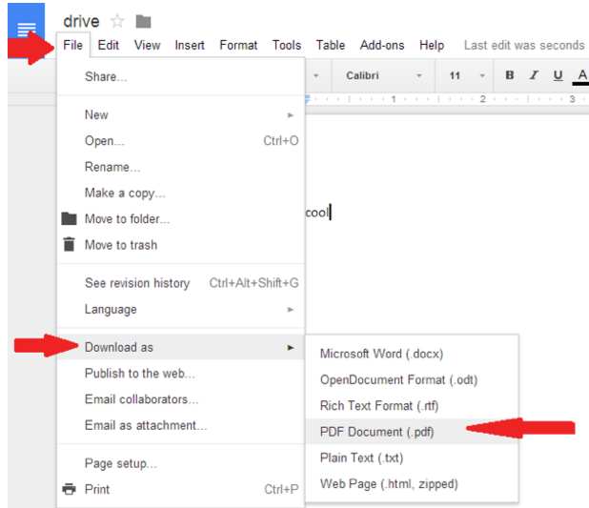
From http://oregonstate.edu/helpdocs/faq/how-do-i-export-google-doc-pdf

