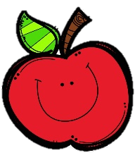
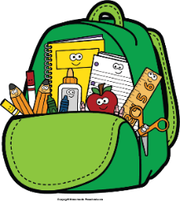
Mr. Marks’ Messages
February 23-27, 2026
Assessments
Thursday Math Assessment: Graphs will send study guide Wednesday
Friday Assessments: Phonics, Grammar, Reading Skills, Vocabulary, and Spelling
- March 2nd- March 6th- Read Across America Week
Reading Story and Skills:  Story: Where’s the  Honey, Honey?  Phonics/Fluency:  long /u/ spelled  _ew, _ue, u, u_e;  long /o/ spelled  _ow, oa_, o, o_e;  Prefixes dis-, un-  Word Analysis:  Prefixes dis-, un-  Text-Based Comprehension:  Main Idea and Details  Grammar/Language:  Pronouns |  | Vocabulary Words  - Wednesday, February 25th- Book Fair  - Friday, February 27th- Rodeo Field Trip  - Wednesday, March 4th- Book Fair  - beehive – a nest or house a bee lives in  - wilderness – a natural place where few people live  - flush – to drive from the cover of a hiding place  - wax – the yellow substance that is used by honeybees to  make their honeycombs  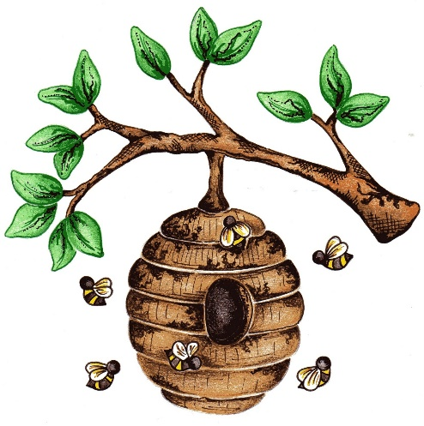  - effective – bringing about or able to bring about a  desired result  - ancient – of or having to  do with times very  long ago  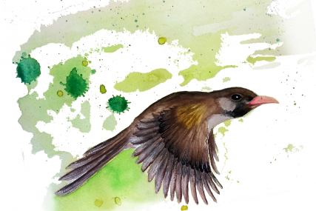
Math  Topic 15: Data and Graphs  Lesson 4: Picture Graphs  Lesson 5: Draw Conclusions from Graphs  Lesson 6: Problem Solving  Topic Review  Thursday: Topic 15 Test |  |  |  | Social Studies/Science  We are continuing  our unit on animals  and their habitats  this week.
Spelling Words:
- tow  - humid | - disagree  - soap |  | - unplanned  - fuel |  | - cone  - unlock | - distrust  10. pure

