September 27 Lesson
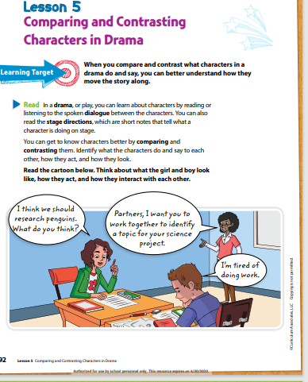
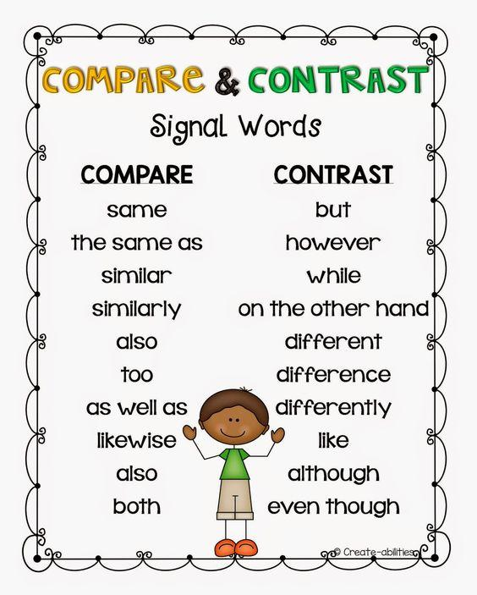

Bellringer
- _________ is a person in a novel, play, or movie.
- Theme B. Recount C. Character D. Summarize

RL 5.3-Compare and contrast two or more characters, settings, or events in a story or drama, drawing on specific details in the text (e.g., how characters interact).
Opening-Crittle All
1. SO – RL 3 Compare and contrast two or more characters, settings, or events in a story or drama, drawing on specific details in the text (e.g., how characters interact).
2. SP/RW – The students need to know how compare and contrast characters in a story.
3. PK – Ask students if they understand the difference/ similarities of characters
4. CV – Compare, contrast, Setting, Plot (Week 1) Climax, Resolution, Conflict, Describe (Week 2)
Vocabulary
Compare-It is something that is similar to something else.
Contrast- It is something that is different from another thing.
Setting- It is the place where an event took place.
Plot-It is the main event of the story.
5. DI- [Monday]-Short Passage
- Teach (I Do): Utilize Word Document for short passage and student package. I DO: Model Sample Test Items #8 12 13. We DO: Practice using (Student Package)
- YOU DO: Exit Ticket.

Closing-1. Select students to orally state what was learned from the lesson.
Compare and Contrast | English For Kids | Mind Blooming - YouTube
Compare and Contrast for Kids - YouTube
Intro to Compare/Contrast - First Grade - YouTube
Same and Different for Kids (Compare and Contrast with a Quick Quiz) - YouTube
Compare and Contrast | Stories & Thinking skills for Kids | Storybag - YouTube

Mongoo closed her eyes. She did not even want to see the fish on the bucket. For the last time, she did not want to eat an animal or see that it was about to become “food.” Bataar, who wanted his sister to become tough, had tricked her into seeing it, again. He felt bad when Mongoo was about to cry.
“Okay. Sorry.” Bataar said softly. “You can just eat your leaves. You won’t be big like me, though.”
Mongoo stormed out of the porch and ran into her bedroom. She stood near the window and started talking to her aloe vera plant. “Vera, my brother never gets it. Why do I have to be like him? Why do I have to like what he likes?” She waited for the evening to pass and wanted to skip dinner. However, she could not say no to her mother and joined Bataar and the rest of her family for bordzig¹, fish, and pickled cabbages.
“Mom, Mongoo will not eat fish, and I am sorry I scared her today,” Bataar said as his sister sat next to him.
Mongoo, surprised at her brother’s words, stopped feeling bad. “Thanks,” she said. “But, I can speak for myself.”
¹a soft, wheat pastry made in Mongolia

I Do We Do You Do Activity
RL 5.3 #8 #12 #13
I Do
At the beginning of the story, how are Mongoo and Bataar different? RL 5.3 #8
- Mongoo wants to eat fish and Bataar doesn’t.
- Mongoo doesn’t want to eat fish and Bataar does.
- Mongoo wants to kill a fish and Bataar doesn’t.
- Mongoo doesn’t want to think of animals as food and Bataar does.

Compare and contrast the characters in the story. RL 5.3 #12
Select the box for each phrase that describes Mongoo, Bataar, or both
 | Mongoo | Both | Bataar
enjoys fish
younger
did not enjoy eating animals
apologized

How does the setting change from the beginning of the story to the end of the story? RL 5.3 #13
- They were inside of the house.
- They were on the porch.
- They were at the dinner table.
- They were in bed.

Leah sat on her bed and looked around her new room. It was smaller than her room had been back in Tennessee. But Mom had painted the walls the same shade of lavender as her old room and Boo-Boo, her teddy bear, sat on her bed, just as he always had. She looked out her window at the yard below It was strange being on the second floor. She had never lived in a two-story house before.

We Do

At the beginning of the story, how are Leah and her mom different? RL 5.3 #8
- Leah is sitting on her new bed and her mom is painting.
- Leah is painting and her mom is sitting on her new bed.
- Leah is looking out the window and her mom is sitting on her new bed.
- Leah is painting and her mom is painting.

Compare and Contrast the two different settings in the story. RL 5.3 #12
Select the box for each phrase that describes the new room, the old room, or both
 | new room | Both | old room
painted lavender
smaller
two story
teddy bear

How does the setting change from the beginning of the story to the end of the story? RL 5.3 #13
- Leah is in Tennessee.
- Leah is in a new town.
- Leah is in a new state.
- The setting stays the same and Leah is in a new area.

"Hurry up, Slow Poke," Logan called from further up the trail. Nolan took one last look at the ant hill he had been watching and rushed to catch up. He wondered why Logan always had to be in such a hurry. There was so much to see in the forest, and Logan was missing it all. It was hard to believe they were twins. They had the same dark hair, the same brown eyes, even their smiles were similar. But they had almost nothing in common At least they both liked hiking, even if Logan did like it at faster pace.

You Do
At the beginning of the story, how are Logan and Nolan different? RL 5.3 #8
- Logan walked fast and Nolan walked slow.
- Logan walked slow and Nolan walked fast.
- Logan and Nolan walked fast.
- Logan and Nolan walked slow.

Compare and contrast the two characters in the story. Select the box for each phrase that describes Logan, Nolan, or both. RL 5.3 #12

 | Logan | Both | Nolan
always in a hurry
enjoys hiking
brown eyes
takes his time

How does the setting change from the beginning of the story to the end of the story? RL 5.3 #13
- It is raining.
- It is sunny.
- The boys are on a bike trail.
- The setting stays the same they are on a hiking trail in the forest.

Homework-Teacher Assigned I-Ready Reading Lesson (Choose one)

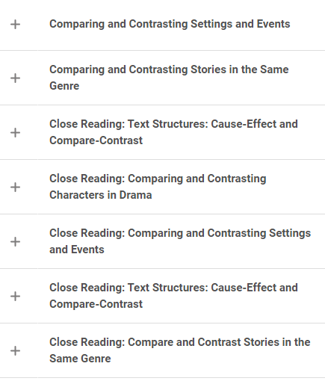

September 28 Lesson

Bellringer
Write a signal word for Compare and Contrast. Write a sentence with each of those words.

RL 5.3-Compare and contrast two or more characters, settings, or events in a story or drama, drawing on specific details in the text (e.g., how characters interact).
Opening-Crittle All
1. SO – RL 3 Compare and contrast two or more characters, settings, or events in a story or drama, drawing on specific details in the text (e.g., how characters interact).
2. SP/RW – The students need to understand the setting of a story.
3. PK – Can you compare the student’s outfit that sits next to you?
4. CV – Compare, contrast, Setting, Plot (Week 1) Climax, Resolution, Conflict, Describe (Week 2)
Vocabulary
Compare-It is something that is similar to something else.
Contrast- It is something that is different from another thing.
Setting- It is the place where an event took place.
Plot-It is the main event of the story.
5. DI- [Tuesday]-Short Passage
- Teach (I Do): Utilize Word Document for short passage and student package. I DO: Model Sample Test Items #33. We DO: Practice using (Student Package)
- YOU DO: Exit Ticket.

Closing-1. Select students to orally state what was learned from the lesson.
Compare and Contrast | English For Kids | Mind Blooming - YouTube
Compare and Contrast for Kids - YouTube
Intro to Compare/Contrast - First Grade - YouTube
Same and Different for Kids (Compare and Contrast with a Quick Quiz) - YouTube
Compare and Contrast | Stories & Thinking skills for Kids | Storybag - YouTube

Mongoo closed her eyes. She did not even want to see the fish on the bucket. For the last time, she did not want to eat an animal or see that it was about to become “food.” Bataar, who wanted his sister to become tough, had tricked her into seeing it, again. He felt bad when Mongoo was about to cry.
“Okay. Sorry.” Bataar said softly. “You can just eat your leaves. You won’t be big like me, though.”
Mongoo stormed out of the porch and ran into her bedroom. She stood near the window and started talking to her aloe vera plant. “Vera, my brother never gets it. Why do I have to be like him? Why do I have to like what he likes?” She waited for the evening to pass and wanted to skip dinner. However, she could not say no to her mother and joined Bataar and the rest of her family for bordzig¹, fish, and pickled cabbages.
“Mom, Mongoo will not eat fish, and I am sorry I scared her today,” Bataar said as his sister sat next to him.
Mongoo, surprised at her brother’s words, stopped feeling bad. “Thanks,” she said. “But, I can speak for myself.”
¹a soft, wheat pastry made in Mongolia

I Do We Do You Do Activity
RL 5.3 #33
I Do
Based on the story, which statement expresses the relationship between Mongoo and Bataar? RL 5.3 #33
- Mongoo is sensitive to killing animals to eat and Bataar doesn’t care about killing animals to eat.
- Mongoo doesn’t care about killing animals to eat and Bataar is sensitive to killing animals to eat.
- Mongoo and Bataar both are sensitive to killing animals to eat.
- Mongoo and Bataar don’t care about killing animals to eat.

Leah sat on her bed and looked around her new room. It was smaller than her room had been back in Tennessee. But Mom had painted the walls the same shade of lavender as her old room and Boo-Boo, her teddy bear, sat on her bed, just as he always had. She looked out her window at the yard below It was strange being on the second floor. She had never lived in a two-story house before.

We Do
Based on the story, which statement expresses the relationship between Leah and her mom? RL 5.3 #33
- Leah is thinking about her old home and her mom is focused on the new home.
- Leah is focused on the new home and her mom is thinking about the old home.
- Leah and her mom are thinking about the old home.
- Leah and her mom are focused on the new home.

"Hurry up, Slow Poke," Logan called from further up the trail. Nolan took one last look at the ant hill he had been watching and rushed to catch up. He wondered why Logan always had to be in such a hurry. There was so much to see in the forest, and Logan was missing it all. It was hard to believe they were twins. They had the same dark hair, the same brown eyes, even their smiles were similar. But they had almost nothing in common At least they both liked hiking, even if Logan did like it at faster pace.

You Do
Based on the story, which statement expresses the relationship between Logan and Nolan? RL 5.3 #33
- Logan was in a rush and Nolan took his time.
- Logan took his time and Nolan was in a rush.
- Logan and Nolan were in a rush.
- Logan and Nolan took their time.

Homework-Teacher Assigned I-Ready Reading Lesson (Choose one)

September 29 Lesson
Bellringer- Write a signal word for Compare and Contrast. Write a sentence with each of those words.
RL 5.3-Compare and contrast two or more characters, settings, or events in a story or drama, drawing on specific details in the text (e.g., how characters interact).
Opening-Crittle All
1. SO – RL 3 Compare and contrast two or more characters, settings, or events in a story or drama, drawing on specific details in the text (e.g., how characters interact).
2. SP/RW – The students need to understand the plot of the story.
3. PK – Can you contrast the fourth grade hall from the fifth grade hall?
4. CV – Compare, contrast, Setting, Plot (Week 1) Climax, Resolution, Conflict, Describe (Week 2)
Vocabulary
Compare-It is something that is similar to something else.
Contrast- It is something that is different from another thing.
Setting- It is the place where an event took place.
Plot-It is the main event of the story.
5. DI- [Wednesday]-Short Passage-Independent Practice
- Teach (I Do): Utilize Word Document for short passage and student package. I DO: Model Sample Test Items #. We DO: Practice using (Student Package)
- YOU DO: Exit Ticket.

Closing-1. Select students to orally state what was learned from the lesson.
Compare and Contrast | English For Kids | Mind Blooming - YouTube
Compare and Contrast for Kids - YouTube
Intro to Compare/Contrast - First Grade - YouTube
Same and Different for Kids (Compare and Contrast with a Quick Quiz) - YouTube
Compare and Contrast | Stories & Thinking skills for Kids | Storybag - YouTube

Venn Diagram-is an illustration that uses circles to show the relationships among things or finite groups of things
Venn Diagram
Contrast Compare Contrast
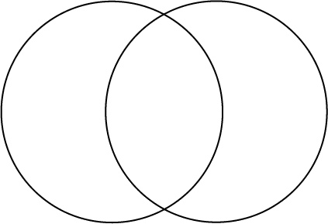
Students the contrast circle is the difference in each character. The compare is the similarities in each character. Complete the assignment below. When you finish work (choose one) on a Teacher Assign I-Ready Reading Lesson about Compare and Contrast.

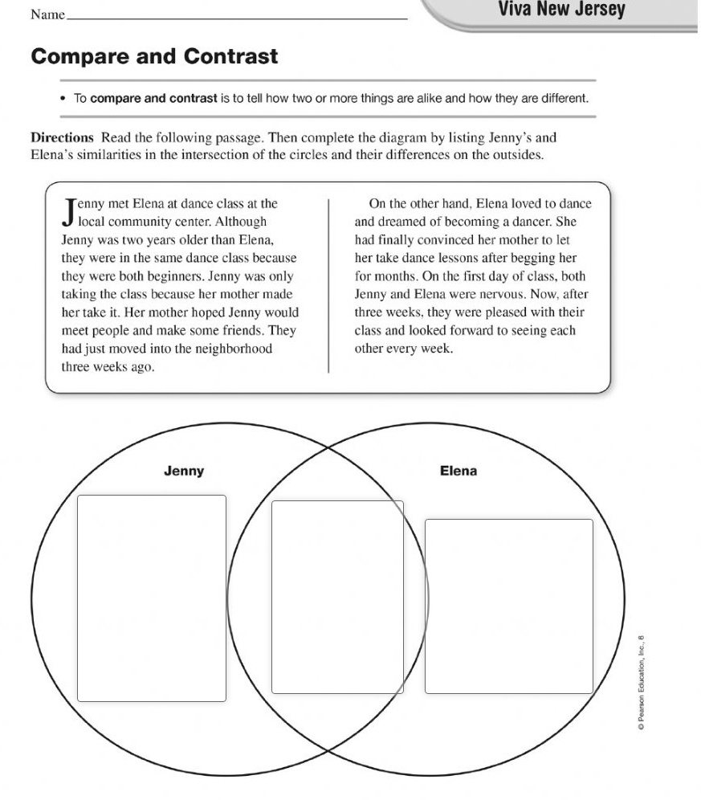

September 30 Lesson

Bellringer- Use the Venn Diagram to compare and contrast your Walmart and Dollar Tree
Venn Diagram
Contrast Compare Contrast

RL 5.3-Compare and contrast two or more characters, settings, or events in a story or drama, drawing on specific details in the text (e.g., how characters interact).
Opening-Crittle All
1. SO – RL 3 Compare and contrast two or more characters, settings, or events in a story or drama, drawing on specific details in the text (e.g., how characters interact).
2. SP/RW – The student needs to understand signal words will help them determine contrast and compare.
3. PK – Can you contrast hand sanitizer from hand soap?
4. CV – Compare, contrast, Setting, Plot (Week 1) Climax, Resolution, Conflict, Describe (Week 2)
Vocabulary
Compare-It is something that is similar to something else.
Contrast- It is something that is different from another thing.
Setting- It is the place where an event took place.
Plot-It is the main event of the story.
5. DI- [Thursday]-Short Passage-Independent Practice
- Teach (I Do): Utilize Word Document for short passage and student package. I DO: Model Sample Test Items #. We DO: Practice using (Student Package)
- YOU DO: Exit Ticket.
Closing-1. Select students to orally state what was learned from the lesson.
Compare and Contrast | English For Kids | Mind Blooming - YouTube
Compare and Contrast for Kids - YouTube
Intro to Compare/Contrast - First Grade - YouTube
Same and Different for Kids (Compare and Contrast with a Quick Quiz) - YouTube
Compare and Contrast | Stories & Thinking skills for Kids | Storybag - YouTube
Venn Diagram-is an illustration that uses circles to show the relationships among things or finite groups of things
Venn Diagram
Contrast Compare Contrast
Students the contrast circle is the difference in each character. The compare is the similarities in each character. Complete the assignment below. When you finish work (choose one) on a Teacher Assign I-Ready Reading Lesson about Compare and Contrast.

