WEST POINT CONSOLIDATED SCHOOL DISTRICT
2024-2025 PACING GUIDE CHECKLIST

ENGLISH II HONORS

Please complete this form for SY2024-2025. By each standard, click in the box under the term. If you selected in error, just click on the box again and the x will disappear.

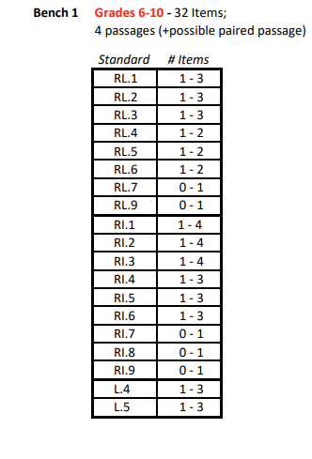

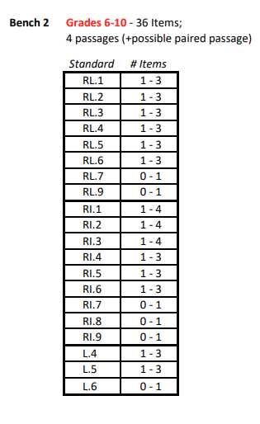

NOTE: WE USE THE ELA BLUEPRINT ESTABLISHED BY ELS FOR ENGLISH II.

THE HONORS CLASS USES THE SAME PACING GUIDE AS THE OTHER ENG II CLASSES. ENRICHMENT AND HIGHER DEPTH OF KNOWLEDGE, ASSIGNMENTS, ALTERNATE ASSIGNMENTS, RESEARCH PROJECTS, AND ADDITIONAL ACTIVITIES ARE ADDED TO MEET THE HONORS CRITERIA.

