**Mathieu Lesson Plan Jan. 6-10**

| **Subject** | **Learning Targets** | **Monday** | **Tuesday** | **Wednesday** | **Thursday** | **Friday** |
| --- | --- | --- | --- | --- | --- | --- |
| **Science** | **I can explore stem** |  | STEM bins | STEM bins | STEM bins | STEM bins |
| **Whole Group (Phonics and Reading)** | **I can isolate and identify beginning and ending consonant sounds. I can decide if two words rhyme. I can break compound words into parts and then create new compound words.**  **I can practice blending CVC, CVCC, and CCVCC words.** | **Today is a teacher's work day. Students will return on Tues., January 7th.** | Heggerty:  Week 17/Day 2  **Phonics skill:**  Soft c and g  Review: long vowel sounds | Heggerty:  Week 17/Day 3  **Phonics skill:**  soft c and g  Review long vowel words  Use illustrations and Details to Describe Key Ideas  Sort words into Categories | Heggerty:  Week 17/Day 4  **Phonics skill:**  Soft c and g  Review Long Vowel Sounds  Apply Phonics and Vocabulary in Context | Heggerty:  Week 17/Day 5  Review Long O and Long A sounds  Describe Connections Between information |
| **Grammar** | **I can practice grammar skills with my classmates** |  | Prepositions | Prepositions | sentence types | sentence types |
| **Interactive Read Aloud (shared reading)** | **I can identify the main idea of a story.** |  | Book: I Wonder | Book : Picture This | Book: Picture This | Reading: The Drinking Fountain |
| **Small Group** | **I can blend cvc letters to read words/ I can read high frequency words** | *Decodables with high frequency words*  *soft c and g*  *long vowel sounds* | | | | |
| **Writing** | **I can state facts about the topic.** |  | Review Week | Review week | Review Week | Review Week |
| **Vocabulary** | **I can recognize sight words in a text.**  **I can describe the meaning of vocabulary words.**  **I can write sentences using words from a word bank.** | **High Frequency: try , give, far , too**  **Books with soft c and soft g** | | | | |
| **Centers** | **I can complete seatwork and center tasks.** | Explore ELA centers | | | | |
| **RTI Tier II** | **I can practice letter naming fluency and letter sound fluency** |  | B.D., E.H.: letter recognition  Identify initial sounds:R.R., E.T. | B.D., E.H.: letter recognition  Identify initial sounds:R.R., E.T. | B.D., E.H.: letter recognition  Identify initial sounds:R.R., E.T. | B.D., E.H.: letter recognition  Identify initial sounds:R.R., E.T. |
| **Math whole group** | **I can add and subtract fluently. I can recognize numbers up to ten. I can read number words.** |  | Numerals to 100  Practicing adding and subtracting fluently.  **I do:**  **Part/Part**  **Whole**  **We Do: Practice skills together**  **You do: independent practice** | -Numerals to 100  Practicing adding and subtracting fluently.  **I do:**  **Part/Part**  **Whole**  **We Do: Practice skills together**  **You do: independent practice** | Numbers to 100  Practice adding and subtracting fluently.  **I do:**  **Part/Part**  **Whole**  **We Do: Practice skills together**  **You do: independent practice** | Numbers to 100  Practice adding and subtracting fluently.  **I do:**  **Part/Part**  **Whole**  **We Do: Practice skills together**  **You do: independent practice** |
| **small group math**  **Tier II Math** | **I can add and subtract.** |  | # Recognition: BD/EH  Subtraction Practice:  Exar/ Londyn  Chloe/ | # Recognition: BD/EH  Subtraction Practice:  Exar/ Londyn  Chloe/ | # Recognition: BD/EH  Subtraction Practice:  Exar/ Londyn  Chloe/ | # Recognition: BD/EH  Subtraction Practice:  Exar/ Londyn  Chloe/ |
| **Centers** | **I can complete my seatwork and center tasks.** |  | Math Center Tasks | Math center  tasks | Math Center Tasks | Math Center Tasks |
| **Social Science** | **I can set goals** |  | New Years/ Goal Setting | New Years/ Goal Setting | New Years/ Goal Setting | New Years/ Goal setting |

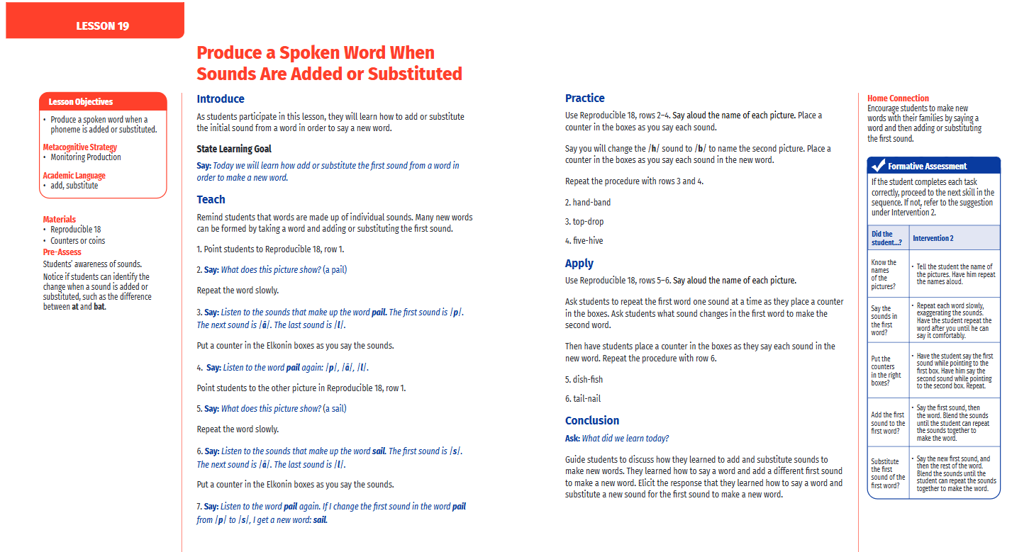

| **ELA CCRS:**  1. Engage in collaborative discussions about topics and texts with peers and adults in small and large groups, utilizing agreed-upon rules.  2. Actively participate in shared reading experiences and collaborative discussions to build background knowledge and learn how oral reading should sound.  5. Locate a book's title, table of contents, glossary, and the names of author(s) and illustrator(s).  6. Demonstrate basic to advanced phonological and phonemic awareness skills in spoken words.  7. Apply knowledge of phoneme-grapheme correspondences and word analysis skills to decode and encode words accurately both in isolation and within decodable, grade-  appropriate texts.  8. Apply previously-taught phoneme-grapheme correspondences to decodable words with accuracy and automaticity, in and out of context.  9. Read grade-appropriate texts with accuracy and fluency.  10. Read high-frequency words commonly found in grade-appropriate text.  11. Utilize new academic, content-specific, grade-level vocabulary, make connections to previously learned words, and relate new words to background knowledge.  12. Ask and answer questions about unfamiliar words and phrases in discussions and/or text |
| --- |

| **Math CCRS:**  **1.Use addition and subtraction to solve word problems within 20 by using concrete objects, drawings, and equations with a symbol for the unknown number to represent the problem.**  **3. Apply properties of operations as strategies to add and subtract.**  **5. Relate counting to addition and subtraction.**  **6. Add and subtract within 20.**  **6.a Demonstrate fluency with addition and subtraction facts with sums or differences to 10 by counting on.**  **6.b Demonstrate fluency with addition and subtraction facts with sums or differences to 10 by making ten.**  **6. c Demonstrate fluency with addition and subtraction facts with sums or differences to 10 by decomposing a number leading to a ten.**  **6.d Demonstrate fluency with addition and subtraction facts with sums or differences to 10 by using the relationship between addition and subtraction.**  **6.e Demonstrate fluency with addition and subtraction facts with sums or differences to 10 by creating equivalent but easier or known sums.**  **10.b Read numerals (within 50)**  **10.c Write numerals (within 50)**  **10.d Represent a number of objects (within 50) with a written numeral** |
| --- |

| **Social Science CCRS:**  **Science:**  Unit 1 benchmark : Science CCRS Standard: 1. MO.5: Design a solution to a human problem by using materials to imitate how plants and/or animals use their external parts to help them survive, grow, and meet their needs (e.g., outerwear imitating animal furs for insulation, gear mimicking tree bark or shells for protection).* |
| --- |