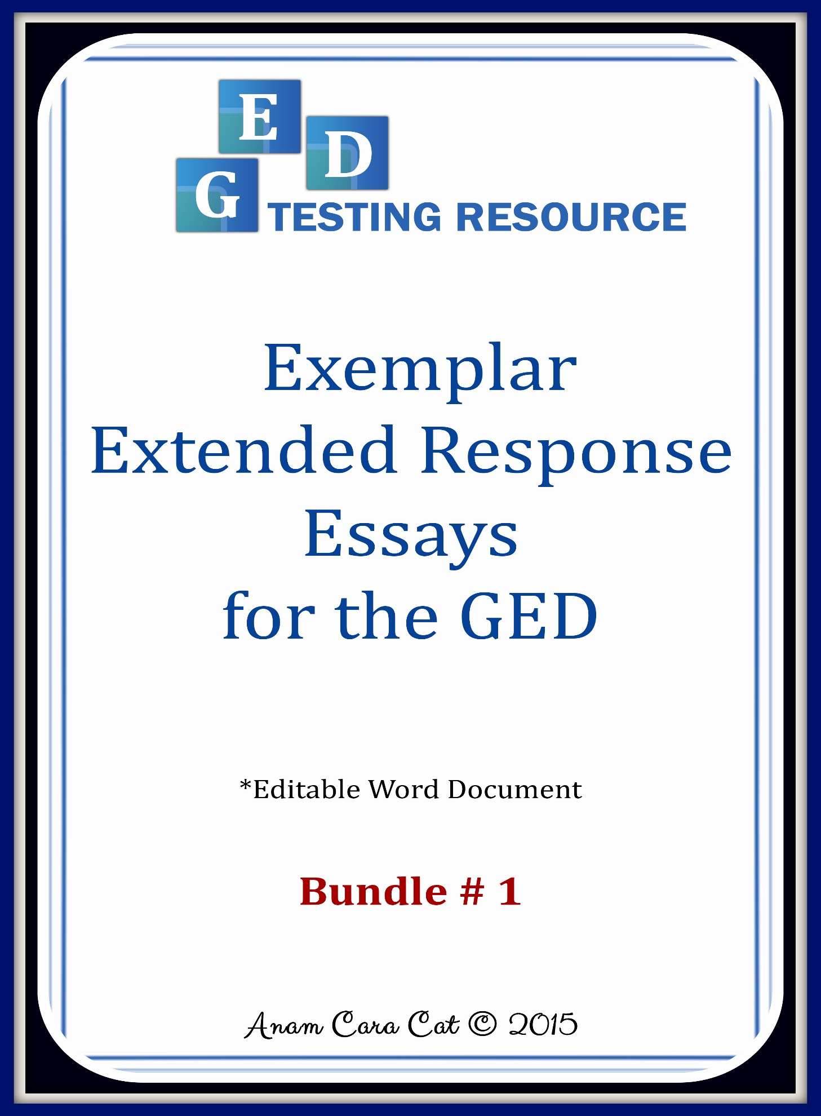

Note to Teachers…  
  
Below is the four step process I use with my students to support– and gradually pull support– for writing the extended response/argumentative essay for the GED. Obviously, some students will need more or less support, so some steps may need to be repeated more than once or omitted altogether at your discretion.   
  
The GED testing resources suggest students write between four and seven paragraphs in their extended response. I have found that students more easily organize, remember, and master a five paragraph essay. A strong five paragraph essay is always better than a weak seven paragraph essay; therefore, that is the structure I teach, and this has successfully prepared students to pass the LA test with high scores. Of course, this is an editable document, so you can always alter content or add to it as you choose.

The use of color coding to guide students with structure within their essays is highly recommended, as research shows it significantly aids with comprehension and retention.   
  
**Link to prompts:** <https://www.teacherspayteachers.com/Product/GED-Prompts-for-Extended-Response-Essays-2995681>

**Step 1.** I begin by giving students (1) the sample prompt, (2) the structure guide with sentence stems, and (3) the color-coded exemplar. I do not time the first essay. I have students refer to my exemplar as they type their first essay, and I have them highlight their paragraphs as shown in the exemplar, which will help them remember the structure. (If they have to hand write, they can use markers to highlight.) The five paragraphs are highlighted as follows:

1. Summarize the topic of the two arguments and state which argument is strongest (claim)
2. Note specific arguments from the speech to support your claim
3. Note more specific arguments from the speech to support your claim
4. Concession/*Rebuttal:* Acknowledge opposing arguments. *Then refute or invalidate them*
5. Restate your thesis (reiterate who has the strongest argument)

**Step 2.** With the second practice essay, I give students an exemplar, but I have them turn the exemplar face down and challenge them to only refer to it if absolutely needed. They still have the structure guide with sentence stems to refer to, and they are still instructed to color code each paragraph as they write. I challenge them to complete the essay within an hour. When they are finished, I have them compare their paragraphs with the exemplar paragraphs and reflect on what they could have done to make their essays stronger. Then, I edit grammar and mechanics within the essay and address weaknesses accordingly with mini-lessons.

**Step 3.** With the third practice essay, I pull the exemplar and only give students the structure guide. They’re still instructed to color code each paragraph. I challenge them to complete the essay in 45 minutes. Again, when they are finished, I give them the exemplar have them compare their paragraphs with the exemplar paragraphs and reflect on what they could have done to make their essays stronger. Then, I edit grammar and mechanics within the essay and address weaknesses accordingly with mini-lessons.

**Step 4.** With the fourth practice essay, no supports are given. Students have the prompt but no structure guides, and they are given 45 minutes to complete the essay. You can delete the mini-structure guides above the exemplar at this point as well if you wish. Students are still instructed to color code their paragraphs according to introduction, support, concession and rebuttal, and conclusion. Then, we compare and contrast their essays with the exemplar and end by editing grammar and mechanics.

**Structure Guide  
Suggested Argumentative Essay Structure**

**1. Introductory Paragraph:** Summarize the two arguments in a sentence or two. Then state your claim (State which text has the strongest argument)

**2. Supporting Paragraph:** Support your claim with specific evidence from the text. Then comment on the effectiveness of that information.

* “One of the strongest arguments in the text is…” (Refer to specific information in the text: examples, facts, statistics, studies, etc.)
* “This strongly supports the position because…” (How is this information important/relevant/convincing?)

**3. Supporting Paragraph:** Support your claim/argument/thesis with more specific evidence from article. Then comment on the effectiveness of that information.

* “Another powerful point addressed in the text is…” (Refer to specific information in the text: examples, facts, statistics, studies, etc.)
* “This further supports the claim by…”   
  (How is this information important/relevant/convincing?)

**4. Concession/*Rebuttal*:** Acknowledge the opposing argument’s main points. *Then rebut (refute/disprove/invalidate) them*

“The opposing text makes some valid points. For example,…” (Specifically mention strong opposing points in counter argument)

*“However, those arguments are weak because…”* (Rebut/disprove/invalidate the opposing claim and reemphasize your claim)

**5. Conclusion:** Creativelyrestate your claim and leave readers with strong final thoughts on your position.

1. Summarize the topic of the two arguments and state which argument is strongest (claim)

2. Note specific arguments & facts from the speech to support your claim

3. Note more specific arguments & facts from the speech to support your claim

4. Concession/*Rebuttal:* Acknowledge opposing arguments. *Then refute or invalidate them*

5. Restate your claim (reiterate who has the strongest argument)

**Are Tweens Ready for Cell Phones?   
Exemplar:**

The two speeches debate the appropriate age for children to own cell phones. While both speakers make valid points regarding safety, Deborah Pendergast’s speech, which is in favor of tweens having cell phones, presents the strongest argument.

To begin, Pendergast says that cell phones give parents and their kids a sense of empowerment and security. Cell phones connect children to their parents while simultaneously allowing them to feel independent and learn responsibility. The line of communication allows parents to keep in close contact with children, which, often times, can help ensure children’s safety. For example, if a parent is late picking up his child, he can make a phone call to ensure his child is not waiting anxiously and avoid potentially risky situations.

Furthermore, Pendergast reinforces her argument in favor of children having cell phones by referring to developmental research. She states that psychologists say between the ages of 10 and 12 is the ideal time to teach independence. Allowing children to have cell phones, she argues, is an opportunity to help children develop age appropriate responsibility.

Linda Sidner, who argues that cell phones makes children less safe, makes some valid points. For example, she states that parents might be become careless about knowing where their children are, simply because they have cell phones, so they may take the easy access for granted. She also states that cell phones give children access to dangerous sites on the internet, which parents may not monitor. Furthermore, she warns that allowing children to have cell phones puts them at risk for cyber-bullying. *While these arguments are valid, they are weak compared to the opposing view, which emphasizes the benefit of safety and age-appropriate personal growth. There may always be potential risk involved with cell phone use, but the sure benefits outweigh those risks.*

Sidner and Pendergast both present valid arguments, but Pendergast’s speech in favor of providing children with cell phones provides more reasonable arguments.

1. Summarize the topic of the two arguments and state which argument is strongest (claim)
2. Note specific arguments & facts from the text to support your claim
3. Note more specific arguments & facts from the text to support your claim
4. Concession/*Rebuttal:* Acknowledge opposing arguments. *Then refute or invalidate them*
5. Restate your claim (reiterate who has the strongest argument)

**Automatic Traffic Light Cameras  
Exemplar:**

The arguments presented in the speech and the letter to editor address whether or not investing in automatic traffic lights would be an effective use of resources for Baler. Although both sides make some strong points, the letter to editor presents the strongest claims stating that the cameras are too costly and money would be better spent hiring new police officers.

One of the strongest arguments in the letter is that the automatic lights will end up costing the town money instead of saving it money. The yearly cost of having 10 automatic traffic lights would cost around 600k, which is an enormous expense. Beyond that, there are “hidden costs” such as law suits that could cost the town even more money. Several cities have been sued because of illegally short yellow lights, and this is another significant drain because of the related legal fees and settlements.

Another powerful point made in the letter is that safety is not necessarily improved by having the automatic traffic lights. Although the National Highway Traffic Safety Administration reports reflect a decrease in front-into-side collisions, rear-end collisions actually increase because of the lights. So, in addition to costing more, the lights also cause additional collisions.

The opposing speech makes some valid points. For example, the speaker states that having automatic traffic lights frees up police officers to “focus on duties that require human attention.” *However, that argument is weak because instead of spending hundreds of thousands on automatic lights, the town could spend that money hiring more officers.* He also argues that money would be generated from traffic fines. *However, that point is weak as well because money gained from traffic fines don’t come close to recovering the cost of the lights themselves and the potential law suits that could ensue.*

Both sides of the debate present valid arguments, but the letter to editor provides stronger evidence supporting the need to hire more police officers instead of installing automatic traffic lights.

1. Summarize the topic of the two arguments and state which argument is strongest (claim)
2. Note specific arguments & facts from the text to support your claim
3. Note more specific arguments & facts from the text to support your claim
4. Concession/*Rebuttal:* Acknowledge opposing arguments. *Then refute or invalidate them*
5. Restate your claim (reiterate who has the strongest argument)

**Saving Our City One Plastic Bag at a Time  
Exemplar:**

The editorial and the letter to editor present opposing views on Proposition 328, which would make using reusable shopping bags mandatory in every store. While both positions are well-supported, the editorial in favor of requiring customers to bring their own reusable bags makes the strongest argument.

One of the strongest arguments in the article is that requiring customers to bring their own bags benefits the environment. Because plastic bags "litter the landscape and threaten wildlife," plastic is clearly not a good choice for consumers or for the landfills. Paper bags are not a wise alternative either because paper products also contribute to environmental destruction. Cutting down trees for paper is eliminating forests, and the process of manufacturing trees into paper bags creates more pollution. Bags made of man-made materials are the better option as they are inexpensive and readily available.

Another powerful point the editorial makes in favor of the proposition is that using reusable bags will save consumers money. Because they won’t have to pay penalty costs each time they use plastic or paper bags, over time, consumers will save a significant amount of money because they won't have to pay the additional fees for using them. The one-time fee for reusable bags is simply more cost-effective.

The opposing article makes some valid points as well. For example, the gift shop owner states that most shop owners cannot afford to provide reusable bags to every customer, so this would create a financial burden for small business owners. It could also threaten their sales because customers might choose to take their business elsewhere, where bags are conveniently provided in other towns. *However, these arguments are weak compared to environmental concerns. The long term effects on the environment are obviously more important than a minor inconvenience to tourists or minimal investments in reusable bags.*

Business owners have a responsibility to do their part in maintaining and conserving the world's resources. Reusing bags may not be convenient or fashionable, but, as the editorial emphasizes, there are too many solutions to the minor problems to reject Proposition 328.

1. Summarize the topic of the two arguments and state which argument is strongest (claim)
2. Note specific arguments & facts from the text to support your claim
3. Note more specific arguments & facts from the text to support your claim
4. Concession/*Rebuttal:* Acknowledge opposing arguments. *Then refute or invalidate them.*
5. Restate your claim (reiterate who has the strongest argument)

**Workplace Internet Use   
Exemplar:**

The email from the company CEO Justine Timmons proposes a new policy about installing an internet filter to limit “cyberslacking” and restrict employee use of personal internet. The email representing his employees urges management to reconsider the internet filters, claiming the policy would be counter-productive. While both arguments are valid, the employees’ argument is better supported.

One of the strongest arguments made by the employees against the installation of internet filters is that studies reveal internet breaks actually lead to more productivity. They reference a study from the National University of Singapore wherein studies found that web-surfing actually refreshed employees, which led to increased productivity. They also emphasize that statistics from the Salary.com study mentioned in the CEO’s letter only refer to one hour of net surfing. They argue that one hour of web-surfing is the equivalent to taking a break for water or chatting with fellow employees, which is reasonable.

Another strong claim made by the employees is that the internet is a tool for communication, much like the telephone. Employees argue that using the internet to communicate with others is the equivalent of making brief personal calls, which is permitted in the workplace.

Finally, the employees end by saying the CEO would best invest his time hiring responsible employees and showing them they are trusted by not treating them like children. Rather than breeding resentment amongst the staff, employees urge the CEO to reevaluate if internet surfing is really a problem at all.

On the other hand, the CEO makes some valid arguments as well. He states that it is in the interest of the company’s productivity to limit personal internet use. He argues that surveys reveal cyberslacking wastes company resources because employees are distracted by social media sites and don’t give their full attention to their jobs. He also states that installing filters will promote a more positive workplace and decrease the possibility of lawsuits because it will restrict employees from accessing inappropriate or offensive material that could contribute to a hostile workplace environment*. While his arguments are reasonable, they are based less on facts and more on fears. He mentions “potentially costly downsides” to unlimited internet access but bases this fear on information taken out of context from a single Salary.com survey. Furthermore, he presents employees with no evidence that web-surfing causes harm in their particular workplace, either through demonstrating a lack of productivity or by creating a hostile work environment after visiting inappropriate sites.*

Both the CEO and the employees have strong cases for and against the installation of internet filters. However, the employees’ position that the filters would be counterproductive, demoralizing, and would rob them of basic and courteous liberties in the workplace is better supported.

1. Summarize the topic of the two arguments and state which argument is strongest (claim)
2. Note specific arguments & facts from the text to support your claim
3. Note more specific arguments & facts from the text to support your claim
4. Concession/*Rebuttal:* Acknowledge opposing arguments. *Then refute or invalidate them.*
5. Restate your claim (reiterate who has the strongest argument)

**Diamond Mining: Harmful to the Environment  
Exemplar:**

The two articles are debating the extent to which the environment is damaged by diamond mining. While both articles make some strong points, the article claiming diamond mining is extremely harmful to the environment has the best supported argument.

One of the strongest arguments Tavin McLeavitt makes against diamond mining is that it affects millions around the world by destroying and wasting natural resources. To begin, the mining process pollutes and displaces large amounts of soil, which impacts shorelines and natural animal habitats. Excessive amounts of water are also used in diamond mining, which is especially harmful in places like Africa where water is scarce. Even in countries like Canada, the water usage for diamond mining is destructive to the environment because it disrupts the natural habitats of many species. In addition to affecting soil and water, diamond mining pollutes the air. Diesel fuels, electricity, and hydrocarbons release harmful carbons into the air, which causes short and long-term affects including smog and climate change.  
 Another powerful point McLeavitt makes is that the diamond mining industry has historically abused and exploited its workers. A few companies get rich while the rest of the world pays the price.

The opposing article written by Shaunna Rangel makes some valid points. For example, while she admits that diamond mining does disturb the environment, she states that “world governments are cooperating to ensure environmental safety and preservation around diamond mines.” She emphasizes that environmental management is monitoring the impacts of mining and making efforts to preserve wildlife, monitor harmful chemical, and reduce waste. *However, those arguments are weak because no matter how great the effort to improve or decrease the level of destruction done to the environment, diamond mining remains a significant threat to the land, water, air, and natural habitats. Rangel also does not address the human rights violations that are involved with mining. Governments may be trying to “reduce” the harmful impacts of mining, but, as McLeavitt claims, the long-term destruction is not worth the financial gains.*

While, many may consider diamonds to be “the world’s most precious and symbolic resource,” McLeavitt’s effectively argues that the planet’s natural resources are much more valuable.

Looking for detailed daily lesson plans for an argumentative essay unit? Check out my TWO WEEK unit—already aligned with ELA Common Core Standards for grades 8-12 here: <https://www.etsy.com/listing/560191703/law-of-attraction-the-secret-lesson-plan?ref=shop_home_active_18>

As middle and high school teachers we’ve all suffered through teaching the dreaded argumentative or persuasive essay. Well, those days are over, my friends…  
  
I started using the documentary style film The Secret, which is based on Rhonda Byrne’s book, more than ten years ago in the secondary classroom, and I’ve yet to find a more engaging topic for argument. I’ve used it with various grades and multiple demographics over the years, and every class has been completely captivated, enchanted from beginning to end.   
  
The basic premise of The Secret is that thoughts and feelings are energy and people “attract” situations, people, things, etc. based on the individual “frequency” they emit. If a person has a habit of thinking—and therefore feeling—negatively, this will be reflected in his or her life by attracting negativity. Likewise, if a person has a habit of thinking—and therefore feeling—positively, this too will be reflected in his or her life by attracting positivity.   
  
This concept is coined as “the law of attraction.” It’s an intriguing concept that is certainly worth exploring and debating, but most importantly for your students—it’s INTERESTING, which means they genuinely pay attention to the related lessons and exercise critical thinking skills.   
  
Whether students decide to argue for or against the LOA is irrelevant. What’s important is that they are exposed to a potentially life-changing way of thinking (positive thinking can never hurt), and they simultaneously learn how to structure an argument. It’s a win-win for everyone involved.   
  
After students watch the film, I have them research counter claims on the internet to read some opposing views. I simply instruct them to Google phrases like: the law of attraction hoax, or the law of attraction delusion. Then, once they have a balanced perspective, I ask them to reflect on their own lives and decide for themselves if they want to argue for or against the LOA based on their experiences, observations, and knowledge.   
  
The film is available on Net Flix. If you don’t have a Net Flix membership, you can sign up for a free monthly subscription and use it with your class within their 30 day trial period offer. Net Flix will send you a reminder to cancel before 30 days is up. Or, you can find the DVD on Amazon for around five bucks. I’ve ordered multiple copies over the years because I’ve lent it out or given it away so many times.   
  
The book by Rhonda Byrne is also available (you can usually find copies on Amazon for around four bucks), but the film is incredibly engaging, so I opt for the media version.   
  
IN THIS BUNDLE YOU'LL RECEIVE:  
  
~ 10 detailed daily lesson plans + CC Standards for grades 9-12  
~ Suggested film prompt: Documentary style film: The Secret (available on NetFlix)  
~ Film summary  
~ Film comprehension questions (27)  
~ Argumentative essay structure guide  
~ Exemplar argumentative essay  
~ Argumentative essay rubric   
  
  
***THESE RESOURCES ARE ALSO INCLUDED IN MY LIFE STRATEGIES FOR TEENS BUNDLE AND MY FIVE PEOPLE YOU MEET IN HEAVEN UNIT HERE: https://www.teacherspayteachers.com/Product/Life-Strategies-for-Teens-The-Five-People-Bundle-17-WEEKS-of-Lesson-Plans-3722862