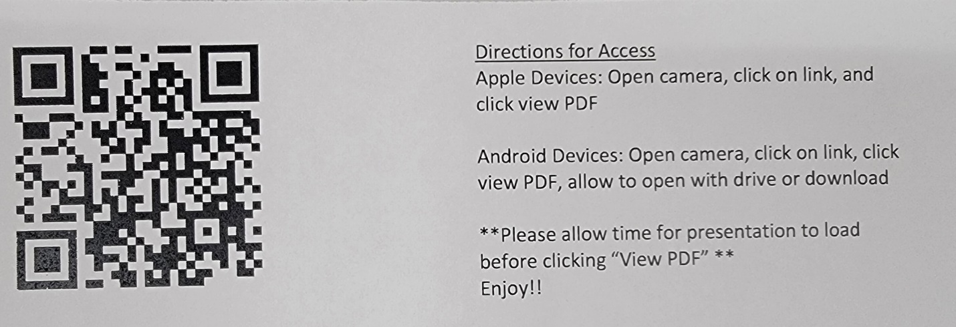
Golden Memories
Valedictorian speeches can be about almost anything—an old sports injury, how much work was put in to receive the title, hardships, but none of those are the actual reason we are here tonight. We are here to celebrate the amazing group of people on this stage. The class of 2023 is the class that held the first Homecoming Dance at Portage Area, held tailgates on the cold mornings before school started, and were serenaded by Mr. Johnson and his guitar. These are only some of the wonderful memories we have made. Tonight, I am going to tell you something special I will hold with me about everyone on this stage. Before I get started, I want to mention that there is a QR code included in the programs that you can scan to give you a glimpse of these memories and great people. First and foremost,
- Lauryn Bobolsky, or ming, the whole year in FCS, you insisted that we make buffalo chicken pasta. The day we finally made it, you weren’t there. The day we ate it, you weren’t there, even though it was your recipe.
- Zach Brown—You are the mullet king of the grade; I think we can all agree. Your chevy truck with the lift and LED lights just adds to the role
- Sydney Castel and Dalton Churilla—you two went all out at powderpuff. Sydney, you probably had double the steps than I did that night, and Dalton, you were our only cheerleader. Not only did you carry the role by yourself, but you went above and beyond by letting Andrew paint your body.
- Mike Coffee—Sorry! I mean Matt. For some reason, Ms. Kenny could never get your name right, and now I can’t either! Thank you for accepting it and signing it that way on the senior sign.
- Grace Corte-- I will never forget the time that we had to do some “repairs” on the school roof, when a janitor came to check the furnace and we thought we were going to get suspended for days
- Andrew Davis— Your arguments in the soup salad or sandwich debate in Ms. Fisher’s class were stellar. Also, props to you for being the first volunteer to try the food loaf when we visited the prison.
- Billy Dobrowolsky—I’m glad that you don’t remember the time in Mrs. Seder’s first grade class when I glued your seat in hopes that you stuck to it when you stood up. I don’t remember why I was so upset with you that day!
- Brandon Dugan—We absolutely killed the most likely to be famous superlative picture.
- Cole Ellis—I'm sorry in advance. I know you didn’t want me to tell this story. I don’t want to, but I have to. Ms. Ellis, if you have any questions, don’t take them to Cole, see me after graduation. Back to the story—We were at lunch sophomore year, and Billy was shooting spitballs. One spitball hit Cole, and he flipped the table and said “Hit me one more time!” And nothing happened. I will also never forget the time in 4th grade when you sneezed so hard that you hit your head off of the desk.
- Madison Foreman—for our senior superlatives, you won the quietest. I think we nailed that as a class.
- Nathan Fuenffinger— or foo-fin-finger- it was always so entertaining to hear substitutes, and even some full-time teachers, butcher the pronunciation of your last name.
- Ethan Geer—You just always know the most random facts. I still question how you knew that there was a court case on if pizza was a salad or sandwich.
- Trenton Gentile—when the volume wasn’t working on Ms. Fisher’s board, we didn’t have to worry because you narrated the video for us. The whole video. I have to thank you for helping me out with fragments and run-ons that day.
- Jacob Graessle—Hands down best dance moves at prom.
- Madison Gribbin—one of my favorite memories from last summer was when we were on the black widow at Kennywood. We were screaming to be stupid, but at the end of the ride, we looked over at Grace and she was legitimately crying.
- Demi Harshberger-- I always got a kick out of you arguing with Ms. Chobany and Luke during fourth period
- Jillian Hodge—even though you are going to school for physical therapy, I know I will see you on the news as a broadcaster someday. Your voice is just so perfect for it. Not to mention that you qualified for NATIONALS in forensics!!!
- Maddy Hudak—We have been great business partners since fifth grade with our dog walking business. You were always willing to help out with anything. We took on so many projects and accomplished so many great things together.
- Curtis James—I’m glad that you came into Mr. Johnson’s class not so long ago and expressed your concerns about the AI on snapchat. You’re right, it is sketchy.
- Isaac Jubina—you were the lucky winner of the $20 sheetz gift card at the homecoming dance. I never experienced a crowd so excited.
- Mason Kargo—At the farm show, we were all walking around trying to avoid stepping in any animal feces. When we got into the food area, you dropped a pierogi onto the gross floor and ate it because, “Five Second Rule”
- Cole Kaufman—We admire you for so many reasons. I have always been in awe of how easy you make drawing look. You are such a talented artist.
- Tayla Kennedy—thank you for giving me the best hugs in the hallways when you thought that I needed it
- Ty Kennedy—Nothing gets the dance crowd more excited than when freaks comes on and you lead the jumping
- George Kissell—on picture day, you and others wore fake mustaches. When Mr. Burkett came up and asked you to take it off, you said that you were going to need a razor.
- Abby and Bella Koban—I’m not sure if anyone in the audience remembers collecting Box Tops, but I used to rue the day that you two would bring them in. The people in your homeroom were the luckiest because you two would lead them for the win
- Logan Krestar—we didn’t get much time with you here, but you immediately fit in. You were a great addition to our class
- Nathan Krisko—I was extremely impressed with your hair when Ming and Grace could French braid it in public speaking. It was shocking when you cut it off.
- Maurah Krumenacker—thank you for not freaking out during the band prank. That is all that needs to be said on that subject.
- I need to give you a little background information for the next one. It was a warmer day in Mr. Johnson’s class, and the fan was on. While we were all fully engaged in Mr. Johnson’s lesson, of course, we heard a noise. Then, we heard it again. No one wanted to say it, but it was a farting noise. It got to the point that Mr. Johnson said to excuse yourself if it was you. With the noise continuing, the whole class was laughing and wondering who it was. Finally, Taylor Learn looked down and noticed that it was her poster board getting moved by the fan. Taylor—thank you for that hilarious moment
- Madison Litzinger-- I was so confused when I saw you pulling out your Nintendo switch one random day at lunch. It turned out that it was for your superlative picture
- Jakob Lundberg—You could finish your physics worksheets in five minutes or less. I still want to know how you did that
- Jeremy Madigan—I always laugh when I think about the time that we were playing volleyball and you served the ball off of the back of Cole Ellis’s head. I never heard Luke laugh so hard
- Lily Mathieson—There was a full on crisis on the spelling of your last name when we were sending you cards last year!
- Andrew Miko—I'm sure that you still have people believing that they got a picture with Jess Lockwood, the famous bull rider, at the PA Farm Show. Those poor kids
- Mason Milburn—I still can’t believe that you melted chocolate in the microwave for 8 minutes in FCS
- Collin Miller-- I always found it funny when you would text me asking for dates of things that we said in the 2023 group chat. I don’t remember why you left it, but my prediction is that it was during the Lily Mathieson name spelling crisis.
- Braedan Oravecz—you scarred me for life after you answered Mr. Duffy’s phone in 4th grade and got demerits. I never wanted to touch a school phone again
- Makenna Redfern—my favorite PSSA memory was when I made homemade stress balls out of flour and yours popped on you. I am still so sorry for that! But it was hilarious
- Brianna Remick—thank you for all of the times that you talked to me when I worked front desk at the pool. It made time go much faster
- William Rocker—thank you for sending Toby memes in the 2023 group chat
- Luke Scarton-- I think everyone remembers the time in Mrs. Gdula’s FCS class in 8th grade when you were dangerously rocking on one of her stools. Not long after, you fell flat on the floor.
- Jonas Sciko—you are probably the best at parking your car at school; I loved the awkward eye contact when I pulled in
- Ryan Semanchik—thank you for dealing with my mess of a locker in 7th to 9th grade. I am so sorry that you are next to me in the alphabet. One good thing that came out of the pandemic is having all the lockers apart
- Lexi Slanoc— I will never forget the time that we got our hands on our own trumpets. It was 8th grade and we didn’t know the meaning behind taps, so we decided to play it to each other from our front porches. I am so sorry to anyone in the neighborhood that heard that
- Keira Sossong— One random night in the fall many years ago, you and I had the genius idea to go ding dong ditch Lexi’s house. So, we did. The second we rang that doorbell, though, we saw the firetruck coming up the road with a spotlight. I hid behind the bush in their front yard and you booked it into the woods. We thought that they were searching for us, but it turned out that they were going around for donations. I am pretty sure that night was the end of my ding dong ditching career.
- Toby Thomas—Every single Friday, you would wear your “Yall Crazy” shirt to school. It took me so long to catch on, but I appreciate that tradition.
- Keaton Troxell—You probably did the bravest thing done at this school ever- you had Ms. Kenny take your BeReal.
- Ari Wozniak—I wish I could show everyone the millions of clips I have of you screaming your head off during Thriller. I also wish that I could have captured the face you would give Coach Vasilko when you would shank the golf ball
- Makenna Young-- I WISH I could sing like you.
- Last but not least, Adanya Zunich. You are the only girl in our grade that can kick a ball. You were a true asset to the soccer team and most definitely our powderpuff team.
On behalf of the class of 2023, I would like to thank the wonderful staff and administration at this school for educating us and helping us decide our futures, and our families for their constant love and support. To my classmates, thank you for making my last 12 years here so memorable and enjoyable. I wish you all the very best in your futures. Thank you!

