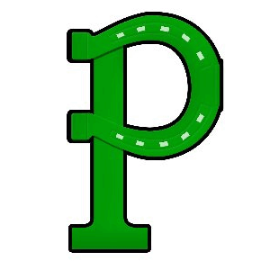
Harms of Copyright Piracy

Title I, Part A, Section 1116 of the Every Student Succeeds Act (ESSA) states that Title I schools shall provide information and resources to help parents and families work with their children to understand the harms of copyright piracy. In keeping with this requirement, definitions of relevant terms as well as links to websites that may be helpful in educating children concerning copyright piracy regulations are included below.

What is Copyright?
Copyright is a set of rights that protects all kinds of creative work so that artist/creators can get paid for their effort. This includes original wring (stories), art, photographs, audio, images, music, song lyrics, even the doodle you drew on your napkin at lunch! It doesn't matter if it was created by a famous artist or you.
When you create an original work, you get to decide who can:

● make copies
● distribute copies
● display or perform the work in public
● make spin-offs (for example, like a book being made into a movie).

These rights are given to artists and creators to encourage them to make even more creative work. The Supreme Court has called copyright "an engine of free expression,” because it provides incentive for authors and creators to devote me and money to producing new works. In this way, copyright encourages speech and creativity.
Definition taken from https://www.copyrightandcreativity.org/

What is Fair Use?

Fair use is an important part of copyright that lets us copy or re-use copyrighted work without permission in certain ways that are still fair to the artist/creator, f or example: for teaching or school projects, for giving commentary or criticism, or for making something completely new—transformative—using elements of the original work (like a photo in a collage or a parody).
Definition taken from https://www.copyrightandcreativity.org/

For additional information about the Harms of Copyright Piracy, please view the following websites:
https://www.copyrightandcreativity.org/elementary-school/
http://www.copyrightkids.org/

