Basketball tryouts will begin April 2nd and run through April 19th. Students will be allowed to try out during their activity/athletic period. A first cut posted on Friday, April 5th. If your name is on the list, you will continue to tryout during your activity/athletic period April 9th-12th. A second cut will be made Friday, April 12th. If your name is on the second cut list, then you will again tryout during your activity/athletic period April 16th-19th. If needed, an after-school tryout date will be announced after the second cut.
During the spring tryouts, a total of ten kids per grade will be kept on the summer roster. There will be another tryout once we return to school after summer break. However, that tryout will only be for new students and players that are invited back from the 2024 spring tryouts.
All athletes need to come to tryouts dress appropriately: tennis/basketball shoes, shorts, and t shirt. No boots, slides, or crocs will be allowed to be worn. If you forget your proper gear, you will have to miss that day of tryouts.
The 2024/25 Desoto Central Middle Basketball team will be posted in the commons, on the DCMS Facebook page, and the Desoto Central Middle Boys Basketball twitter page.

Desoto Central Middle Athletics @BoysDCMS

All Athletes must complete the online form PRIOR to tryouts to be eligible participate in tryouts. Forms need to be completed by 5 PM on April 1st. If you have any questions, please see Coach Berryhill in the gym or email questions to ben.berryhill@dcsms.org.
Below is a list of everything that is required to tryout and will need to be submitted through the Google Form. Scan the QR code below to complete the form.
- Player questionnaire
- Current Physical
- Current Grades/Report Card (need ALL grades for the current year)
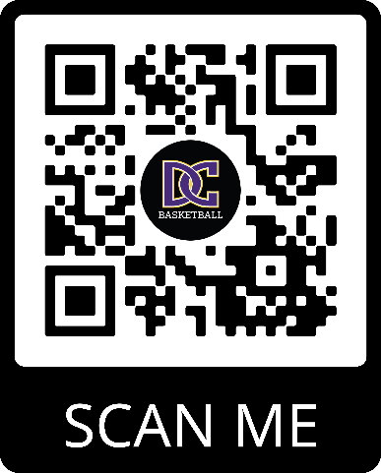

Desoto Central Middle School * 2611 Central Parkway Southaven, MS 38672 * 662-349-6660
*2020,2021,2023,2024 Desoto County Champions
*2024 MHSAA Middle School State Champions

