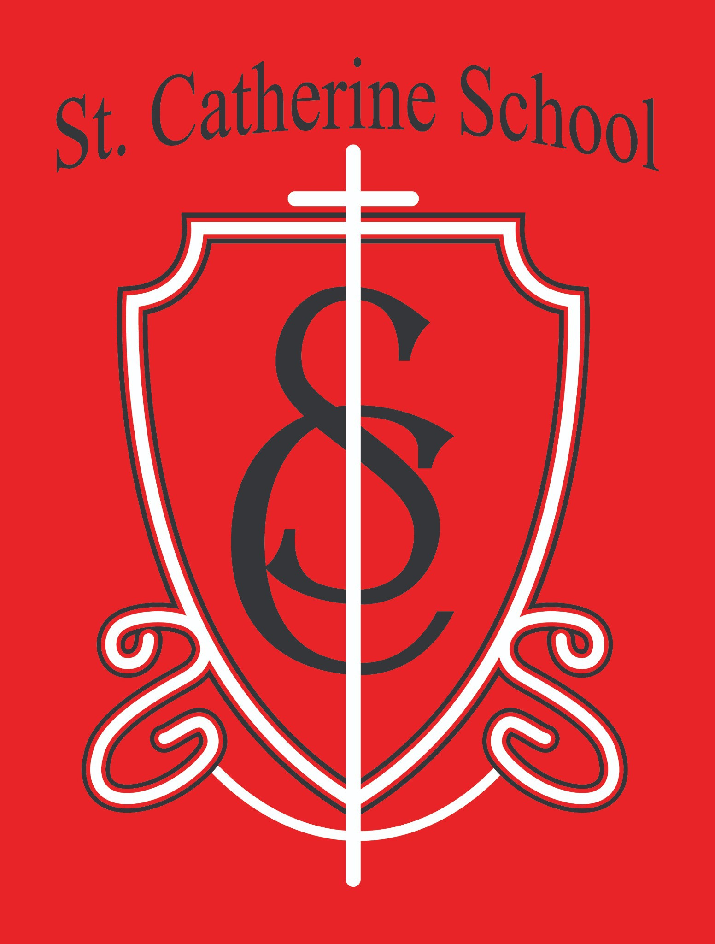

St. Catherine School Weekly Newsletter
https://www.stcatherine.k12.nd.us/parents

Principal's Message
Dear St. Catherine Families,
As we move through the Easter season, we are filled with gratitude for the continued growth of our Little Saints Childcare Center. We are transitioning from a group license to a center license, which will allow us to increase our licensed capacity and continue serving more families in our community.
We have been blessed with strong enrollment interest across all our classrooms. Recently, we have had the opportunity to give tours to expecting mothers and new families, and one of the most common themes we hear is the sense of peace within our facility. Families consistently share how much they appreciate the warmth of our environment, the care shown by our staff, and the welcoming nature of our classrooms.
This growth and positive momentum would not be possible without the strong leadership of our director, Ms. Beth, and the dedication of our lead teachers. We are incredibly thankful for their commitment to creating a nurturing, faith-filled environment for our youngest learners.

Reminders

Spring Weather:
The forecast is beginning to look more spring-like, but temperatures can still vary. Please continue sending:

Coat, hat, and gloves daily
Snow pants and boots are now optional
We will continue to go outside for recess each day unless it is actively raining.

Upcoming Dates:
May 7: All School Mass (May Crowning)
May 7 (Thursday): Spring Program – 6:30 PM (Gym) May 8: States & Countries Presentation – 1:30 PM (Gym) May 20: 6th Grade Graduation
May 22: Last Day of School

Summer Childcare Enrollment:
We are still accepting enrollments for our school-age summer camp at Little Saints Childcare.
For more information or to schedule a tour, please contact Ms. Beth at
beth.nadelin@k12.nd.us or visit:
https://www.stcatherine.k12.nd.us/littlesaintschildcare

Summer Projects & Volunteer Opportunities:
We are planning several improvement projects this summer, including:
If you are interested in helping with any of these projects, please reach out—we would greatly appreciate your support!
Painting the cafeteria
Work on the gym entrance overhang Painting exterior doors
Interior painting in several areas Landscaping projects
Removal of the old wood fence near the fuel tank Installation of new playground fencing

St. Catherine Spotlight

All School Mass with the Bishop:
What a beautiful and reverent celebration! The music, student readers, and servers all did an outstanding job. It was a truly fitting liturgy for this season and a great reflection of our Catholic identity in action.

Growth in Our School & Childcare:
One of the greatest joys this time of year is seeing the results of the hard work put in throughout the year. The many hours, projects, and efforts by our staff are clearly visible as new families walk through our doors and express a desire to be part of St. Catherine School and Little Saints Childcare. That is something truly special.

Stay Connected with St. Catherine School
📍 Address: 540 3rd Ave. NE, Valley City, ND 58072
Email: nicholas.lee1@k12.nd.us
📧
Phone: 1-701-845-1453
📞
Website: www.stcatherine.k12.nd.us

🌐
📘 Follow Us on Facebook: St. Catherine School on Facebook

“Inspiring excellence through faith, learning, and service.”

