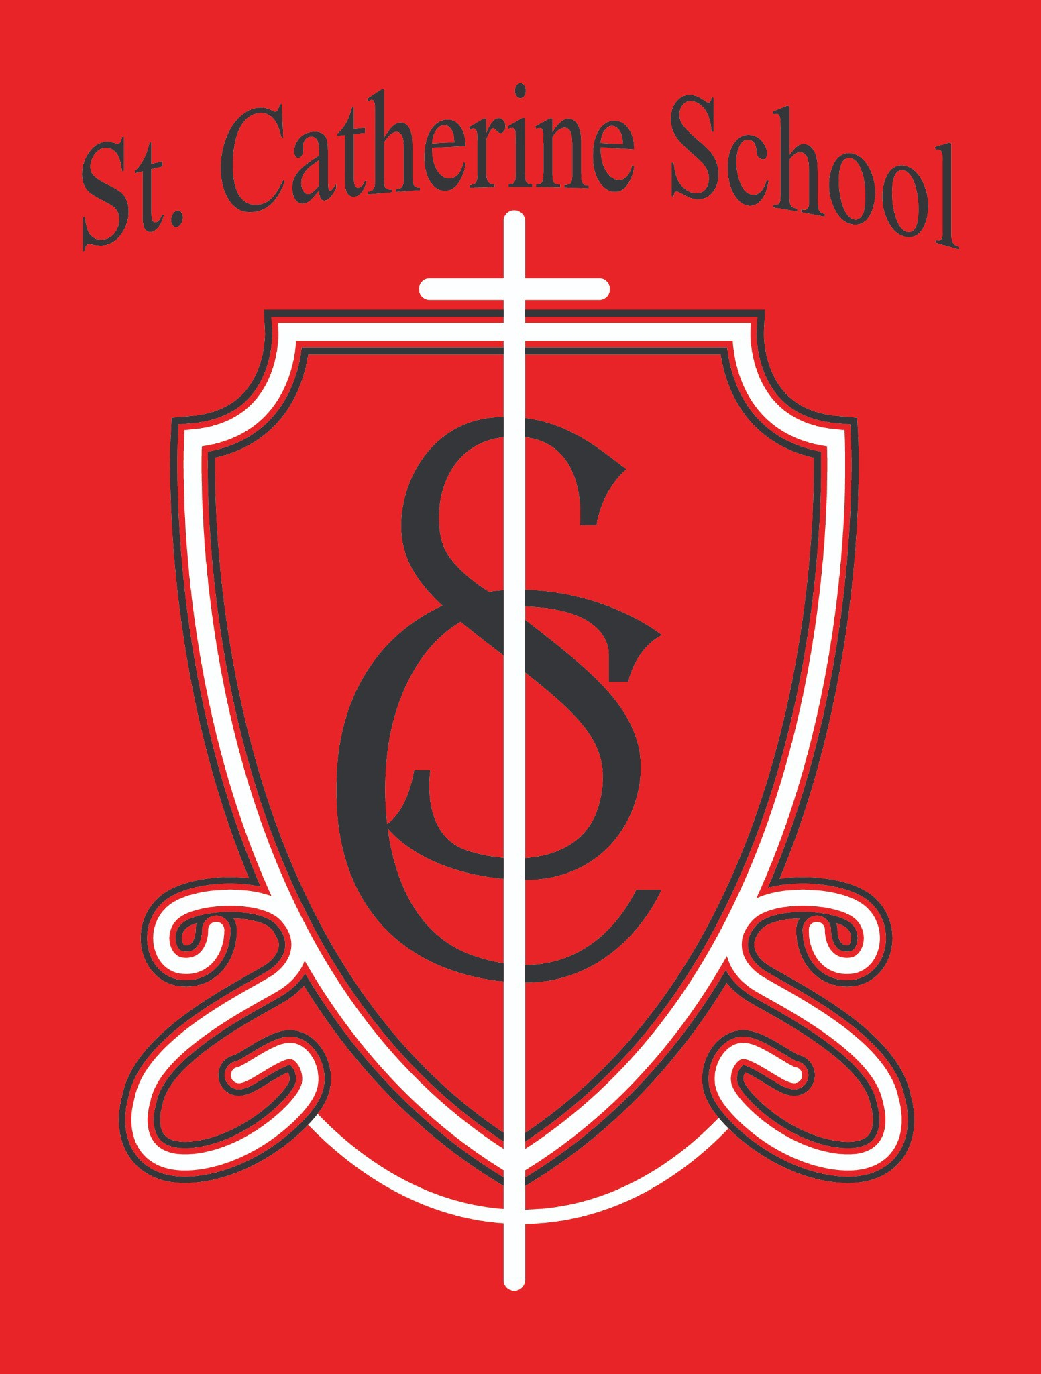

St. Catherine School Weekly Newsletter (Week of March 2- 6th)
https://www.stcatherine.k12.nd.us/parents

Principal's Message
Dear St. Catherine Families,
Principal Reflection
As we move through this time of year, I am nearing the completion of a two-year journey in my own education. I am finishing my Master’s Degree in Educational Leadership through the University of Mary as part of the Rural School Leadership Institute.
Two years ago, starting another graduate program seemed like a great idea. There were a few moments along the way—especially this past fall—when I questioned that decision a little!
Balancing coursework, school leadership, and family life certainly created a few long evenings and a lack of “R and R” on the weekends.
That said, continuing to grow professionally is important to me. If we ask our students to work hard and grow in their learning, it is important that we as educators continue learning as well. My hope is that the knowledge and experiences gained through this program will help me better serve our students, staff, and families.
For those who may not know, I previously completed a Master of Arts in Teaching and a Bachelor of Science in Health Sciences and Biology, both from Valley City State University. And for those wondering—no, I do not plan on pursuing a doctorate anytime soon.

Reminders

No School

There is no school today, Friday, March 6, and Monday, March 9. We look forward to seeing everyone back in the building on Tuesday.

Food Service – Maternity Leave

Looking ahead in March, Mrs. Kennedy will be going on maternity leave. Once she begins her leave, please direct any food service-related questions to the school office rather than contacting her directly.

Winter Gear

All winter gear was sent home recently and it likely needs a good wash. With the weather warming up, things are getting very muddy outside, and there is nothing quite like mud that attracts kids to play in it. If you still have waterproof or water-resistant winter gear, especially gloves, those can be very helpful this time of year.
Music Reminder – 3rd & 4th Grade

Ms. Busch asked me to remind parents of 3rd and 4th-graders to encourage students to practice their instruments at home. Instruments are a great way to learn musical notes and help students understand different instrument families and how they work.
Kids Heart Challenge

Information about the Kids Heart Challenge recently came home. Donations can be submitted now through March 20.
If you have any questions, please contact Ms. Busch at alexis.a.busch@k12.nd.us. Summer Projects at the School

As we begin planning for summer, we hope to complete several exterior improvement projects, including painting in the cafeteria and some fencing work. If you feel called to help with any projects around the school in preparation for next year, please let me know. Volunteer help is always greatly appreciated.

St. Catherine Spotlight
We had a great All School Mass on Thursday, and the 3rd graders did a beautiful job with the music. It is always a blessing to see our students take leadership roles during Mass and help guide our school community in prayer.
We are also excited to begin Science Olympiad activities. A big thank you to Mrs. Gulmon, Ms. Hilgemann, and Mrs. Ihry for helping organize and support this

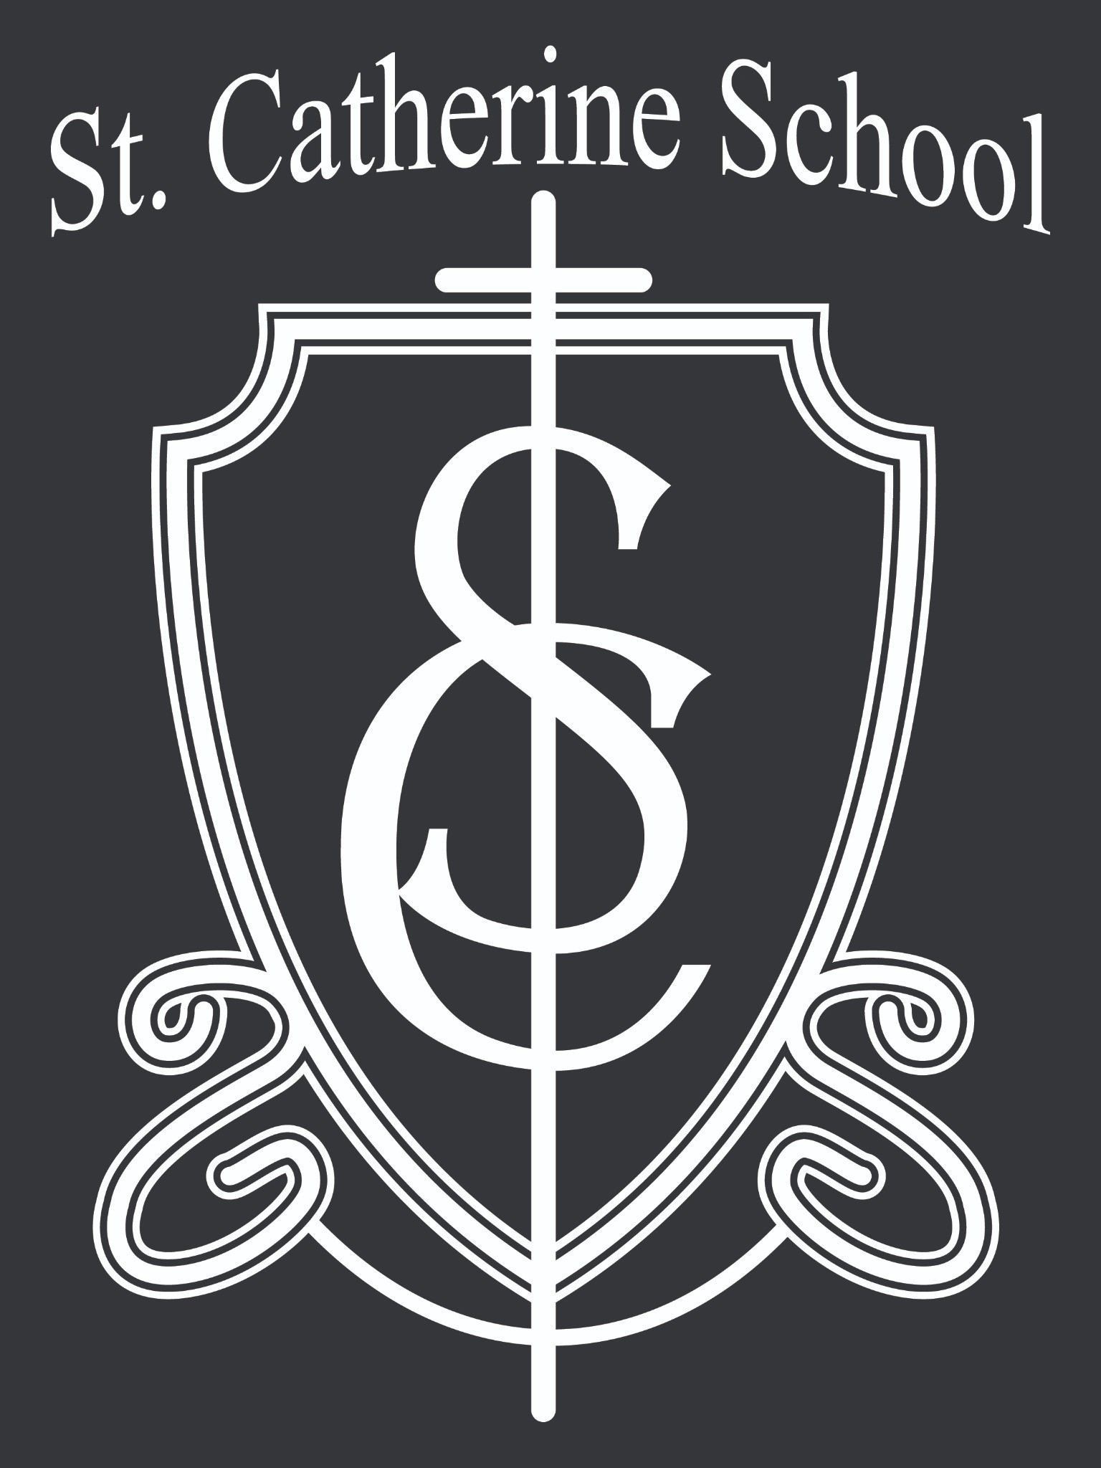
opportunity for our students.
Stay Connected with St. Catherine School
📍 Address: 540 3rd Ave. NE, Valley City, ND 58072
Email: nicholas.lee1@k12.nd.us
📧
Phone: 1-701-845-1453
📞
Website: www.stcatherine.k12.nd.us
🌐
📘 Follow Us on Facebook: St. Catherine School on Facebook

“Inspiring excellence through faith, learning, and service.”

