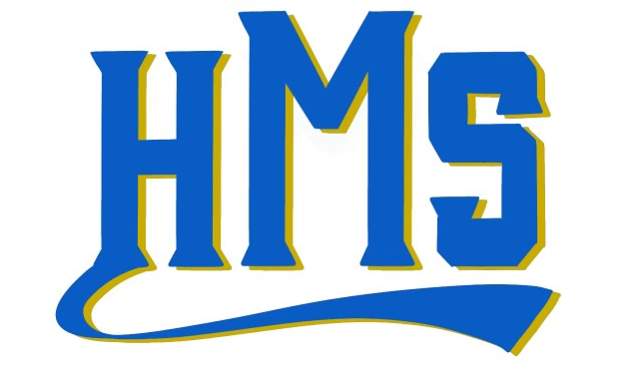
January Newsletter 2022
199 Browning Avenue
Huntingdon, TN 38344
PH: 731-986-4544 FX: 731-986-8689
hms.huntingdonschools.net

Greetings from Huntingdon Middle School! In an effort to increase communication, there will be a newsletter sent home each month with important dates and information about the happenings at HMS. This is not an exhaustive list, so please continue to check grade-level Remind messages for more up-to-date information.
- January 12th: Report cards sent home. Please sign and return.
- January 17th: Dr. Martin Luther King, Jr. Day…No school
- January 20th: Fall Sports Banquet: Information will be provided by your child’s coach regarding time and location.
- January 22nd: HMS Mustangs and Fillies play in the Blue Suede Tournament.
- January 27th: 6th grade field trip to The Dixie Carter PAC for Rosa Parks and Friends. Look for permission slips as we approach this date.
Dr. Martin Luther King, Jr. once said, “Intelligence plus character…that is the goal of true education.” This past semester students, teachers, and staff spent time examining the culture of our school. All students and staff provided input regarding character traits that we would like to focus on, and using this information, we revised our school mission and vision statements. The chosen traits were as follows: compassion, respect, integrity, service, and self-discipline. While we want to be more intentional about recognizing and modeling all of these traits, for the month of January, our school will focus specifically on compassion. We would love for you to join us in encouraging your child to show compassion for others: recognizing the struggle of another person and being willing to help.
We would also like to share our new mission and vision statements:
- Huntingdon Middle School’s mission is to provide a student-centered, caring environment where a high-quality education allows students to become life-long learners and people of good character.
- We envision Huntingdon Middle School as a place where all students desire to learn and grow both academically and as a civic-minded individual. Teachers, students, parents, and community members take part in challenging every student to meet high expectations in an open, caring environment that promotes compassion, respect, integrity, service, and self-discipline.
We would appreciate your participation as we strive to meet the standards of our mission and vision at HMS. #sameteam

