
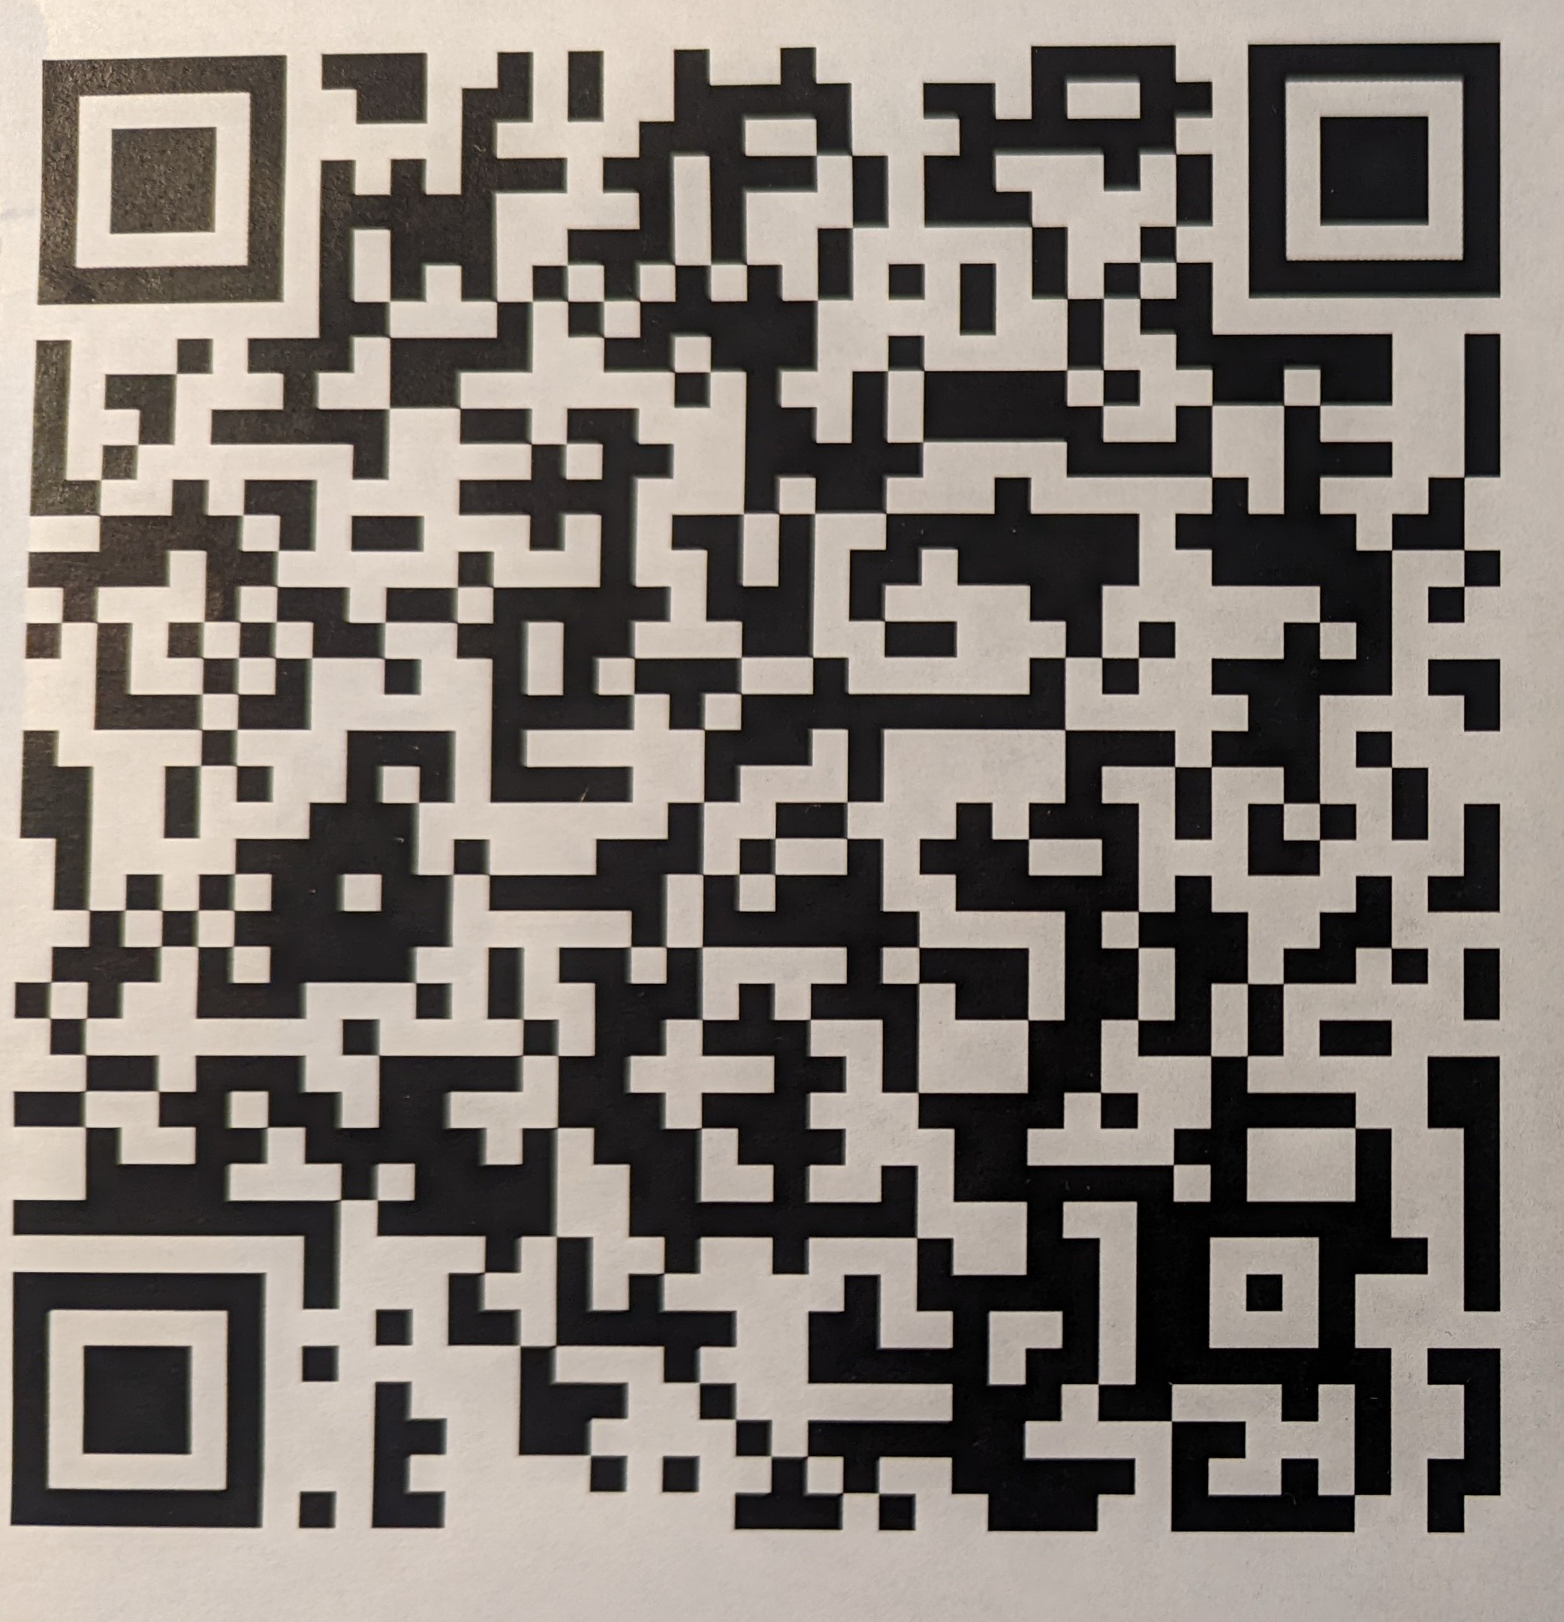
Art Club Application
- Scan the QR Code
- Fill out all information online.
- Download a picture of a piece of artwork you have previously completed.

