SPOTLIGHT Newsletter
August 2023

Welcome to the 23-24 school year. We have lots of learning opportunities planned for gifted students this year. Throughout the year we will complete activities/projects that correspond with our six outcomes.
Major Units of Study:
This fall, we will complete a unit on LEGO. In this unit we will learn about the founder and history of the LEGO company. Students will learn the hiring process for LEGO and create their own LEGO kit. Students will research ideas and work in small groups.
In the spring, students will complete a unit on Space Tourism. In this unit, students will research the future of space tourism, create a space travel company, and keep up to date with current NASA endeavors.
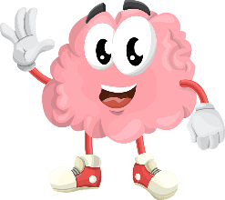
Thinking Skills:
PETS Characters – Max the Magician, Sybil the Scientist, Yolanda the Yarnspinner, Isabel the Inventor, Dudley the Detective, Jordan the Judge. Students will learn various thinking styles by learning about the six main characters of Crystal Pond Woods. Students will create a tool box of memory triggers to remind them of the various ways we can think.

Affective Skills:
Students will work on demonstrate responsibility for their personal growth through the year by listening to Big Life Kids, challenging themselves to try new things, and learning how to manage emotions.
This Photo by Unknown Author is licensed under CC BY-NC
Communication:
Students will work on writing, speaking and listening to communicate ideas, feelings, and information; as well as interpret that of others.
Information Literacy:
Students will conduct research to develop solutions to problems and share their findings with an audience.
Success Skills:
Students will participate in group activities to utilize organization skills, time management, and goal setting. In addition, students will explore occupational areas of interest.
Creativity:
Students will focus on fluency, flexibility, originality, and elaboration to better discover solutions to problems.

