PHONICS/READING | GRAMMAR &  WRITING | MATH | SCIENCE/SOCIAL STUDIES
- Vowel Patterns: o, or, ow  - Draw Conclusions, Visualize | - Verbs with Singular & Plural Nouns  - Practice Cursive Handwriting | - Subtract Within 100 Using Strategies  - Practice Addition & Subtraction Facts for Weekly Quiz | - American Symbols  - Matter: Solids, Liquids, & Gases
Mrs. Sharpe’s Class •Keisha.Sharpe@acboe.net
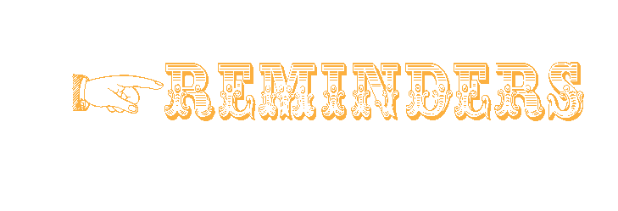

- 11.17: Reading & Grammar Tests
- 11.18: Spelling & Vocabulary Tests
- 11.19: Santa Pics/Spirit Day/Buy Special Snack
- 11.22-26: Thanksgiving Break
- 12.13: Dress Like a Candy Cane

- 11.12: E-Learning Day

Ladies & Gentlemen!

If your child is a car rider in the mornings, be sure to get him/her to school before 7:45 to ensure he/she has time to eat breakfast before 8:00. Please send a bottle of water to school with your child daily. Also, allow your child to read for at least 20 minutes each night. Homework is due on Fridays.
Our school website is: pinelevelelem.com

Dear Juno
High Frequency Vocabulary Words
answer company faraway parents
picture school wash

goat ago
most toad
toast show
told float
hold open
bowl slow

BONUS WORDS Small treat given for correctly spelled bonus words.
elbow throat cocoa

No bonus words this week.
Dear Juno
Spelling Words
Look at what we are learning!

Every Journey Has a Great Story!

November 15, 2021

