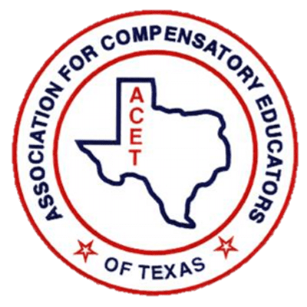

**Instructions for Regional Directors**

Thank you for supporting the ACET scholarship programs. Please see the detailed instructions below in order to assist students and paraprofessionals in completing the appropriate application.

* To locate the scholarships, use the link: [Giving Back & Scholarships – Association For Compensatory Educators of Texas](https://acetx.org/giving-back-scholarships/)
* Select student or Para on the right side. A screenshot of a web page

  Description automatically generated
* Scroll down this page to see:
  + region
  + the rubric
  + Then all the way at the bottom to see the **Apply Now** button (orange font)
* Students should be aware that toward the end of the application they will need a Counselor’s signature, so they will need to do the following:
  + Click Save and Resume

* + Copy the link shown AND check their email to ensure they have received the link

* + Send the link to their counselor
* The Counselor will need to
  + Review the application
  + Select the correct region
  + Click submit on behalf of the student

(See example of Counselor Certification section below)

* Once the counselor has submitted the application for the student, the student will receive a copy of their responses and so will the appropriate regional director.

