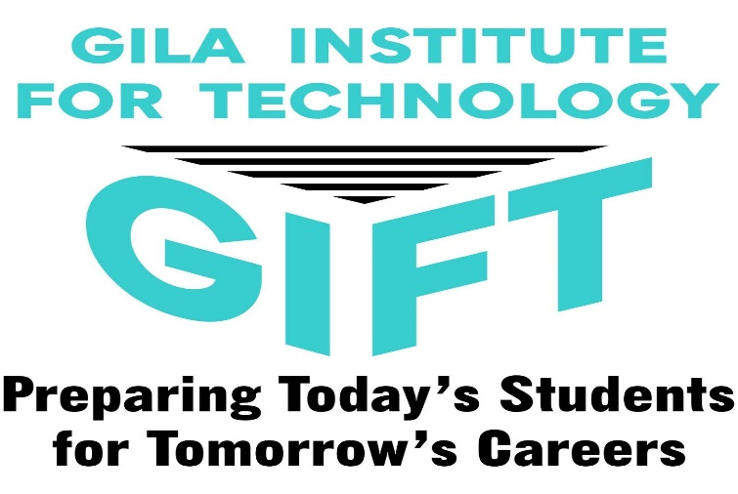

Gila Institute for Technology
GIFT now registering for 2022-2023
“Meet the Instructor Night"
at EAC Gherald L. Hoopes Activities Center
Tuesday, February 22, 2022, 6-7:30pm
(Come & Go)

