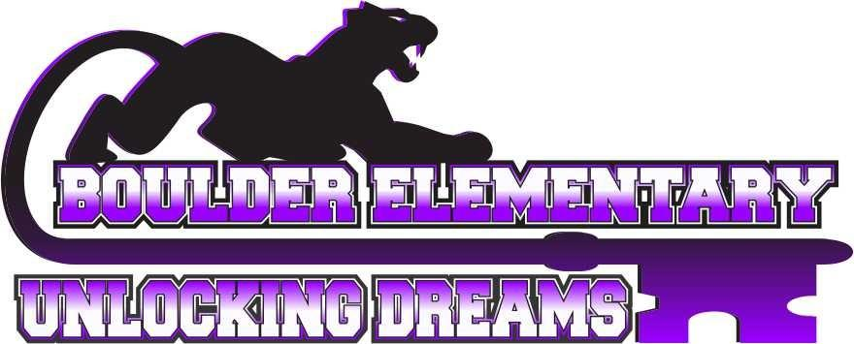

Boulder Elementary School

Kindergarten Supply List for 2025-2026

* **1** 2-pocket folder
* **2** pack of dry erase markers (fine tip works best)
* **1**  8-pack of washable markers
* **1** pack of watercolor paints (8 colors)
* **3** boxes of crayons (24 count)
* **1** pair of youth scissors
* **1** backpack
* **2** bottles of Elmer’s glue (please no glue sticks)
* **3** packages of Graham crackers
* clorox wipes
* 3 boxes of tissue
* 1 bottle of hand sanitizer (the pump kind works best)
* Headphones with a 3.5mm (aux) port (no earbuds please)

Our classroom uses community supplies, so please do not label your child’s supplies before you bring them.