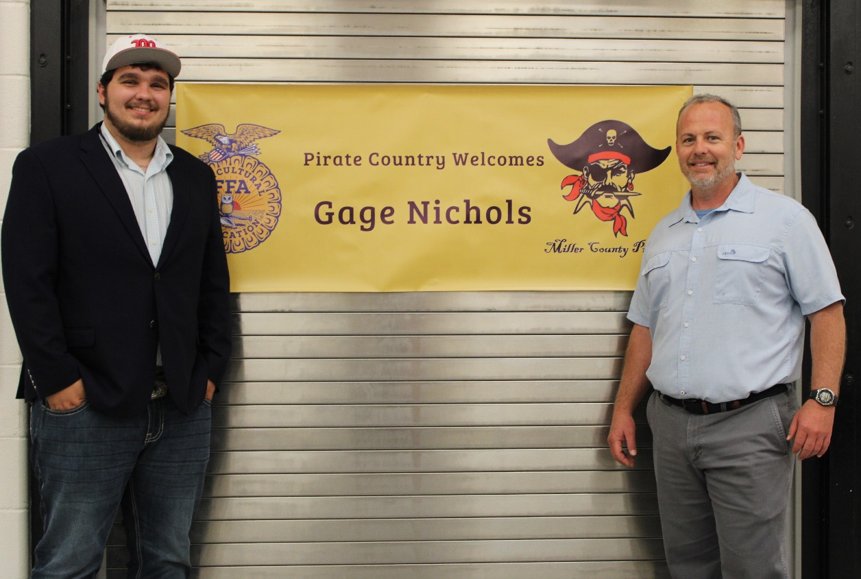

Pictured Gage Nichols and Jamie Ard, Principal
Pirate Country welcomes Gage Nichols

On April 16, 2024, at the Miller County High School cafeteria, Miller County Schools sponsored a “meet and greet” for faculty, community, staff and students in our area to introduce themselves to Gage Nichols our recently hired Agriculture Education teacher. The well- attended function enabled Mr. Nichols and his family to witness Miller County Southern hospitality at its best.
The reception buffet consisted of sandwiches, vegetables, fruit, punch, water, a variety of dips, sauces, and of course cookies of all varieties. The decorations were in a FFA/farm motif.
The fellowship and conversation was unsurpassed. Everyone had a great time meeting this young man and his family. He was warmly welcomed into the Miller County family.
Mr. Nichols graduates from ABAC in Tifton in May and will assume his responsibilities as Ag educator in Miller County on July 1 of this year. Although young in years, he has a rich background in agriculture and FFA. He is “All In” for Miller County. Good luck and Godspeed.

