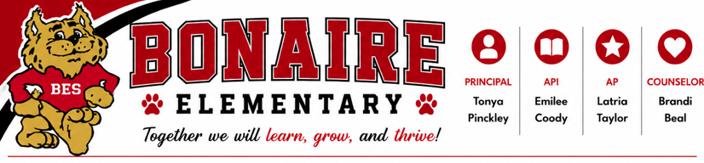
School Council Advisory Committee
September 24, 2026
Agenda

Members:
- Mrs. Alana Camps (Malachi – 4th Grader)
- Mrs. Kelli Hayes (Canaan – 5th Grader and Hollin – 3rd Grader)
- Mrs. Takeytra Marlin (Kenni Jae’ – 4th Grader)
- Mr. Anwar Sadler (Ava – 5th Grader)
- Mrs. Cassie Thompson (Hank – 3rd Grader)
- Mrs. Ashley Williams (Wyatt – 3rd Grader)
- Mrs. Becky McKenzie (Blair – 4th Grader and PTO President)
- Mrs. Kaitlyn Thompson (Teacher – TOTY)

Future Dates:
- Thursday, November 19th @ 8:00 a.m. in Room 402 (Beal and L. Taylor)
- Thursday, January 28th @ 8:00 a.m. in Room 402 (Coody)
- Thursday, March 18th @ 8:00 a.m. in Room 402 (Wrap Up)

Conversations of the Past:
- Technology Concerns/Safety
  - CIPA Lessons
  - Safety Talks
  - Computer Access Limited 10:00 p.m. – 6:00 a.m.
  - Go Guardian Penalty Box
- Explain MAP Assessment
  - We now conduct a MAP Night to explain what it is and how we use it
- Share Safety Protocols
  - We have a committee that discusses safety concerns
  - As a faculty we review safety scenarios
  - We also have a “Safety Night” for parents to ask question and learn about our protocols
- STEM
  - We have STEM activities once a month
  - We have Extension Nights once each semester
  - 4H comes to 4th and 5th grade classrooms and conducts STEM lessons during science

Notes:

