## aug09_divider1.png

November 6-10, 2023

**Important dates:**

* November 10th- Veteran’s Day program (wear red, white, and blue)
* November 15th- Friendsgiving items due
* November 17th- Charlie Brown friendsgiving feast
* November 20th- 24th- Thanksgiving break

**\*ice cream and Chick-Fil-A biscuits must be PAID FOR and PRE ORDERED- this is optional**

**Weekly focus:**

**Theme**– Veteran’s

**Letters**- Qq, Zz

**Words**- that, the

**Math**- count to 50 by ones, write recognize and work with numbers 0-10, addition to 5, name 2d and 3d shapes, sort objects, positional words

**Reading/ language-** ask and answer questions about what is read, identify characters in a story, identify parts of a book, produce rhyming words, isolate and identify beginning & ending sounds, identify letters and sounds of the alphabet

**Writing**- their name and all letters of the alphabet from memory, invented spelling

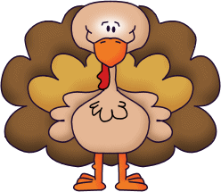



FYI:

As the weather is getting cooler, please practice “self-help” tasks at home with your child, such as putting on and zipping up his/her jacket, removing and hanging up jackets/coats, tying shoelaces, etc. This will help your child gain independence. Please label all jackets/sweaters with your

child’s name.

**Reminders:**

\*Million cans recycling contest- send in your aluminum cans

\*ice cream order forms and money are due Thursday- kiddos will get ice cream on Friday for snack if they purchased

\*practice sight words and letters/ letter sounds, and writing letters at home

\*check folders daily