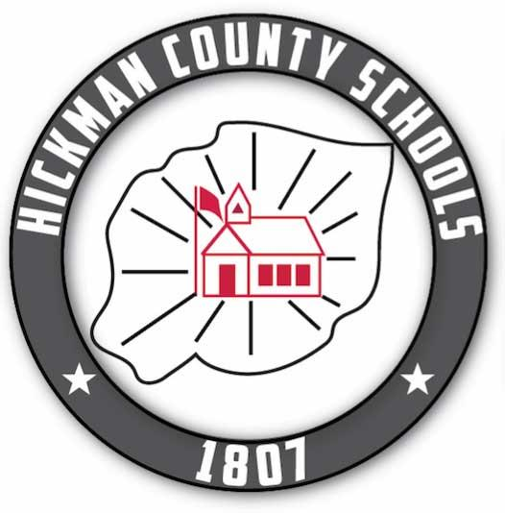
Hickman County Schools
Vision, Mission, and Core Values

Our Mission: The Hickman County School System exists to engage and develop the mind, body and character of every student so that each is prepared for success in education, work and life.
Our Vision: We engage and inspire our students from start to finish by setting high expectations for both students and adults. Every student is valued by teachers, leaders and support staff who provide each one access to quality instruction and support.
Our Core Values:
- Our schools must be safe, welcoming and positive for students, parents and teachers.
- Each student can learn, can be successful and deserves our high expectations. We encourage and support growth without limitations for all.
- We engage and inspire our students from start to finish.
- We expect to develop our students into well-rounded citizens who continue to learn throughout life.
- We strive to develop citizens who can apply knowledge ethically and with integrity in our community and world.
Goals
- Caring educators will create a positive environment and culture of high expectations and empower students to establish and pursue their future aspirations and goals.

- High quality instruction and a rigorous and engaging curriculum will positively impact student learning and improve achievement.

- Identify, grow, and support future teachers and leaders to sustain an educational system of excellence.

- Nurture partnerships between schools and stakeholders to serve the community and its citizens by sharing resources to create learning opportunities.

Hickman County Schools
Vision, Mission, and Core Values

Strategic Planning Priorities for 2022-2023:
Culture
- Build and promote a positive environment and caring culture in all schools.
- Hold high expectations for students at all levels of learning.
- Expose students to the world of college and career at all levels and provide opportunities early for students to experience success at the postsecondary level.

Instruction
- Increase literacy achievement and TVAAS growth across all grades.
- Increase numeracy achievement and TVAAS growth across all grades.
- Emphasize course offerings for early postsecondary and ACT success.

Effective Personnel
- Recruit, hire, and retain high quality personnel.
- Promote the education profession to current students.
- Provide opportunities to develop teacher leaders.
- Develop a local leadership pipeline.

Community Engagement
- Promote the school system initiatives in the community and celebrate success.
- Communicate effectively with stakeholders.
- Promote and expand partnership opportunities with local businesses and employers.

Culture
Action Steps for 2022-2023:

Increase work-based learning opportunities in CTE for students and provide more high-demand opportunities that align with TISA model.

College and career days at each of our schools in Hickman County.

Implement YouScience in grades 8 and 11 for students to analyze aptitude and interest for students.

Partner with emergency services to provide assistance in drills and safety planning.

Additional security enhancements based on school assessments.

Additional school nurse to prepare for situations where a nurse must be absent.

Utilize AWARE program for student mental health awareness: small group learning, student advisory groups, and mental health check-ins.

Graduation Walk for EHHS and HCHS through lower grade schools

STOPit app for anonymous reporting for bullying and harassment; promotion by student AWARE councils

Utilize building level social emotional leaders to train teachers on the use of Restorative Practices.

Implement Work Ethic Distinction Program for high school seniors

Collaborative planning between school nutrition department and coordinated school health for menu planning alternatives

Contract for professional learning for school nutrition staff on menu planning and preparation

Future Action Steps (2023-2026):
Implement SWPBS at the high school level for positive school environment including the development of school-wide expectations and a matrix for behavior and consequences.

Potential alternative school location in the East Hickman zone.

Alumnae reach out program—share our own success and build upon it.

Training for RTI2B for culture, bullying, and positive behavior.

Instruction
Action Steps for 2022-2023:

PLC Meetings for content/grade level bands for planning towards the rigor and expectations of the curriculum standards.

Teacher committees formed and trained for math adoption and curriculum selection.

Leadership teams meeting in every school to prioritize needs based on data analysis.

Utilize technology ambassadors to work with all teachers on the integration and utilization of technology, in particular the Google Education Suite

Provide mentoring for new teachers with highly effective teachers in content areas, outside of school-based if needed.

Provide training for counselors on You Science and CTE offerings and programs of study for consistent scheduling.

Walkthrough feedback for all new teachers and teachers identified through TEAM data and by the building principal as needing assistance.

Expansion of virtual school in Hickman County to offer to homeschool students that want additional support in high-level classes.

Implement and establish high dosage tutoring program

School-based work based learning opportunities

Future Action Steps (2023-2026):

Implement a district-wide PLC for singleton teachers to allow collaboration and planning.

Increase offerings in STEM, Music, and Arts. Re-establish music and art in lower grades.

Expand school-based work-based learning opportunities

CAD introduction in high school programming

Foreign language opportunities in younger grades

Effective Personnel
Action Steps for 2022-2023:

Provide mentoring for new teachers with highly effective teachers in content areas, outside of school-based if needed.

Three-year induction plan for new teachers

Participate with other districts in the Grow Your Own Initiative through NSCC and APSU.

Institute local leadership pipeline to identify and recruit teacher leaders.

Provide signing and/or bonus for teachers and leaders in areas that are considered hard to fill.

Utilize task force groups to recommend action steps for strategic planning for each goal.

Utilize student advisory council to meet with district leaders regarding student experiences and concerns, as well as extended learning.

Future Action Steps (2023-2026):

Further develop a collaborative team for strategic planning and goal setting to include specific objectives and timelines for each group. Provide stipend for each group leader.

Provide local job shadowing as a part of the leadership pipeline experience.

Explore childcare facility for school employees

Community Engagement
2022-2023 Action Steps:

Community mental health awareness events: walk, festival, speaker

Read 20 initiative expansion to include restaurant placemats in partnership with Chamber of Commerce

School system presence at community events to provide information and free books

Work Ethic Distinction partnership with Hickman County Economic Development, Chamber of Commerce, and Business Education Council

Individualized high school planning for all students yearly

Joint meeting with county commission regarding budgeting and facilities

Recognition of businesses during basketball games

“Hometown Heroes” Part III video highlighting success stories from Hickman County

Industry Partnership kickoff--host event at Career Center to show our CTE programs

Future Action Steps (2023-2026):

Recognize children from birth with a book and bib from the school system

Schools open after hours from parent and student clinics for tutoring and/or assistance with content

Sewer Plant Design

Long-term facility planning

