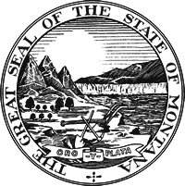 | Notice of Location of Polling Place and Accessibility Designations  Not more than 10 days or less than 2 days before an election, the election administrator shall publish in a newspaper of general circulation in the county a statement of the locations of the precinct polling places. The election administrator shall include in the published notice the accessibility designation for each polling place according to the classification in 13-3-207. Notice may also be given as provided in 2-3-105 through 2-3-107.
Notice to be published in newspaper of general circulation in county

Statement of the Location of Precinct Polling Places and Accessibility Designations for __Treasure_ County for the _May 7_, 2024, _School_ Election:

**Polling places marked with an asterisk will be open for voting from 12:00 noon to 8:00 p.m.

All other polling places will be open for voting from 7:00 a.m. to 8:00 p.m.

Precinct Number | Polling Place Name and Location | Accessibility Designation (A – Accessible,  I – Inaccessible)
1 | **Hysham High School-Lobby 115 Summit St., Hysham, MT 59038 | A

Updated April 26, 2024

