Mrs. Daniel’s Newsletter
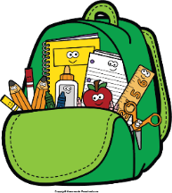
January 10-14, 2022
Grammar (adjectives and our senses) and Reading Skills Tests: Friday
Spelling (-le) and Vocabulary Tests: Friday

Monday, January 17: MLK Jr. Holiday (NO
SCHOOL)
Friday, January 28: Spirit Day; Special Snack

Friday, January 14: Class Pictures; Honor
Roll Recognition

Reading Story and Skills:  Story:  A Froggy Fable  by John Lechner  Phonics/Fluency:  final syllable  -le  Text-Based Comprehension:  draw conclusions, background knowledge  Grammar:  adjectives and  our senses | Selection Vocabulary Words:  - preserve – to keep something safe from harm so it won’t be ruined  - valuable – worth something or is important to you  - concentration – thinking hard about one thing without being distracted  - homeland – the country where you were born or where you live  - represent – to stand for  - tough – very difficult  - patient – to be able to wait for something to happen without complaining  - frown – to turn down the corners of your mouth when you are worried  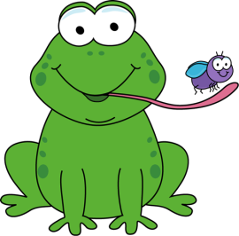  Vocabulary Words  (these words will be tested each week):  - clearing – piece of land that has no trees  - crashed – fell with a loud smashing noise  - perfect – as good as is possible  - pond – water with land all around it; a small lake  - splashing – making water scatter and fall in drops  - traveled – went from one place to another
Math  Topic 6: Fluently Subtract within 100  Lesson 4: Continue to Subtract Using Partial Differences  Lesson 5: Practice Subtracting  Lesson 6: Solve One-Step and Two-Step Problems  Lesson 7: Problem Solving (Reasoning)  We will be doing a weekly assessment on Friday. |  |  |  | Social Studies/Science  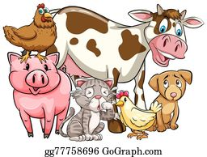  We will  continue to  study animals  this week.
Spelling Words: Students who correctly spell the bonus words get a small prize.
- ankle  - title  - apple |  | - cable  - purple  - able | - bugle  - bundle  - bubble |  | - giggle  - sparkle  - tickle | ***BONUS***  13. puzzle  14. mumble  15. ladle

