**2024-2025**

**Harvest High School**

**Handbook of Policies & Procedures**

**Website:** [**http://www.harvesthigh.net**](http://www.harvesthigh.net)

729 West Main Street

Ripon, CA 95366

Tel: 209-599-5009

Fax: 209-599-7050

**Mission Statement**

To provide students with a quality education, the opportunity to recover credits, and earn a high school diploma.

**Vision Statement**

To train young adults to be positively connected with their community and prepared to transition to technical careers and/or college.

**Harvest High School Staff**

Mrs. Kathryn Diederich - Principal kdiederich@riponusd.net

Mrs. Marti Ulrich - Secretary mulrich@riponusd.net

Mrs. Tara Hooks - Academic Counselor thooks@riponusd.net

Ms. Julie Castoe -Teacher [jcastoe@riponusd.net](mailto:jcastoe@riponusd.net)

Mrs. Ranjita Singh - Teacher rlal@riponusd.net

Ms. Michele Cook - Instructional Assistant mcook@riponusd.net

Mrs. Pam Wilkins - Special Ed pwilkins@riponusd.net

Mrs. Nichele Kaiser- Counselor nkaiser@riponusd.net

**Important Dates**

Back to School Meet and Greet - August 2, 5 & 6

First Day of School – August 7, 2024

Last Day of School – May 23, 2025

Graduation – May 21, 2024

| **HHS BELL SCHEDULE**  School Opens @ 8:15 am   | 1st Period | 8:30 – 9:15 | | --- | --- | | 2nd Period | 9:18 – 10:03 | | **BREAK** | **10:03 – 10:13** | | 3rd Period | 10:13 – 10:58 | | 4th Period | 11:00 – 11:45 | | **LUNCH** | **11:45 – 12:15** | | 5th Period | 12:15 – 1:00 | | 6th Period | 1:03 - 1:48 | | **\*EXTENDED DAY PROGRAM\*** | | | **BREAK** | 1:48 – 1:58 | | 7th Period | 1:58 – 2:43 | | 8th Period | 2:43 – 3:28 |   ***\*Minimum Day Schedule - Every Wednesday at 1:48*** | **Extended Day:**  The purpose of extended day is to offer extra time for students to work on their credit recovery, Gradpoint coursework, class assignments or get extra one-on-one help from a teacher.  *Harvest High School is primarily a **closed campus** so once students arrive they are not allowed to leave until the end of the school day.  *Students can earn the privilege of off campus lunch by meeting various attendance, PBIS or APEX/Edmentum expectations. If they do not return on time they may lose the privilege of off campus lunch. |
| --- | --- | --- | --- | --- | --- | --- | --- | --- | --- | --- | --- | --- | --- | --- | --- | --- | --- | --- | --- | --- | --- | --- | --- | --- | --- |

**BACK TO SCHOOL MEET AND GREET:** To ensure student success here at Harvest High, it is important that both parent and student meet prior to the start of school with the principal at our meet and greet. This gives the opportunity to review the student handbook and expectations as well as answer any questions. Parents will be sent out a day and time over the summer. It is important that parent/guardian attend this meeting along with their student.

**PARENT COMMUNICATION**

At Harvest we work hard to make sure we have great communication with students and parents. We use a Google texting app where parents can communicate with us during school hours and on the weekends. All staff have access to the texting app so anyone of us can answer questions you may have. At our meet and greet I will also give you my personal cell number to communicate with me on private matters as needed. We will be using REMIND to send out school announcements. In addition, we encourage parents and students to download the AERIES app to view grades. At our meet and greet we can help you get set up to access AERIES.

**ATTENDANCE**: Perfect attendance at school is the expectation of every student. State law requires children between the ages of 6 and 18 years (except those exempted by law) to attend school full time. Students who are 18 years old are still required to follow school rules, including attendance. All attendance issues including self-checkout are subject to review and verification by staff. All absences, partial and full day, excused or unexcused, more than 12 days in the school year may require a doctor’s note. Continual attendance problems may result in disciplinary action (SARB Referral)), disenrollment (transfer to an alternative program), or referral to the District Attorney.

**ABSENCE PROCEDURES:** If you are absent from school, your parent or guardian must verify the reason and the dates of absence within 3 days. If not cleared within 3 days, the absence will remain unexcused. All unexcused full day and single period absences will accumulate and may initiate the truancy process.

Verification of excused absences will be accepted in the form of a **note**, **phone call** or an **email** to the site secretary. **Parents may call anytime, 24-hours a day**, (**209) 599-5009**.Students, it is your responsibilityto ensure that your parents or guardians clear any absence(s) with the school.

| Absences considered ***Excused*** by School Board Policy:   * Illness of student * Appearance in court (verification required) * Attendance at an employment conference * Jury Duty (verification required) * Necessary visits to the doctor, dentist, or counseling. * Death in the immediate family * Observation of a Religious Ceremony or holiday * Attendance at a religious retreat for no more than four hours per semester * College Visits*. Students may use two school days for college visits. These days must be approved prior and upon return, the student will have their College Visit form completed upon arrival. See the attendance office for questions.* | ***Unexcused Absences***include, but are not limited to, the following:   * Car Trouble * Missed Bus * Needed at home * Out of town * Vacation/Trips * Work * Personal Appointments (hair, nails, DMV) |
| --- | --- |

**Independent Study**

A short-term Independent Study Program may be considered for students who will be absent 3-14 consecutive days. In order to determine if this program of study is appropriate for your student, please contact your school administrator a week prior to the absence. Independent Study Contract forms are available at your school office. If approved, the Independent Study Contract must be completed, signed and dated preferably prior to the absence or within 10 days of the date of the contract. Students with individual education plans require additional IEP team agreement. Your student will then be issued school work to be completed while away from school. Your student must complete and return all the work that was assigned in order to receive full credit.

**The following situations are considered Unexcused absences:**

* Any absence not cleared in a manner consistent with the absence procedures.
* Leaving class or school without permission.

*\*\*If you leave school or class, you are subject to disciplinary action by the school administration. Depending on the circumstances the disciplinary action may vary.*

**Check-Out Procedures: Permission to Leave School Grounds**

Students are not permitted to leave school during school hours without following the check-out process through the school office. Violation of this rule will result in disciplinary action. To get permission, report to the school office. Permission may be given after your parent has been contacted by phone, or if you are in possession of a valid note.

**If you know you are going to leave school on a particular day or time,** have your parent/guardian contact the school office in advance. The school phone number is 599-5009. If you reach the recorder, leave a message with the student’s name, time of departure, and date.

**Off-Campus Lunch Privilege:**

Harvest High School is a closed campus during the school day. Students may earn the privilege of walking off campus for lunch by participating and meeting various attendance, PBIS or Gradpoint expectations. Students are allowed to walk off campus for lunch **NOT driving or being driven**. Students cannot order food to be brought to campus from UBER eats, DoorDash or other food delivery services. Students who leave campus must be back on time. Students who are late may lose their off campus privilege.

**\*\*Students caught driving or as a passenger off campus during lunch are subject to disciplinary action by the school administration**

**Food Delivery Services:NO DELIVERY SERVICE FOOD ACCEPTED** Due to excessive disruption and safety concerns, we do not accept food deliveries from outside delivery services (i.e., DoorDash, Uber Eats, etc.). We will only accept food deliveries from parents/guardians for their own child(ren) and delivery MUST be dropped off in the front office for student/s to pick up. Any unauthorized food deliveries will not be accepted. Please note that the money paid for the food will not be reimbursed.

**Age of Majority:**

We have many students who turn 18 during the school year. It is important that parents/guardians understand that when a student turns 18 that they assume educational rights. This means that parents are no longer allowed to request student information from the school without the written consent from their child. The consent form can be requested from the school office for the student to sign. Access to school records shall be permitted to parents of a pupil 18 years of age or older who is a dependent as defined in Section 152 of the IRS code of 1954 (Ed Code 49076)

**Military Recruiter Information**

20 U.S.C. section 7908 requires that school districts disclose the names, addresses and telephone numbers of high school students to military recruiters upon request, unless parents request that this information not be released without prior written consent. Parents have the option of making such a request. If parents do not wish this information to be provided to military recruiters, they must notify the District office of this fact in writing. The writing should be directed to the District official listed : Harvest High School Administration 729 W. Main Street Ripon , CA 95366 (209) 599-5009

**Work Permits**

## Congratulations on your new job! Once you have been hired for a job, you will need to obtain a valid work permit from school in order to work.

## 1. Request a work permit form from the secretary.

## 2. Take the work permit to your employer, they will fill in the employer section, you fill in the minor/school information.

## 3. Bring the completed form to the front office.

## 4. Pick up your completed work permit and submit it to your employer. ​

## Reminder: In order to obtain a work permit you must have at least a 2.0 GPA (as of last reporting period) and no F grades. This also includes no attendance issues. It should be noted that a work permit can be revoked at any time if a student fails to meet school requirements.

**AERIES**

AERIES is our grading and attendance system. Both parents and students have sign-on privileges to see grades. You will be provided information on how to access AERIES and you are encouraged to check on grades and attendance.

**School Based Counseling**

Harvest offers on-site school based counseling for any student that needs this service. Parent permission slips are signed so the counselor can work with the student 1:1 in a confidential setting. In addition, the school counselor conducts small group sessions during life skills centered around the issues of today’s teen.

**PBIS System**

Harvest High school strives to provide all students with support in both academics and social emotional. We believe that students should earn rewards based on meeting expectations set forth in our Positive Behavior Intervention Support (PBIS) system. As students earn points/school bucks, they can purchase items from our student store. Points are given throughout the day based on students following our school motto of PAWS.

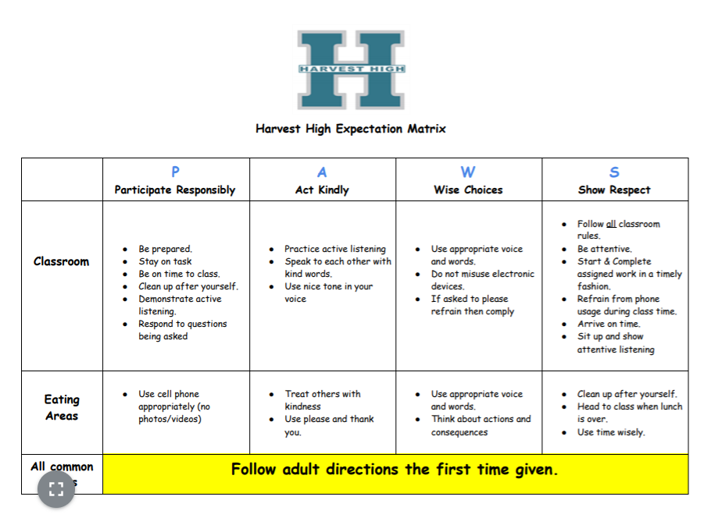

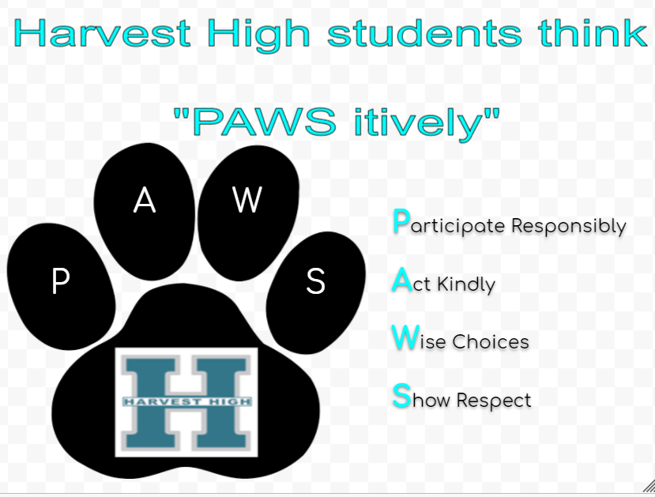

**Tardy Policy**

A student is tardy when a student is not in their seat ready to learn by the beginning of 1st period.

Consequences for tardies are as follows:

| ***First Tardy*** | Warning |
| --- | --- |
| ***Second Tardy*** | Students will owe the time of the tardy during a student’s lunch period or at the end of their school day if it is prior to 3:28. |
| ***3rd-4th Tardy*** | Students will continue to owe time during lunch or after school and their parents will be notified either through text message, email or phone call. |

**The 5th time a student is tardy a parent conference will be set up to address the issue. Any student who is tardy 30 minutes or more is documented for truancy and may be subject to the SARB process.**

**Discipline**

Harvest High School is committed to providing a safe and orderly environment for all students and staff to learn and teach. In conjunction with Ripon High School’s discipline committee the following rules, regulations, policies and procedures were created to protect our school from violence, threats of violence, drugs, weapons, gang activity, bullying and disruption. Students are subject to school disciplinary action for improper or unsafe behavior

1. While on school grounds
2. While going to school or leaving school
3. During the lunch period, whether on or off the campus
4. During or going to or from any school-sponsored activity. (ED Code 48900)

By clearly communicating our policies to students and parents, we hope to minimize the need to impose disciplinary action. However, persistent or severe misbehavior can lead to expulsion.

**General Guidelines/Corrective Procedures**

The administration has the authority to impose Detentions, In School Suspension, Saturday School, Attendance/Discipline contracts, and out-of-school suspensions or to recommend expulsion to the Board of Trustees. Discipline Policies apply during school and school-related activities.

**Right to Due Process**

Students have a right to a hearing with the principal or his designee for:

1. Receiving an oral or written notice of charges
2. An explanation of the evidence leading up to the decision to suspend a student from school
3. An opportunity to present the student’s side of the story.

Students and parents have the right to request a conference with the principal or his/her designee. If you and your parents appeal or desire a further review of the case, you may ask for a meeting with the district superintendent or his/her designee.

Also, the school may contact your parents to request a conference and will inform you and your parents of the length of the suspension and will mail a letter with the details of the incident and subsequent suspension.

**Suspension**A suspension is the temporary removal of a student from school or from class for violation of school rules as defined in the California Education Code, Section 48900. There are two forms of suspension: suspension from class (Teacher Suspension ED 48910) and suspension from school. Any teacher may suspend a student from his/her class for a maximum of 2 days per incident. Students may not be suspended from school for more than five days at a time, nor more than 20 days per school year without school board approval.

If a student is approaching 20 days of suspension, administration may consider expulsion or alternative education under a restricted behavior contract. An administrator will not suspend or expel a student from school for alleged misconduct without due process.

***Categories of Offense & Discipline Consequences:***

| **LEVEL A OFFENSES (Least Serious)**   * Violation of class rules * Parking violation * Out of class without a pass * Non-dress PE * Non-directed profanity * Loitering * Talking/disruptive * Public Display of Affection * Minor Misbehavior * Intentional Disruption * Littering * Eating/Drinking in class (except water in a clear, resealable container) * Possessing any object considered disruptive to the educational process | **LEVEL A range of CONSEQUENCES:**  First Offence: Warning, possible teacher administered outcome, parent notification.  Second Offence: Detention, teacher suspension, referral to Vice Principal, 1-5 day suspension, parent notification, behavior agreement.  Third Offence: Teacher suspension, referral to Vice Principal, 1-5 day suspension, the possible recommendation to an alternative program.  **NOTE: Level A offenses require teacher intervention steps before referral to the Vice Principal.** |
| --- | --- |

| **LEVEL B OFFENSES**   * Leaving school without checking out * Leaving class early or without permission * Rough, boisterous activity * Bus citation/violation * Honor Code Violation * Computer/Internet violation * Failure to follow staff directions * Forged note * Defiance * Failure to serve detention * Running to a fight * Possession of a lighter * Obscene or vulgar act * Failure to identify yourself to school personnel * Possession of Dice * Knowingly receiving stolen property * Reckless driving * Profanity to staff * Dangerous Behavior * Bullying/Hazing * Driving off Campus * Refusing to forfeit cell phone to a staff member | **LEVEL B range of CONSEQUENCES:**  First Offense: Parent notification, Detention, Teacher suspension, referral to Vice Principal, behavior agreement, 1-5 day suspension.  Second Offense: Referral to Vice Principal, 3-5 day suspension, possible recommendation to alternative program or recommendation for expulsion.  Third Offense: Referral to Vice Principal, 3-5 day suspension, possible recommendation to alternative program or recommendation for expulsion. |
| --- | --- |

| **LEVEL C OFFENSES**   * Alcohol/controlled substances * Attempt or commit Sexual Assault/Battery, Hate Crime * Possession of, providing, or use of a firearm * Possession or brandishing a knife or dangerous object * Selling a controlled substance * Use or possession of explosives * Robbery/Extortion * Knowingly receiving stolen school or private property * Profanity/Vulgarity/Obscene Act * Vandalism * Fighting-which includes provoking a fight * Fireworks * Threatening Behavior/Comments/Statements * Threats to Adults * Terror Threats * Sexual Harassment (inappropriate and/or unwelcome touching) * Theft | **LEVEL C Range of CONSEQUENCES:**  First Offence: Referral to Vice Principal, 1-5 day suspension, possible recommendation to alternative program or recommendation for expulsion.  Second Offence: Referral to Vice Principal, 5-day suspension, recommendation to alternative program or recommendation for expulsion.  Third Offence: Referral to Vice Principal, 5-day suspension, recommendation for expulsion.    **SENIORS: “Level C” offenses committed by a Senior within the last quarter of the school year may result in their exclusion from the graduation ceremony.** |
| --- | --- |

***General Policies:***

**Tobacco, Electronic Cigarettes, Vaping and Drug-Free District**

In the interest of public health, tobacco use, and use of tobacco products, electronic cigarettes, hookahs, vaping/aerosolized devices with or without nicotine are strictly prohibited on SJCOE/SJC School District property, including vehicles, district buildings and during district operations and functions. Health and Safety Code, Section 104420; SJCOE policy 3513.3; Ripon Unified School District Board Policy 3513.3. Harvest High School utilizes sensor devices in the bathrooms. Students are expected to not tamper with devices.

**Skateboards, Wheelies, Rollerblades, and Bikes:**

Students are allowed to use these items for transportation to and from campus; however, these items must be stored in the area designated by the administrator. All skateboards, wheelies, rollerblades, bicycles (and other wheeled items) carried on campus during school must be placed in the appropriate designated area and returned at the end of the day. Repeated offenses will be considered defiance and will result in progressively more severe discipline.

**Report Cards**

Report cards will be mailed home to parents eight times during a school year. Each quarter grades are issued and are part of the official school records and are on student transcripts. 1st Quarter grades are mailed home in October, 2nd Quarter grades are mailed home in December, 3rd Quarter grades are mailed home in March and 4th Quarter grades are mailed home in May. Additionally, we will mail Progress Reports in September, November, February, and April.

**ACADEMIC COUNSELING SERVICES:**

Throughout the school year, there will be times when you will need assistance and information in dealing with some of your classes, concerns, or problems. The counseling staff along with the principal work together to service all student needs. To see your counselor let the site secretary know and she will relay the information. The counselor is onsite twice a week. For the principal, during an appropriate time throughout the day drop in is fine. .

*Your counselor is able to provide you with advice and information regarding:

* Higher education and other future plans
* College and University requirements
* Grants, scholarships, student loans, etc.
* Your high school course of study
* Vocational interest, aptitude and other testing, such as PSAT, SAT, ACT, etc.
* Program changes, changes of your classes (see below)
* Graduation requirements
* Whatever else you need to know to assist in your educational career.

**Harvest High School Graduation Requirements**

| **Subject** | **Title** | **Required Credits** |
| --- | --- | --- |
| English | English 1 - 4 | 40 |
| Math (including Algebra 1) | International Math 1 plus one additional year | 20 |
| Social Studies | World History(10)  US History (10)  Government(5)  Economics(5) | 30 |
| Science | Physical Science (10)  Life Science (10) | 20 |
| Fine Art/Foreign Language | Art, Spanish, (Choir and Band if taken at RHS and with Harvest Admin approval) | 10 |
| Health | Health | 5 |
| Physical Education | P.E. 9 (required)  Elective P.E. | 20 |
| Life Skills | Life Skill | 5 |
| Electives | Any Elective Courses | 45 |
| **Total** | | **195** |

*The number of credits required for graduation from Harvest High School is 55 fewer than the 250 credits required for graduation from the comprehensive site due in large part to a reduction in the number of required elective courses.*

**Dress Code**

**Notification to Parents and Students**

The administration has an obligation to take action to control any conditions pertaining to grooming or dress when safety, health, or the educational process may, in any way, be hampered. It is expected that ALL pupils will come to school neat, clean, and with consideration for proper hygiene. Any student found to be in violation of the Dress Code shall be required to make a change in their grooming and/or dress in order to come into compliance.

Harvest High School reserves the right to amend the Dress Code if any clothing, apparel, symbol or combination thereof has been identified as gang related apparel by any law enforcement agency OR when safety, health, or the education process is being violated.

Part of career planning is to learn to dress appropriately for the job, or for certain occasions that requires a particular type of dress. Despite changing fashions, certain guidelines and limitations must be set for the best interest of students and the educational process. Extreme fashions or appearance, which are considered inappropriate or distracting to the educational process, will not be allowed.

**Harvest High School Dress Code Guidelines All Students**

**Dress Code**

Students who are found to be in violation of the dress code will be given a dress code violation. The first two violations are considered warnings. The student will be offered an opportunity to correct their dress code violation and return to class; however, they will still receive the violation. On the third violation, the vice-principal or designee will make a call home to inform the student’s guardian of the dress code violation and discuss a plan to avoid dress code violations in the future. Repeated violations of the dress code will be considered defiance and will result in progressive discipline. After the first two warnings, students will receive a 30 minute detention with each violation that occurs thereafter.

There are district policies related to student dress that must be enforced, which include (BP 5132): The Governing Board believes that appropriate dress and grooming contribute to a productive learning environment. The Board expects students to give proper attention to personal cleanliness and to wear clothes that are suitable for the school activities in which they

participate. Students' clothing must not present a health or safety hazard or a distraction that would interfere with the educational process.

Students and guardians shall be informed about dress and grooming standards at the beginning of the school year and whenever these standards are revised. A student who violates these standards shall be subject to appropriate disciplinary action.

In addition, the following guidelines shall apply to all regular school activities:

* Shoes must be worn at all times.
* Clothing, jewelry, and personal items (backpacks, fanny packs, gym bags, water bottles, etc.) shall be free of writing, pictures, or any other insignia which are crude, vulgar, gang related, profane, or sexually suggestive, which bear drug, alcohol, or tobacco company advertising, promotions, and likenesses, or which advocate racial, ethnic or religious prejudice.
* Clothes shall be sufficient to conceal undergarments at all times. See-through or fish-net fabrics, halter tops, off-the-shoulder or low-cut tops, bare midriffs, and skirts or shorts shorter than mid-thigh (5 inches) are prohibited. Hair shall be clean and neatly groomed. Hair may not be sprayed by any coloring that would drip when wet.

**Gang Activity**

The Board of Trustees has directed the administration of Ripon High School to provide students with a safe, secure learning environment that is free from harassment, intimidation, or fear of confrontation. ***Therefore, if you engage in gang activity, you will lose your opportunity to be a student here and will be referred for expulsion.***

**All gang activity results in a minimum 1-5 day suspension**

**Gang-related incidents, photos, drawings, graffiti, clothing, accessories, and paraphernalia will be reported to the Ripon Police Department.**

**May result in expulsion upon first offense:**

* Gang-related initiation, hazing, or intimidation
* Admission of gang membership
* Involvement in criminal gang incidents (even if an incident takes place off school grounds)
* Writing about gang affiliation or activity
* Official documents (police, probation, court, school records, etc.) indicate gang membership
* A judicial finding of gang membership
* Student’s victims are members of a rival gang

**May result in expulsion upon repeated or multiple offenses:**

* Has gang tattoos, whether temporary or permanent
* Writes or is in possession of written gang graffiti
* Uses a gang-related name, moniker, or nickname
* Wears gang-related colors or clothing imprinted with gang names or symbols
* Uses gang signs or other non-verbal expressions of gang affiliation
* Student’s name appears on a gang document, hit list, or gang-related graffiti
* Identified as a gang member by a reliable informant
* Identified as a gang member by another gang
* Identified as a gang member by a public source (newspaper story, etc.)

**Gang-Related Dress Code Restrictions**

Articles of clothing, manner of grooming, or accessories of any kind denoting gang affiliation are not allowed. The final determination of which items denote gang affiliation is done by the administration. The following guidelines are provided to assist students to choose appropriate attire while attending Ripon High School.

1. Attire and accessories advocating, advertising, or denoting gang affiliation or activity are not permitted. Such attire includes, but is not limited to, belts, belt buckles, bandanas, shoelaces, wallets, purses, backpacks, notebooks, jewelry, badges, emblems, symbols, tattoos, signs, or any item determined by the administration to be gang affiliated.
2. Clothing that depicts any advertising or glorification of gangs, guns, violence, drugs, put-downs, or any anti-group slogans is not permitted.
3. No solid red, solid blue, or solid brown (without logo or designs) shall be allowed. Logos or designs added need to be visible in the torso area of the shirt. No jackets, sweatshirts, shoelaces, hairpieces, and/or belts shall be allowed if they are gang-related in any way. Red shirts, sweatshirts, hats, and jackets that are official Ripon High attire are allowed.
4. Pro teams can be worn unless determined to be gang-related by the administration or Ripon Police Dept.
5. No engraved, stamped, or lifted initials or numbers shall be permitted on any belts (with the exception of RHS approved or affiliated belts).
6. No long-hanging belts are allowed. Belts must be the appropriate size and must be tucked into belt loops.

Apparel promoting any specific race, culture, or ethnicity over others is not allowed.

**May Result in Expulsion Upon First Offense:**

* Gang related initiation, hazing, or intimidation
* Admission of gang membership
* Involvement in criminal gang incident (even if incident takes place off school grounds)
* Writing about gang affiliation or activity
* Official documents (police, probation, court, school records, etc.) indicate gang membership
* Judicial finding of gang membership
* Student’s victims are members of a rival gang

**May Result in Expulsion Upon Repeated or Multiple Offenses:**

* Has gang tattoos, whether temporary or permanent
* Writes or is in possession of written gang graffiti
* Uses a gang-related name, moniker, or nickname
* Wears gang-related colors or clothing imprinted with gang names or symbols
* Uses gang signs or other non-verbal expressions of gang affiliation
* Student’s name appears on a gang document, hit list, or gang-related graffiti
* Identified as a gang member by a reliable informant
* Identified as a gang member by another gang
* Identified as a gang member by a public source (newspaper story, etc.)

The Board of Trustees has directed the administration of Harvest High School to provide students with a safe, secure learning environment that is free from harassment, intimidation, or fear of confrontation. ***Therefore, if you engage in gang activity at HHS you will lose your opportunity to be a student here and will be referred for expulsion.***

**ELECTRONIC DEVICE/CELL PHONE POLICY**

Electronic devices have become a common means of communication and information access in today’s society. However, these devices have the potential of disrupting the orderly operation of the school. Harvest High School has therefore created this policy to govern the possession and use of electronic devices on school premises, during school hours and at school sponsored activities. **Personal laptops/iPads are strictly prohibited on campus**.

1. Personal electronic devices (PEDs) are privately owned wireless and/or portable electronic handheld equipment that include, but are not limited to: laptops, cell phones, smartphones, smartwatches, iPads, mobile messengers, video games, MP3 players, iPods, headphones, etc. PEDs also include any current and emerging wireless handheld technologies or portable information technology systems that can be used for word processing, wireless internet access, image capture/recording, sound recording and information transmitting/receiving/storing, etc.
2. Just as students are responsible for good behavior in a classroom, on school sanctioned activities, or on school grounds, they must also be responsible when using not only school computer networks but their personal technologies, as well. If a student violates any of the above rules, his/her privilege shall be terminated. Disciplinary action may also result. If possible criminal activity is discovered, the proper law enforcement authorities will be notified. Disciplinary action for students shall be in accordance with existing discipline policies and may include suspension or expulsion in accordance with the laws of the State of California.

**\***Please note; that we discourage students from bringing such items because Harvest High School will not be held responsible for any lost, stolen, or damaged items and it is the discretion of the parent/ guardian to allow their student to bring them to school.**\***

1. Faculty, staff, and administration have the right under law to confiscate any electronic device from students who violate this policy. When any electronic device is confiscated, staff shall take reasonable measures to label and secure the device and give it to the school site secretary or administrator as soon as the employee’s duties permit.
2. Individuals wishing to report a violation of this policy should contact a school administrator.

**Prohibited Use:**

1. The use of any electronic device is strictly prohibited unless authorized by the teacher.
2. **Possession/Use of Cellular Phones and Other Mobile Communications Devices:**

**No student shall be prohibited** from possessing or using an electronic signaling device that is determined by a licensed physician or surgeon to be **essential for the student's health and the use of which is limited to health-related purposes.** (Education Code 48901.5).

**Disciplinary Action That May Be Taken:**

1. Violation of this policy will result in discipline up to and including suspension and expulsion, and notification of law enforcement authorities.
2. A student who violates this policy may be prohibited from possession of an electronic device at school or school-related events.
3. Consequences for students whose phones **HAVE BEEN CONFISCATED** by staff:
   1. 1st Offense: Return to Student after school
   2. 2nd Offense: Return to Parent after school
   3. 3rd Offense: Suspension & Return to Parent
   4. 4th & Future Offenses Suspensions that increase in days up until referral for expulsion

**Security of Devices:** Students shall be personally and solely responsible for the security of electronic devices brought to school. The school shall not assume responsibility for theft, loss, damage, or unauthorized calls made with an electronic device. If devices are loaned to or borrowed and misused by non-owners, device owners are jointly responsible for the misuse or policy violation(s).

**Exceptions:**

With prior approval of the principal, the above rules may be relaxed under the following circumstances:

1. The use is at the direction of a teacher for educational purposes;
2. The use is determined by the principal or staff. (Education Code 48901.5).

--------------------------------------------------------------------------------------------------------------------------------

**Harvest High Classroom Phone Use Policy**

* No earbuds in use during class time - unless given permission by teacher
* Cell phones/electronic devices are turned on vibrate, placed in the cell phone pocket chart which is housed in the back of the classroom. Students may access the phone when assignments are completed and turned in **AND** permission is given by the classroom teacher.
* Cell phones/electronic devices are turned on vibrate, placed in the cell phone pocket chart which is housed in the back of the classroom during credit recovery program unless given permission by the teacher or instructional assistant. Cell phones **must be** put up and away when students are taking pre or post tests on credit recovery online program.
* Absolutely not photos or video of students or staff during school hours.
* If a student chooses not to follow the procedure for cell phones as stated above, the following consequences will occur:

1st: WARNING

2nd: CONFISCATED AND GIVEN BACK TO STUDENT AT THE END OF THE DAY

3rd: RETURNED TO PARENT/GUARDIAN AFTER SCHOOL

**Failure to comply with confiscation will result in a referral to the administrator.**

**I have read the cell phone policy and will abide by this policy:**

**Student Name:______________________________________ Student Signature:________________________**

**HARVEST HIGH SCHOOL ACADEMIC HONOR CODE**

**Plagiarism** includes, but is not limited to:

* Using another person’s idea, opinion, or theory.
* Using any facts, statistics, graphs, drawings – any pieces of information – that are not common knowledge.
* Copying another person’s actual spoken or written words.
* Paraphrasing another person’s spoken or written words without providing proper credit and citations.
* Downloading papers from a website and turning them in as your own, in part or in their entirety.

**Cheating** includes, but is not limited to:

* Copying, borrowing, or turning in as one’s own, the work of another student
* Taking a picture of an assignment/quiz/test (completed or not) to enhance your results or the results of others
* Knowingly sharing your completed work with others so that they can copy your answers and turn in as their own
* Using crib notes/cheat sheets while taking a test
* Getting answers to a test from a student in another period
* Purchasing papers, having someone or hiring someone to write the paper for you
* Signaling or communicating with another student during a test of any kind

**Consequences**

* **1st incident** of plagiarism or cheating – administrative referral, if incident is confirmed teacher calls home, 1-hour detention, “0” on assignment, notification letter sent home, the student is to write apology letters to teacher and parent(s) (student writes the letters while serving detention).
* **2nd incident** of plagiarism or cheating – administrative referral, if incident is confirmed teacher calls home, 1-day suspension, “0” on assignment, notification letter sent home, student writes apology letters to teacher and parent(s).
* **3rd incident** of cheating or plagiarism – administrative referral, if incident is confirmed teacher calls home, 3-5 day suspension, “0” on assignment, notification letter sent home, student writes apology letters to teacher and parent(s), student may be referred for consideration of expulsion.

**Missing or Incomplete Assignments**

Students at Harvest High school do not typically have homework and they are given enough time in class to complete all assigned work. If a student chooses to not complete the assignment during their class time then the student will be expected to make up the assignment during their break, lunch or stay at the end of the day (the same day the assignment is due). A student may not have more than 2 missing assignments total among all teacher-led classes. This does not pertain to students making up work due to absences. If work completion becomes a concern then a parent conference will be held to help support the student in not falling behind. A student may also not turn in incomplete work for a grade below 60%. If an incomplete assignment is turned in and below 60% the student will receive the assignment back and be treated as a missing assignment that needs to be done.

**I have read the policy regarding missing/incomplete assignments and understand that if I have missing work then I will be asked to stay the same day it is due to not fall behind.**

**Student Name: ___________________________________ Student Signature:______________________________**

**This page is intentionally left blank**

**Harvest High School**

**IMPORTANT**

Please read the information contained in this ***Student Handbook*** and discuss it with your child.

If you have any questions about any of the information, please feel free to contact the school.

I read and understand the policies, rules, and requirements.

__________________________________ _________________

Student’s Signature Date

__________________________________ _________________

Parent/Guardian’s Signature Date

**Sign and return this page only to your teacher or office immediately!**

**Student should retain the remainder of the handbook**